**Recipe for:Wild Rice Salad with Pecans and Cranberries**

8 cups water 6 scallions, finely chopped

12 ounces (dry) wild rice 1 cup diced yellow tomatoes

1 teaspoon salt 1 cup raspberry vinaigrette dressing

1/3 cup sun-dried cranberries Salt and pepper, to taste

1/3 cup pecans 1 cup chopped parsley, optional

In a large saucepan, bring water to a boil and add wild rice and salt. Reduce the heat, and cover the saucepan. Cook rice for 50 to 60 minutes*, until rice is completely tender. Drain excess water, and let rice cool. Once rice is cooled, transfer it to a large mixing bowl, and add cranberries, parsley, pecans, scallions, yellow tomatoes, and raspberry vinaigrette. Add salt and pepper, and mix rice salad thoroughly.

*Do you know, you can substitute with quick or instant wild rice to cut down the cooking time



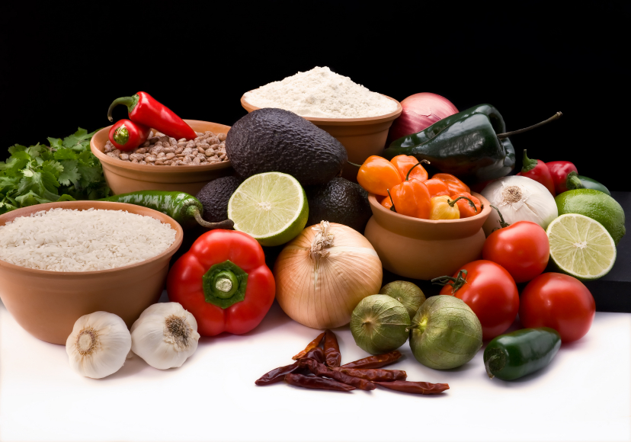

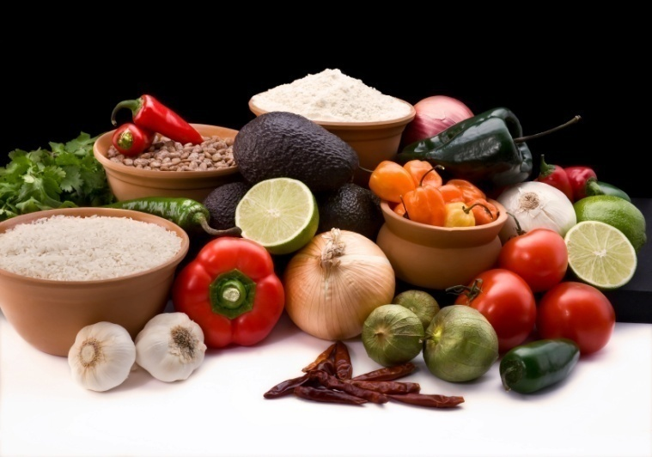

1 Tbs butter

1 small onion, chopped

1 lb fresh mushrooms

1 cup wild rice, rinsed and drained

1/4 cup chopped parsley

Salt and pepper, to taste

In a large saucepan over medium heat, melt the butter. Add the onion and mushrooms and sauté until soft and translucent. Add the wild rice, parsley, salt, pepper. Add water to cover by 1 inch. Bring to a boil, reduce the heat to low, cover and cook until the rice is tender, about 45 minutes. Drain off any excess water. The cooking time will vary with different batches of rice. The wild rice is ready when the grains puff up and the inner, lighter part is visible.

**Recipe for:** **Wild Rice and Mushroom Pilaf**



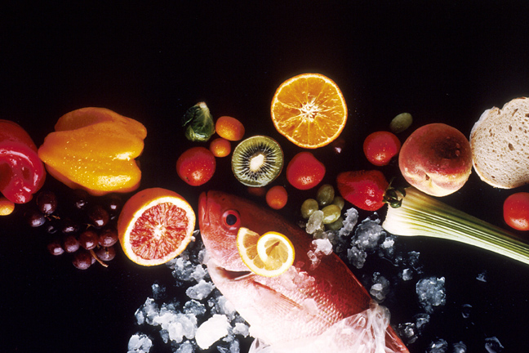

**Recipe for: Wild Rice Soup**

2 cups cooked wild rice 4 cups chicken broth

2 Tbsp. butter 1 can mushrooms, drained

1 Tbsp. minced onion 1 cup cream

¼ cup chopped celery parsley or chives, optional

¼ cup flour

Melt butter in pan and sauté onion and celery. Blend in flour gradually. Add broth, stirring constantly until thick. Stir in rice and salt and simmer 5 minutes. Add mushrooms, blend in cream. Garnish with parsley or chives.





**Recipe for: Chicken and Wild Rice Casserole**

3-4 chicken breasts, cooked and cubed 1 box wild rice

1 can cream of chicken soup 4 oz sour cream  
1-2 stalks celery, chopped 1/2 onion, chopped

Cook chicken, dice into cubes. Sauté celery and onion in a little butter until translucent. Cook wild rice according to package directions. Mix chicken, celery and onion, rice, soup and sour cream together and pour into a greased 8x8" dish. Bake at 350°F for 30 minutes. This casserole can also be assembled the night before and then baked the next day, but bake an additional 15 minutes or until casserole is hot throughout.





**Recipe for: Creamy Chicken Wild Rice Soup**

4 tablespoons unsalted butter 1/4 cup all-purpose flour

3 celery stalks, chopped 1 cup wild rice

2 carrots, chopped 2 quarts chicken broth

1 medium onion, chopped 2 cups water

2 garlic cloves, minced 4 cups cooked chicken or turkey

1 1/2 teaspoons finely chopped thyme 1 cup heavy cream

Salt and Pepper

Melt butter in saucepan. Add the celery, carrots, onion, garlic, thyme and a generous pinch each of salt and pepper and cook over moderate heat, stirring occasionally, until the vegetables just start to soften. Sprinkle the flour over the vegetables and cook, stirring, until evenly coated and lightly browned. Add the wild rice to the saucepan and gradually stir in the stock and water. Bring to a boil, then simmer over low heat, stirring occasionally, until the vegetables are tender, about 30 minutes. Add the chicken and simmer, stirring occasionally, until the wild rice is tender, 10 to 15 minutes longer. Stir in the cream and season with salt and pepper.





**Recipe for: Wild Rice Stuffing**

Cooking spray 1 1/2 tablespoons chopped fresh sage

1 1/2 cups chopped celery 1 cup uncooked long-grain brown rice

1 cup chopped onion 1/2 cup dried sweet cherries

1 cup uncooked wild rice 1/2 cup chopped dried apricots

2 garlic cloves, minced 1/2 cup chopped pecans, toasted

4 cups chicken broth 1/2 teaspoon salt

1/2 teaspoon pepper

Sauté celery, onion, wild rice, and garlic. Stir in broth and sage; bring to a boil. Cover, reduce heat, and simmer 25 minutes. Stir in brown rice, and bring to a boil. Cover, reduce heat, and cook for 30 minutes or until liquid is absorbed. Remove from heat; let stand, covered, 10 minutes. Stir in cherries and remaining ingredients.



