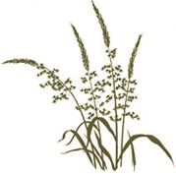

Beneficial Bites

History
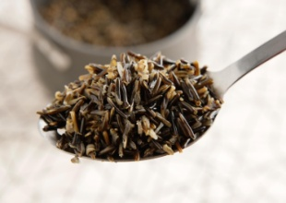
Wild Rice is Minnesota's State Grain. It is not actually rice, but an annual water-grass seed. Naturally abundant in the cold rivers and lakes of Minnesota and Canada, wild rice was the staple in the diet of the Chippewa and Sioux Indians, native to this region. Wild rice continues to be an important staple food for Great Lakes Indian people. It is a spiritual food, considered to be a gift from the Great Spirit or Creator. In Minnesota, one must first purchase a license, and then harvest wild rice during state regulated seasons in the traditional way.

Health benefits
- Twice as much protein as brown rice
- Up to 30 times more antioxidant than white rice, which protects the heart
- High fiber content keeps digestion smooth and helps lower cholesterol
- Rich in phosphorus and zinc is good for bones and joints

Beneficial Bites

History
Wild Rice is Minnesota's State Grain. It is not actually rice, but an annual water-grass seed. Naturally abundant in the cold rivers and lakes of Minnesota and Canada, wild rice was the staple in the diet of the Chippewa and Sioux Indians, native to this region. Wild rice continues to be an important staple food for Great Lakes Indian people. It is a spiritual food, considered to be a gift from the Great Spirit or Creator. In Minnesota, one must first purchase a license, and then harvest wild rice during state regulated seasons in the traditional way.

Health benefits
- Twice as much protein as brown rice
- Up to 30 times more antioxidant than white rice, which protects the heart
- High fiber content keeps digestion smooth and helps lower cholesterol
- Rich in phosphorus and zinc is good for bones and joints

Beneficial Bites

History
Beneficial Bites
Wild Rice is Minnesota's State Grain. It is not actually rice, but an annual water-grass seed. Naturally abundant in the cold rivers and lakes of Minnesota and Canada, wild rice was the staple in the diet of the Chippewa and Sioux Indians, native to this region. Wild rice continues to be an important staple food for Great Lakes Indian people. It is a spiritual food, considered to be a gift from the Great Spirit or Creator. In Minnesota, one must first purchase a license, and then harvest wild rice during state regulated seasons in the traditional way.

Health benefits
- Twice as much protein as brown rice
- Up to 30 times more antioxidant than white rice, which protects the heart
- High fiber content keeps digestion smooth and helps lower cholesterol
- Rich in phosphorus and zinc is good for bones and joints
Check Out the January Menu
for These “Wild Rice” Foods

- Wild Rice Mushroom Pilaf
- Chicken Wild Rice Casserole
- Creamy Chicken and
Wild Rice Soup
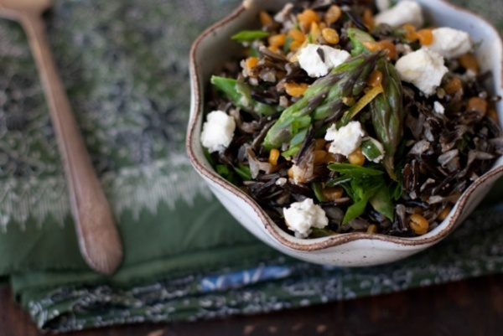

Fun Facts
- Wild rice is also known as “water oats,” “Indian rice,” or “Canada rice.”
- The wild rice was naturally a brownish-green color. Wild rice producers hybridized different wild rice varieties, leading to the commercially dominant style: black-grained.
- Today most commercial varieties are cultivated in manmade rice “paddies” in California.

Created by Li Cheng, MS, UW-Stout Dietetic Intern, 2015
Check Out the January Menu for These “Wild Rice” Foods

- Wild Rice Mushroom Pilaf
- Chicken Wild Rice Casserole
- Creamy Chicken and
Wild Rice Soup

Fun Facts
- Wild rice is also known as “water oats,” “Indian rice,” or “Canada rice.”
- The wild rice was naturally a brownish-green color. Wild rice producers hybridized different wild rice varieties, leading to the commercially dominant style: black-grained.
- Today most commercial varieties are cultivated in manmade rice “paddies” in California.

Created by Li Cheng, MS, UW-Stout Dietetic Intern, 2015
Check Out the January Menu for These “Wild Rice” Foods

- Wild Rice Mushroom Pilaf
- Chicken Wild Rice Casserole
- Creamy Chicken and
Wild Rice Soup

Fun Facts
- Wild rice is also known as “water oats,” “Indian rice,” or “Canada rice.”
- The wild rice was naturally a brownish-green color. Wild rice producers hybridized different wild rice varieties, leading to the commercially dominant style: black-grained.
- Today most commercial varieties are cultivated in manmade rice “paddies” in California.
Created by Li Cheng, MS, UW-Stout Dietetic Intern, 2015

