Whole Grains for Better Health

What is a whole grain?
Whole grains contain all of the parts of the grain. This includes the bran, germ and endosperm.

When a whole grain is stripped of the bran and germ, it is often called a “refined” grain.
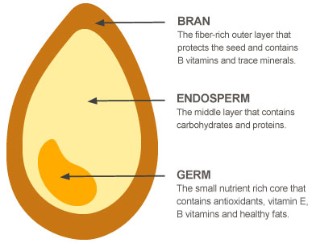
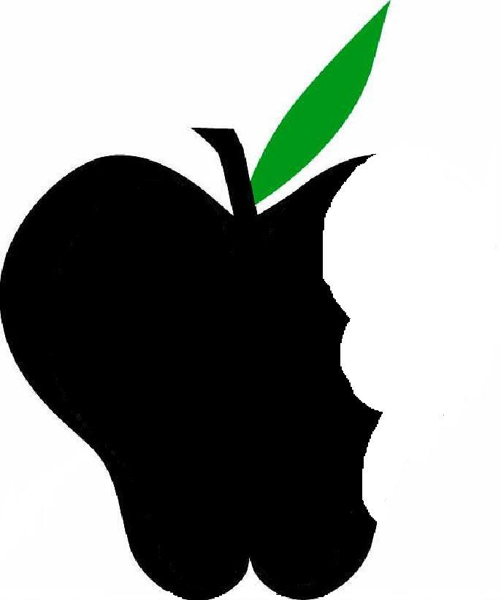
Beneficial Bites

The bran is the outer shell that protects the seed. It provides fiber, B vitamins, and trace minerals.
The germ provides nourishment for the seed (and you), contains antioxidants, vitamin E, protein, B vitamins, minerals.
The endosperm provides energy for the seed in the form of carbohydrates (primarily) and protein.
Look for the Whole Grains Council stamp…
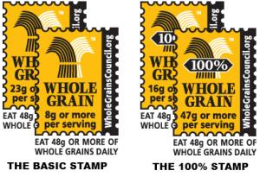

At least half of our grains should be whole grains… that’s 3-5 servings a day!

What’s a serving of whole grain look like?
- 1/2 cup cooked brown rice or other cooked grain
- 1 cup 100% whole grain ready-to-eat cereal
- 1/2 cup cooked 100% whole-grain pasta
- 1/2 cup cooked hot cereal, such as oatmeal
- 1 ounce uncooked whole grain pasta, brown rice or other grain
- 1 slice 100% whole grain bread
- 1 very small (1 oz.) 100% whole grain muffin

With so many grains to choose from, you’ll never get bored! Wheat, Rye, Buckwheat, Corn, Rice, Wild Rice, Barley, Amaranth, Teff, Triticale, Sorghum, Quinoa, Millet, Spelt and more!
Beneficial Bites

