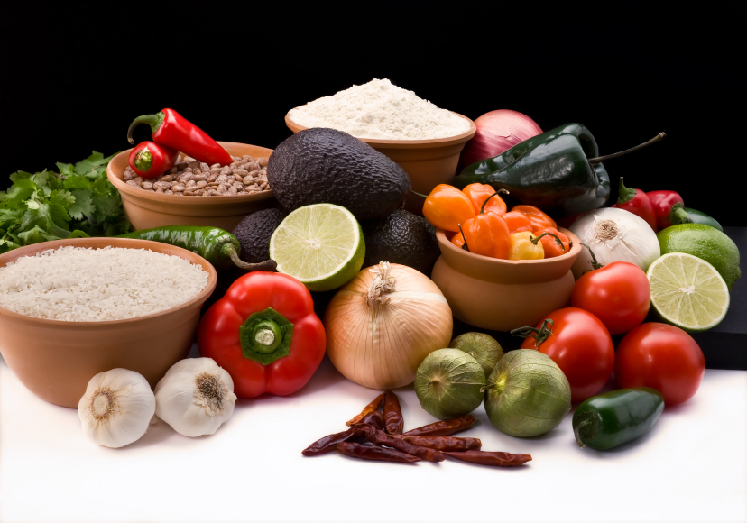
Recipe for: Buckwheat-Oat Snack Cake
¼ cup steel cut oats1 ¼ cups hot water
¼ cup butter or margarine½ cup brown sugar
1 t. cornstarch½ T. vanilla
½ T cold water1t. ground cinnamon
1 cups buckwheat pancake mix½ egg, beaten
¼ cup skim milkoptional ¾ cup diced fresh apple

Preheat oven to 350°. Mix steel cut oats with hot water in saucepan. Let stand 15 minutes before bringing to boil. Reduce heat and simmer until oats are softened, about 30 minutes. Remove from heat, add butter and stir until it melts completely. Add the sugar and beat well. In small dish, whisk together cornstarch, vanilla and cold water. Beat into oat mixture. Add cinnamon, buckwheat pancake mix, milk, egg & apple. Blend until fairly smooth. Pour into 8 x 8 pan treated with cooking spray. Bake for 20-25 minutes or until toothpick comes out clean.


Recipe for: Millet-Cauliflower Mash
½ cup millet
2 ½ cups water
2 cups frozen cauliflower florets
½ teaspoon salt
Butter, roasted garlic or horseradish

Wash and drain millet. Place in saucepan with water, cauliflower and salt. Bring to a boil, reduce heat to lowest simmer and cover. Cook for 35 minutes, checking and stirring after about 25 minutes. The millet will break open and the thicken the liquid in the pot. When millet is very soft and thick, remove from heat and let stand 5 minutes
Using blender or food processor, puree mixture until it is smooth. Stir in butter or other flavorings of your choice. Serve immediately.

Recipe for: Spelt Flour Crackers
¼ t. sea salt
½ cup cold water
1 ½ cups spelt flour
Flax, caraway, poppy, sesame, fennel seeds or course salt
Preheat the oven to 350°F. Dissolve the salt in 1/2 cup of cold water. Stir in the spelt flour until combined. Knead the dough a few turns until a ball forms. Flour an overturned 12-by-17-inch cookie sheet and roll out the dough on top of it, using as much flour as needed to prevent sticking, until the dough covers the sheet from edge to edge. Using a spray bottle filled with water, spray the dough to give it a glossy finish. Prick the dough all over with a fork. If you choose, sprinkle with seeds or coarse salt. For neat crackers, score the dough into grids. Bake until the dough is crisp and golden and snaps apart, 15 to 25 minutes. (Check after 10 minutes to make sure it does not overcook.) Break into pieces and serve.

Recipe for: Triticale Biscuits
½ cup triticale flour
½ cup whole wheat flour
2 ¼ t. baking powder
2 T non-fat dry milk
2 T shortening
1/3 cup water
½ t. salt

Preheat oven to 425°. Sift together dry ingredients. Cut in shortening. Add water, stir quickly. Knead for one minute and roll dough 1 inch thick and cut into biscuits. Place on ungreased cookie sheet and bake for 10-15 minutes until golden brown. Yields 9 biscuits.

Approx 80 calories; 2 gm fiber. Recipe from Bob’s Red Mill website www.bobsredmill.com

