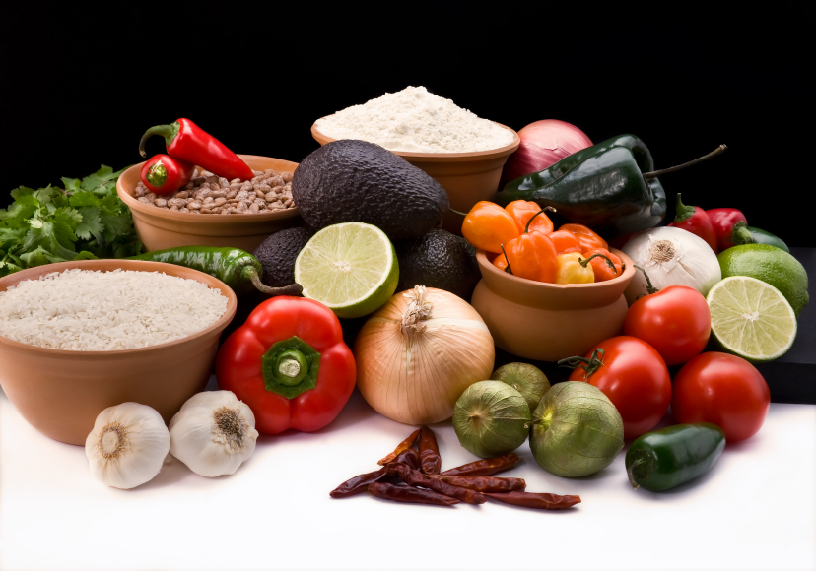
Recipe for: Country Breakfast Cereal
½ cup uncooked brown rice
4 T butter or margarine
¼ cup raisins or dried cranberries
½ t. ground cinnamon
1 cup water*

Combine all ingredients in saucepan. Bring to a boil and stir. Reduce heat, cover and simmer for 40-50 minutes or until rice is tender and liquid is absorbed. Fluff with fork and serve with milk or cream, honey or brown sugar and fresh fruit and nuts.

*For a richer cereal, substitute up to half of the water for milk. If using 2% or whole milk, add another 2 T of liquid.

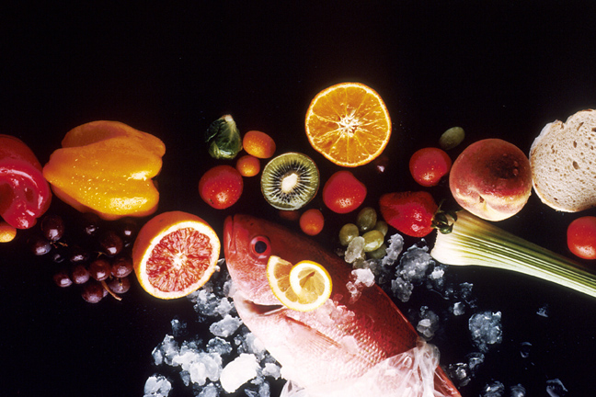
Recipe for: Blueberry Amaranth Porridge
¾ cup amaranth
1 ¼ cup water
1 ¼ cup milk
1 T butter or margarine
3 T. heavy cream (or fat-free half & half)
¼ cup blueberries
2 T maple syrup
Combine the amaranth, water, milk and butter in saucepan. Bring to a boil and stir. Reduce heat and simmer for 20 minutes stirring occasionally. When mixture becomes very thick and the grains are cooked through, stir in heavy cream and blueberries. Divide cereal into two bowls and drizzle each with maple syrup.

Recipe for: Tangy Quinoa Salad
½ cup quinoa
1 cup water
3 green onions, sliced thin
1 red pepper, diced
½ cucumber, peeled and diced
5-10 cherry tomatoes, halved
Italian dressing or vinaigrette

Cook quinoa in water for about 20 minutes stirring often. Refrigerate to cool. Combine the vegetables in bowl, stir in cooled quinoa. Lightly toss with dressing of your choice.

Recipe for: Yummy Banana Bread
1 cup teff flour½ cup whole wheat flour
½ cup all-purpose flour½ t. salt
½ t. baking soda½ t. baking powder
½ t. ground cinnamon1 cup granulated sugar
5 T. butter, softened1 large egg beaten
½ t. vanilla extract 1 cup ripe bananas, mashed (about 2 medium)
¼ c. water1 cup semi-sweet chocolate chips

Preheat oven to 350°. In small bowl, combine flours, salt, baking soda, baking powder and cinnamon, stirring with whisk. In large bowl, cream sugar and butter. Add egg to creamed mixture, beating until well blended. Add vanilla, banana and water, beating until blended. Add dry mixture to creamed beating on low speed just until blended. Stir in chocolate chips. Spoon into 9-inch loaf pan coated with cooking spray. Bake for 50 minutes or until wooden pick comes out clean. Cool 10 minutes before removing from pan.

