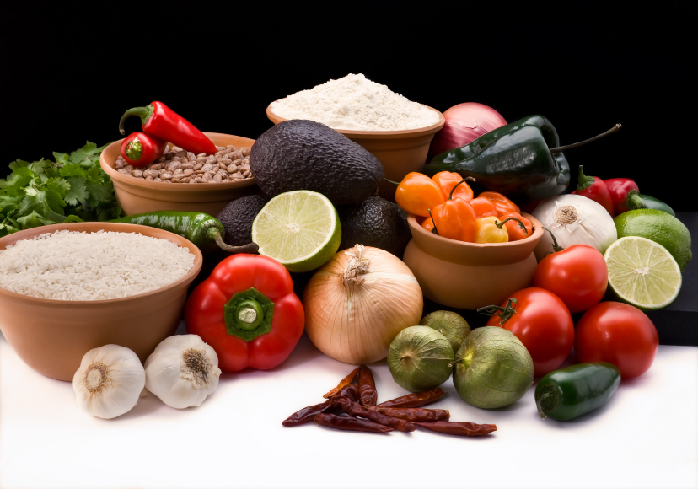
Recipe for: Apple Pecan Muffins
2 cups Great Grains Crunchy Pecan Cereal1 cup milk
1 cup flour1/3 cup brown sugar
¼ teaspoon cinnamon¼ teaspoon salt
2 teaspoons baking powder 1 cup applesauce
1 egg, beaten 2 Tablespoons oil

Preheat oven to 400° F. Combine cereal and milk in small bowl and let stand. In separate bowl, combine flour, sugar, cinnamon and salt. Stir in applesauce, beaten egg, oil and cereal mixture until all dry ingredients are moistened. Batter will be lumpy. Scoop batter into muffin cups about two-thirds full. Bake 20 minutes or until golden brown. Makes 1 dozen. 180 calories per muffin.


Recipe for: Crunchy Chicken Pasta Salad

12 oz package whole wheat pasta, cooked½ cup grated carrots
2 cups grilled, cubed chicken breast1 cup red or green grapes, halved
2/3 cup celery, chopped¼ cup green onions, chopped
¼ cup sunflower seeds½ package Ramen noodles, loosely broken
1 ½ cups Italian dressing

Combine cooked pasta, chicken, grapes, celery, carrots and onions. Toss with dressing and chill at least one hour. Just before serving, stir in sunflower seeds and ramen noodles.

Recipe for: Whole Grain Rolled Triticale Bread
1 cup rolled triticale (rolled oats or other rolled grain)
2 cups water
1 T. dry active yeast
2 T + 1 t. brown sugar
¼ cup warm water
2 t. salt
3 cups whole wheat flour
2 cups unbleached all-purpose flour
½ cup warm milk

In small saucepan, combine triticale and 2 cups water. Bring to boil then simmer until you have a thick porridge. Remove from heat and cool. In small bowl, stir together salt and flours.

Once the porridge is cooled, stir in warm milk. In large mixing bowl, combine the yeast and brown sugar and add the ¼ cup warm water. Let it stand for 5 minutes until bubbly. Stir in cooled porridge to yeast mixture. Add in flour mixture little by little while stirring. Once it gets hard to stir with a spatula, stop adding flour. Dust kneading area with remaining flour mixture. Drop dough onto floured surface and knead well for 10-15 minutes, working in as much of the remaining flour as necessary. (By the end of kneading, the dough should be very slightly sticky though elastic at the same time.)

Place dough in greased bowl, lightly greasing top of loaf, cover with towel and let rise in warm place until doubled. Usually takes about an hour but may vary depending on humidity.

Punch down the dough, knead it 3-4 minutes or until air holes are pressed out. Cut off about 1/3 of the dough. Shape both of them into smooth balls. Place the smaller ball on top of the larger one. (see pictures below) Using the end of a wooden spoon, pierce a hole right in the center of the smaller bowl all the way down through the larger one. Slice it for a decorative pattern. Cover loosely again and let it rise until doubled…about 45 minutes. Bake at 375° until golden brown. The bread should sound hollow if tapped – about 45-50 minutes. Allow to cool before slicing.

