|  |  |  |  |  |  |  |  |  |  |  |  |
| --- | --- | --- | --- | --- | --- | --- | --- | --- | --- | --- | --- |
| V | J | B | F | F | E | T | R | Y | O | L | B |
| M | M | W | R | T | A | K | Z | E | Y | C | U |
| M | U | J | H | O | C | S | A | L | O | T | C |
| N | W | H | N | E | W | M | T | R | V | S | K |
| A | M | I | G | U | A | N | N | A | W | P | W |
| T | U | H | X | R | G | T | R | B | O | E | H |
| Q | U | Z | A | N | O | G | I | I | W | L | E |
| O | O | N | M | N | Q | S | P | Y | C | T | A |
| N | T | E | C | I | R | D | L | I | W | E | T |
| H | M | I | L | L | E | T | N | G | G | Y | F |
| Z | Q | Z | N | P | I | M | M | Z | V | R | L |
| T | R | I | T | I | C | A | L | E | N | G | Z |

**Whole Grains Word Search**

**Amaranth Barley Brown Rice Buckwheat Corn Millet Oats Quinoa Rye Sorghum Spelt Teff Triticale Wheat Wild Rice**

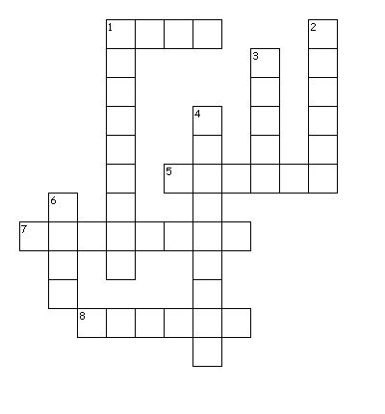 Whole

Grain

Goodness

C:\Documents and Settings\leslie.fijalkiewicz\Local Settings\Temporary Internet Files\Content.IE5\SGU8AHOQ\MC900280959[1].WMF

**Across**

1. The outer skin of the whole grain kernel

5. The B vitamins in whole grains help our bodies make this.

7. Often added to foods to make them darker and give the impression of whole grain.

8. A staple grain throughout much of the world but mainly used in bird feed here.

**Down**

1. This grain is often used in making pancakes.

2. The pearled form of this is not a whole grain because some of the bran is removed.

3. Whole grains have both soluble and insoluble forms of this nutrient.

4. This form of rice is parboiled before refining so some of the vitamins are retained.

6. This grain doubles as a vegetable and has more antioxidants than any grain or vegetable.