Whole Grains for Better Health

What is a whole grain?
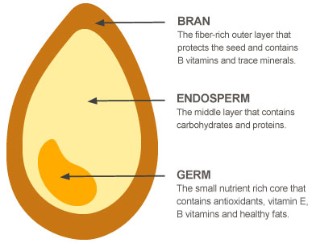
Whole grains contain all of the parts of the grain. This includes the bran, germ and endosperm.

When a whole grain is stripped of the bran and germ, it is often called a “refined” grain.
Beneficial Bites

Whole Grains for Better Health

What is a whole grain?
Whole grains contain all of the parts of the grain. This includes the bran, germ and endosperm.
When a whole grain is stripped of the bran and germ, it is often called a “refined” grain.
Beneficial Bites

Whole Grains for Better Health

What is a whole grain?
Whole grains contain all of the parts of the grain. This includes the bran, germ and endosperm.
When a whole grain is stripped of the bran and germ, it is often called a “refined” grain.
Beneficial Bites

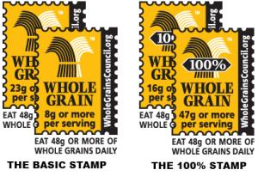
Look for the Whole Grains Council stamp on the package…

Can you find 15 whole grains in the word search below?
V | J | B | F | F | E | T | R | Y | O | L | B
M | M | W | R | T | A | K | Z | E | Y | C | U
M | U | J | H | O | C | S | A | L | O | T | C
N | W | H | N | E | W | M | T | R | V | S | K
A | M | I | G | U | A | N | N | A | W | P | W
T | U | H | X | R | G | T | R | B | O | E | H
Q | U | Z | A | N | O | G | I | I | W | L | E
O | O | N | M | N | Q | S | P | Y | C | T | A
N | T | E | C | I | R | D | L | I | W | E | T
H | M | I | L | L | E | T | N | G | G | Y | F
Z | Q | Z | N | P | I | M | M | Z | V | R | L
T | R | I | T | I | C | A | L | E | N | G | Z
Amaranth, Barley, Brown Rice, Buckwheat, Corn, Millet, Oats, Quinoa, Rye, Sorghum, Spelt, Teff, Triticale, Wheat, Wild Rice
Look for the Whole Grains Council stamp on the package…

Can you find 15 whole grains in the word search below?
V | J | B | F | F | E | T | R | Y | O | L | B
M | M | W | R | T | A | K | Z | E | Y | C | U
M | U | J | H | O | C | S | A | L | O | T | C
N | W | H | N | E | W | M | T | R | V | S | K
A | M | I | G | U | A | N | N | A | W | P | W
T | U | H | X | R | G | T | R | B | O | E | H
Q | U | Z | A | N | O | G | I | I | W | L | E
O | O | N | M | N | Q | S | P | Y | C | T | A
N | T | E | C | I | R | D | L | I | W | E | T
H | M | I | L | L | E | T | N | G | G | Y | F
Z | Q | Z | N | P | I | M | M | Z | V | R | L
T | R | I | T | I | C | A | L | E | N | G | Z
Amaranth, Barley, Brown Rice, Buckwheat, Corn, Millet, Oats, Quinoa, Rye, Sorghum, Spelt, Teff, Triticale, Wheat, Wild Rice
Look for the Whole Grains Council stamp on the package…

Can you find 15 whole grains in the word search below?
V | J | B | F | F | E | T | R | Y | O | L | B
M | M | W | R | T | A | K | Z | E | Y | C | U
M | U | J | H | O | C | S | A | L | O | T | C
N | W | H | N | E | W | M | T | R | V | S | K
A | M | I | G | U | A | N | N | A | W | P | W
T | U | H | X | R | G | T | R | B | O | E | H
Q | U | Z | A | N | O | G | I | I | W | L | E
O | O | N | M | N | Q | S | P | Y | C | T | A
N | T | E | C | I | R | D | L | I | W | E | T
H | M | I | L | L | E | T | N | G | G | Y | F
Z | Q | Z | N | P | I | M | M | Z | V | R | L
T | R | I | T | I | C | A | L | E | N | G | Z
Amaranth, Barley, Brown Rice, Buckwheat, Corn, Millet, Oats, Quinoa, Rye, Sorghum, Spelt, Teff, Triticale, Wheat, Wild Rice

