
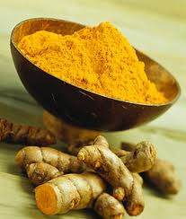
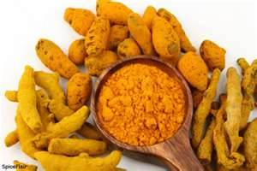
Beneficial Bites
Beneficial Bites
Turmeric has been used in many ways:
For healing: Historically it has been used as a remedy for diarrhea, bruises, colds and more.
As a Condiment: Used as an ingredient in cooking.
As a dye: Gives yellow color to fabric, food, and cosmetics.

TURMERIC
Turmeric is a member of the ginger family, has a bright yellow color, and a warm bitter taste.
It contains a an anti-oxidant called Curcumin that may be helpful in the prevention and treatment of certain diseases.

Making and Using Turmeric

History of Turmeric
Turmeric needs a lot of water to thrive and therefore is grown in the tropical climates of India and Asia.

Turmeric is made from the rhizome or the thick stem or root of the plant.

The rhizomes are dried and ground up into a fine powder then sold as a spice at the grocery store.

Turmeric adds a bright yellow color to dishes as well as a warm spicy flavor to curry dishes typically made with chicken, rice and vegetables.

Created by Carrie Karbon, UWGB Dietetic Intern

