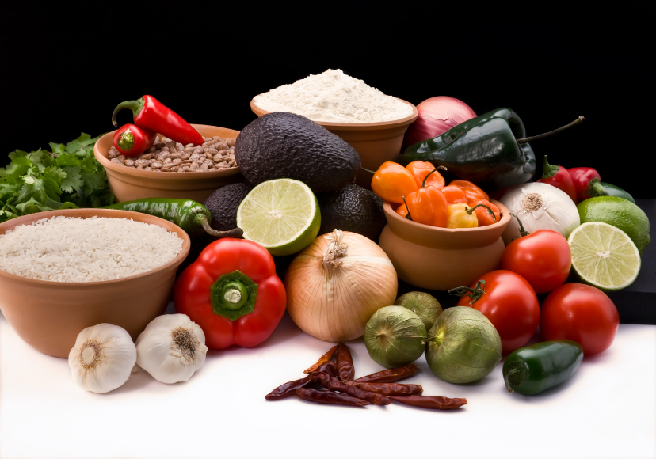
Recipe for: Curried Broccoli Salad
4 cups chopped fresh broccoli florets
½ cup chopped red onions½ cup dried cranberries
½ cup toasted chopped pecans½ cup crisp cooked bacon, chopped
½ cup Miracle Whip2 T. coconut
¼ t. salt¼ t. ground cumin
¼ t. ground turmeric1/8 t. ground allspice
1/8 t. pepper

In large bowl, combine broccoli, onions, cranberries, pecans and bacon. In small bowl, whisk together remaining ingredients. Add to larger bowl and gently toss to evenly coat. Refrigerate at least one hour before serving.

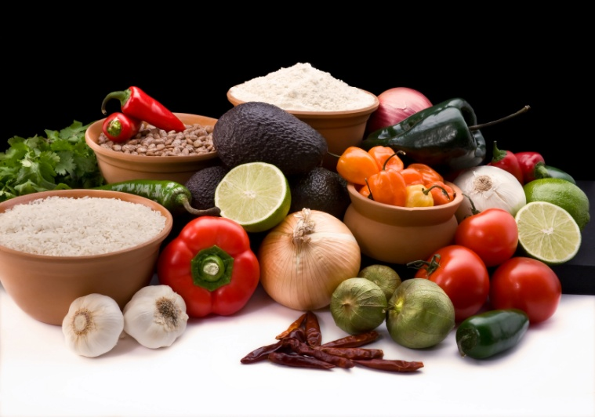

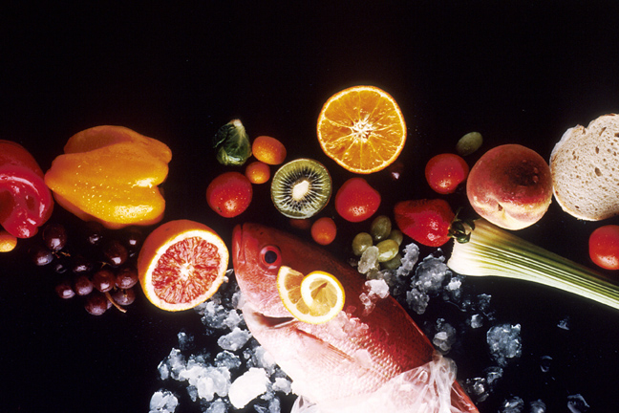
Recipe for: Southwestern Rice

1 medium green pepper, chopped1 medium onion, chopped
2 T. olive oil1 garlic cloves, minced
2 cups chicken broth1 cup rice
½ t. cumin¼ t. turmeric
15 oz can black beans, drained, rinsed10 oz pkg frozen corn, thawed
10 oz can diced tomatoes w/green chilis, undrained

In large non-stick skillet (that has a tight-fitting lid), saute green pepper and onion in olive oil for 3 minutes. Add garlic and saute another minute. Add broth, rice, cumin, turmeric and bring to a boil. Reduce heat, cover and cook for 15-20 minute until rice is tender. Gently stir in beans, corn and tomatoes to heat through. Serve immediately.

Recipe for: Turmeric Chicken & Broccoli Stir Fry
3 Boneless, skinless, chicken breasts
1 medium onion
4 cups broccoli florets
5 cloves garlic, minced
2 t. ground ginger
1 t. ground turmeric
½ t. ground cumin
1/8 t. chili powder
2 T canola oil

Slice the chicken and onions into strips. Saute the onion in oil for 2-3 minutes or until tender. Add garlic, sprinkle with ginger and continue sautéing. Add turmeric, cumin and chili powder and stir. Add chicken strips and broccoli and cook until chicken is no longer pink and broccoli is tender. Serve over rice.

Recipe for: Turmeric Rice

2 T. butter
½ cup chopped onions
1 garlic clove, minced
1 cup Basmati rice
1 T. turmeric
1 ½ cup chicken broth
1 bay leaf
Salt & Pepper

Saute onions in butter on low heat for two minutes. Add garlic and sauté another minute. Stir in remaining ingredients, bring to boil, cover and simmer 15-20 minutes. Fluff with fork, remove bay leaf and serve.

Recipe for: Sunburst Rice
3 T olive oil½ c chopped onions
½ c chopped green bell peppers½ c chopped yellow, orange or red bell pepper
1 c uncooked brown rice½ t salt
1 t turmeric2 c water
½ c chopped fresh tomato*1 T chopped parsley

In medium saucepan, sauté onings and peppers in olive oil until vegetables are soft. Stir in rice, sauté another minute and add water, salt and turmeric. Cover, reduce heat to low and simmer until liquid is absorbed. (about 40 minutes for brown rice; 20 minutes white rice). If all liquid is absorbed but rice is still not cooked, add another 1/3 cup water, cover and simmer another 5-10 minutes. Fluff with fork, lightly toss in fresh tomato and parsley, then serve immediately.

*1/4 cup sundried tomatoes can be used in place of ½ cup fresh tomatoes.

Recipe for: Turmeric Tea
2 cups water
½ t. ground turmeric
½ t. ground ginger
1 T. maple syrup or honey
Lemon juice

Bring water to a boil and add turmeric and ginger. Reduce heat to low and simmer 10 minutes. Strain through cheesecloth into mug. Add syrup/honey and lemon juice to taste.

Variations: Use almond or soy milk instead of water. Can also add cinnamon, cardamom or other favorite spices.

