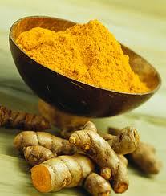
Turmeric

L C N W O U N D S T T D S I T
A A O A B P S Y O W N I L V U
B N C N D S O O C P A W L A R
R V T I D I R W G I L J E S M
E B T G P I N L D S P B C E E
H J H N O O M I R E I S R M R
E V I T A V R E S E R P O O I
C G R O W D M T N A K Z M Z C
U D U M I I I D N T F K U I O
R O Q N E W H X Y J A F T H O
R O D H B Z Q R O E B Z R R K
Y I Z D I G E S T I O N C O I
A L N I M U C R U C T L S P N
A W M U M U S T A R D N B P G
E C I P S W O L L E Y W A X A

ALZHEIMERS ANTIOXIDANT CONDIMENT
COOKING CURCUMIN CURRY
DIGESTION DYE GROW
HERBAL INDIA INDIAN
MUSTARD PLANT POWDER
PRESERVATIVE RHIZOMES ROOT
SAFFRON SPICE SPICY
TROPICAL TUMOR CELLS TURMERIC
WOUNDS YELLOW

