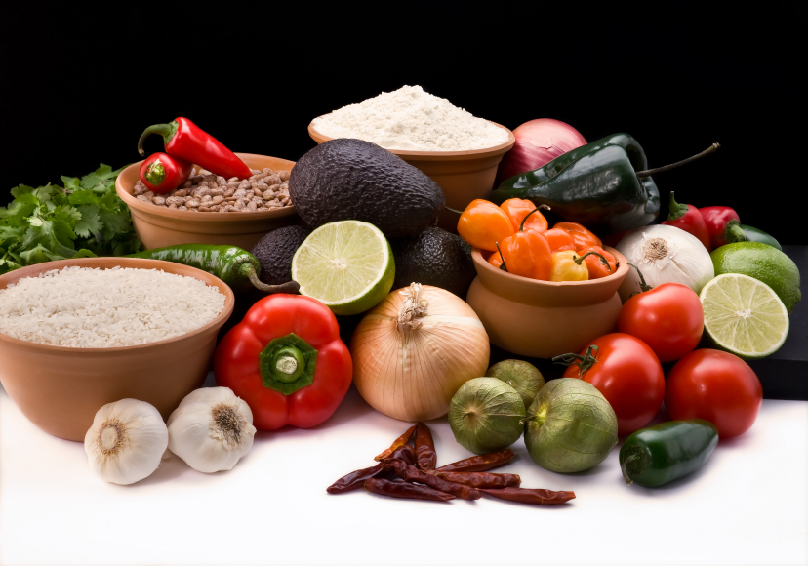
Recipe for: Fresh Salsa
3 tomatoes
½ cup green sweet bell peppers
¼ cup onions, chopped
1 t garlic powder
1 t cumin
¼ t ground red pepper
2 t vinegar
1 t olive oil
2 t lemon juice

Chop vegetables. Add remaining ingredients and mix well. Serve with whole wheat crackers or baked tortilla chips
Recipe from Fix-It and Enjoy It Healthy Cookbook, Phyllis Pellman Good

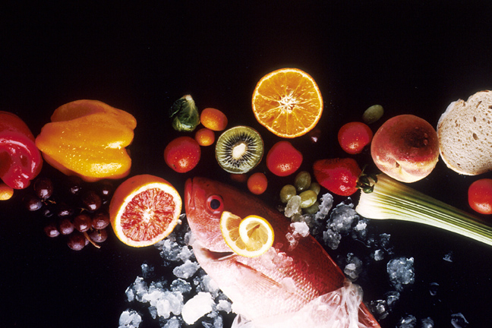
Recipe for: Spinach-Stuffed Tomatoes

4 medium tomatoes
½ of 10 oz pkg frozen spinach
1 T finely chopped onion
¼ c fat free half and half
1 egg white, or egg substitute equivalent

Slice off top of each tomato. Remove pulp and seeds. Place spinach and onion in saucepan with small amount of water. Cook over medium heat until onions are softened.
In small bowl, combine half and half and egg. Stir into spinach and onions. Cook 1 minute. Spoon mixture into tomatoes. Place filled tomatoes in lightly greased baking dish. Bake uncovered at 350° for 25 minutes.
Recipe from Fix-It and Enjoy It Healthy Cookbook, Phyllis Pellman Good

Recipe for: Italian Veggie Bake
1/3 cup Italian dressing 1 small onion, chopped
½ small unpeeled eggplant, cubed 1 medium zucchini, sliced thin
½ c red sweet bell pepper, chopped 1 cup fresh mushrooms, sliced
1 cup freshly diced tomatoes 2 ½ T shredded Parmesan cheese
Parsley

Heat dressing in skillet over medium heat. Add onion and steam/stir-fry until tender. Add eggplant and steam/stir-fry 5 minutes. Add zucchini, pepper and mushrooms. Steam/stir-fry 5 minutes more. Add tomatoes and bring to a boil. Pour mixture into lightly greased baking dish. Sprinkle with cheese.

Bake uncovered at 350° for 25-30 minutes or until bubbly. Sprinkle with parsley before serving.

Recipe from Fix-It and Enjoy It Healthy Cookbook, Phyllis Pellman Good

Recipe for: Green Beans w/Tomatoes & Garlic
1 T olive oil
4 cloves garlic, minced
1 ½ lbs green beans, washed and stemmed
2 – 8 oz cans crushed tomatoes
1 t dried oregano

Heat oil in skillet over medium heat. Add garlic and sauté briefly. Add beans and stir to coat with oil. Add tomatoes. Bring to a boil. Reduce heat to a low simmer. Stir in oregano. Cover and cook until beans are done to your liking and liquid is nearly absorbed.

Recipe from Fix-It and Enjoy It Healthy Cookbook, Phyllis Pellman Good

