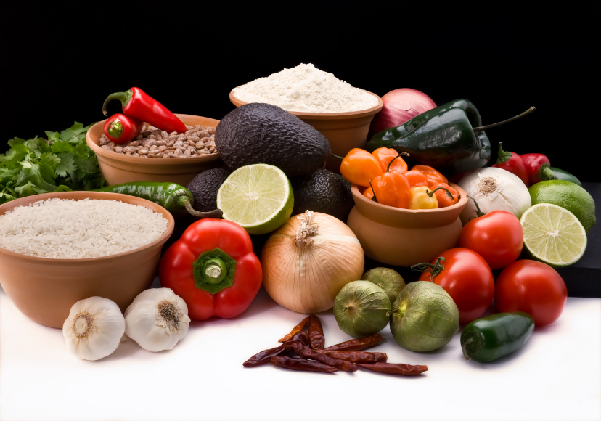
Recipe for: Zucchini & Tomato Stir-Fry

2 T vegetable oil
2 medium onions, sliced
4 medium zucchini, sliced
2 large tomatoes, wedged
1 – 4 oz can sliced mushrooms, drained
Dash salt and pepper

Combine all ingredients in wok or large skillet. Stir-fry over high heat for 6-8 minutes. Cover and reduce heat. Simmer 5 minutes.

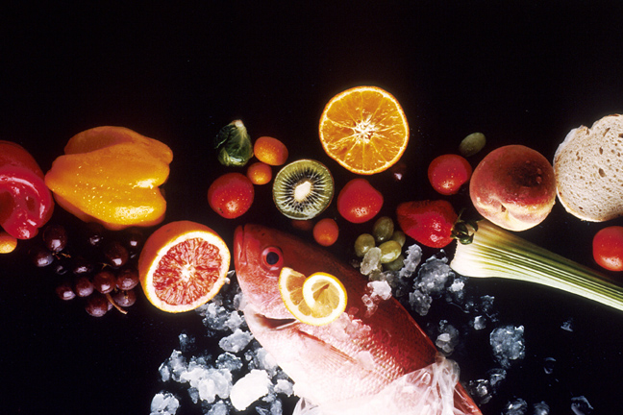
Recipe for: Salsa Fresca

1 lb ripe tomatoes, chopped
¼ c. chopped sweet onion
¼ c. loosely packed fresh cilantro leaves, chopped
2 T. fresh lime juice
1 jalapeno chili, seeded and minced
½ t. salt
1/8 t. coarsely ground black pepper

In medium bowl, gently stir all ingredients. Cover and refrigerate at least 1 hour to blend flavors, or up to 8 hours. Drain before serving if chilled longer than one hour.

Recipe for: Green Tomato Cake

½ cup butter1 c. sugar
2 large eggs2 t. vanilla
1 c. + 2 T all purpose flour1 t.(heaping) baking powder
1 t. ground cinnamon½ t. ground nutmeg
2 medium green tomatoes, finely chopped
Cinnamon-sugar mixture

Cream together butter and sugar. Add eggs and vanilla. In another bowl, combine dry ingredients and add to creamed mixture. Stir in tomatoes. Pour into prepared pan. Lightly sprinkle with cinnamon-sugar mixture and bake at 350° for approx. 45 minutes.

Serve warm as a “coffee cake” or top with ice cream for dessert!

Recipe for: Fried Green Tomatoes

4-6 green tomatoes, sliced ¼ inch thick
Salt & pepper
Flour for dusting
2 eggs, beaten
Cornmeal or bread crumbs
Vegetable oil

Salt and pepper the tomato slices; dust lightly with flour. Dip slices in beaten egg, letting excess drip off, then coat well with meal or crumbs. Fry in hot grease or oil until browned, turning gently (about 3 minutes each side). Keep warm in a low 200° to 250° oven if frying in batches.

