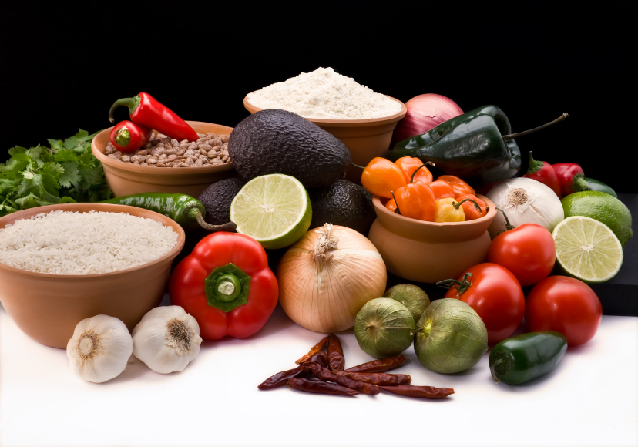
Recipe for: Tomato Corn Salad
1 – 16 oz package frozen corn
3 medium tomatoes, diced
1/3 cup Italian salad dressing
¼ cup minced fresh basil
Salt and Pepper to taste

In microwave-safe bowl, combine corn and small amount of water. Cover and microwave on high for 3-3 ½ minutes or until corn is crisp tender; drain and cool.

In large bowl, combine the tomatoes, salad dressing, basil. Stir in cooled corn. Salt & pepper to taste. Refrigerate. Serve with slotted spoon.

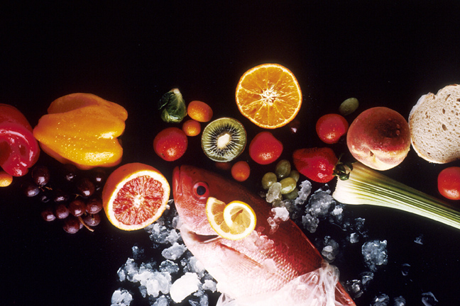
Recipe for: Sweet Corn & Tomato Salad
w/Fresh Cilantro
5 ears fresh corn, husked
1 lb plum tomatoes, diced
1/3 cup finely chopped red onion
¼ cup chopped fresh cilantro
2 T extra virgin olive oil
½ T red wine vinegar

Cook corn in large pot of boiling salted water until just tender, about 5 minutes. Drain and cool. Cut kernels from cobs placing in large bowl. Add remaining ingredients; toss to blend. Season to taste with salt and pepper.

Recipe for: Tomato Basil Soup
2 cans Campbell’s Tomato Soup
3 medium tomatoes
1-2 garlic cloves
6-8 fresh basil leaves
3 cups milk
Romano or Parmesan cheese (optional)

Combine tomatoes, garlic and fresh basil in food processor. Process until consistency is still somewhat chunky (like a very chunky applesauce).

In large pot, combine tomato soup and milk. Add the mixture from the food processor and heat on medium/low stirring frequently, until mixture is bubbling. Serve immediately topped with a little fresh Romano or Parmesan cheese sprinkled on top!

Recipe for: Escalloped Tomatoes
2 T chopped onion
½ green pepper, chopped
1 T sugar
1 t Worcestershire sauce
¼ cup grated cheese (American, cheddar, muenster or Swiss)
2 – 3 cups canned tomatoes
1 ½ cup stuffing mix

Saute onion and pepper in butter until tender. Add all other ingredients except stuffing mix. Treat small casserole dish with food release spray. Place ½ c. of stuffing mix in bottom. Add half of the tomato mixture followed by another ½ c. of stuffing and remainder of tomato mixture. Top with remaining stuffing mix. Bake 20 minutes at 350 degrees uncovered.

