Sweet Potatoes

Did you know sweet potatoes are not related to the potato family at all!! In fact, they are a root vegetable related to the morning glory family.
Several varieties of sweet potatoes exist in the United States including: Beauregard, Centennial, Georgia Jet, Sumor, Jewell, and Vardaman. North Carolina leads the nation in sweet potato production with their number one variety produced being the Jewell variety.

Beneficial Bites

Nutritional Benefits
The sweet potato is a nutrient packed vegetable that is often times overlooked for a white potato.
Sweet potatoes are a good source of fiber, potassium, Vitamin C, Vitamin A, copper, Vitamin B6, Manganese and Iron. They provide more than twice the recommended intake of Vitamin A and more than 1/3 of the recommended intake of Vitamin C.
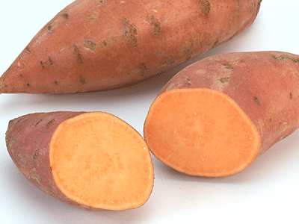
They are also low in fat and sodium and are cholesterol free!

Beneficial Bites

Created by Andrea Griffin, University of Wisconsin-Stout, Dietetic Intern, 10/11
Beneficial Bites

These antioxidant rich vegetables aid in destroying free radicals (known for causing cancer and disease) in the body.

Did you know?!?
Sweet potatoes are often called “yams” and the terms are used interchangeably. In reality, a yam is different than a sweet potato.
Several decades ago Americans began calling the sweet potato a yam to distinguish it from the white potato. Yams have more starch and are grown in the Caribbean whereas sweet potatoes have more sugar and a sweeter flavor.

