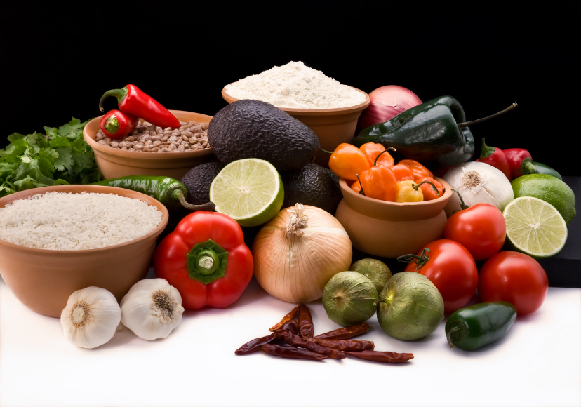
Recipe for: Sweet Potato Sticks

3 sweet potatoes cut into strips¼ cup sour cream
½ teaspoon paprika3 tablespoons brown sugar
1 teaspoon olive oil3 tablespoons crushed pineapple

Preheat oven to 350 degrees. Place sweet potato strips into a Ziploc bag with paprika and olive oil. Shake to coat evenly and bake in the oven for 35 minutes. In a small bowl combine sour cream, brown sugar, and crushed pineapple. Stir well and serve with tender sweet potato sticks.
Created by Andrea Griffin, University of Wisconsin-Stout, Dietetic Intern, October, 2011


Recipe for: Sweet Potato Bake

2 sweet potatoes, peeled, and cubed2 tablespoons milk
¼ cup raisins3 tablespoons maple syrup
¼ cup pecans1 teaspoon cinnamon

Preheat oven to 400 degrees. In a greased baking dish, spread potatoes and top with raisins and pecans. In a small bowl, combine milk and maple syrup. Pour mixture over the sweet potatoes and sprinkle with cinnamon. Bake for 50 minutes or until tender.

Recipe for: Caribbean Sweet Potato Salad
1 large sweet potato, peeled, and cubed
1 large potato, peeled, and cubed1 garlic clove, minced
1 cup corn1 cucumber, diced
1 teaspoon Dijon mustard½ red onion, diced
¼ cup peanuts, chopped1 tablespoon olive oil
2 tablespoons cilantro2 tablespoons lime juice

In a sauce pan cook potatoes until tender (note: potatoes take about twice as long to reach tenderness as the sweet potato). Add corn and cook another minute. Drain vegetables and let cool. In a bowl, mix together mustard, lime juice, cilantro, and garlic. Slowly whisk in the olive oil and season with black pepper if desired. Pour dressing over the chilled vegetables, add red onion and cucumber, and toss to coat evenly. Garnish with peanuts and serve at room temperature or chilled!

Recipe for: Sweet Potato Casserole

1 large sweet potato, thinly sliced
1 large potato, thinly sliced2 tablespoons flour
1 small onion, thinly sliced¾ cup chicken broth
1 cup pepper jack cheese, shredded¼ cup corn flakes, crushed

Preheat oven to 350 degrees. Layer sweet potatoes, potatoes, and onions; alternating layers of potatoes. In a small bowl combine chicken broth and flour and pour over potatoes. Sprinkle cheese and bread crumbs over potatoes. Cover with aluminum foil and bake for one hour.

