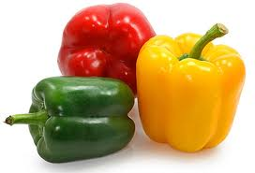
Picking Peppers Word Search

M | K | I | V | Q | Y | E | I | P | N | C | O
B | H | V | V | I | N | D | N | N | E | H | H
A | J | J | E | O | P | U | I | K | E | I | B
K | N | N | A | U | R | C | C | G | R | L | P
X | G | A | R | L | I | Y | N | Y | G | I | F
E | I | P | N | A | A | W | O | C | R | Y | R
H | L | U | S | A | O | P | R | P | Y | E | P
E | N | P | N | R | B | E | E | B | D | L | W
O | A | X | B | L | N | N | P | N | K | L | B
C | E | G | N | A | R | O | P | P | O | O | Y
O | Q | H | A | B | A | N | E | R | O | W | W
B | L | A | C | K | F | R | P | O | L | X | V

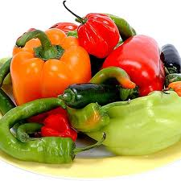
BANANA IVORY
BLACK JALAPENO
BROWN ORANGE
CAPSAICIN PEPPERONCINI
CHILI PURPLE
GREEN RED
HABANERO YELLOW
Picking Peppers Word Search

M | K | I | V | Q | Y | E | I | P | N | C | O
B | H | V | V | I | N | D | N | N | E | H | H
A | J | J | E | O | P | U | I | K | E | I | B
K | N | N | A | U | R | C | C | G | R | L | P
X | G | A | R | L | I | Y | N | Y | G | I | F
E | I | P | N | A | A | W | O | C | R | Y | R
H | L | U | S | A | O | P | R | P | Y | E | P
E | N | P | N | R | B | E | E | B | D | L | W
O | A | X | B | L | N | N | P | N | K | L | B
C | E | G | N | A | R | O | P | P | O | O | Y
O | Q | H | A | B | A | N | E | R | O | W | W
B | L | A | C | K | F | R | P | O | L | X | V

BANANA IVORY
BLACK JALAPENO
BROWN ORANGE
CAPSAICIN PEPPERONCINI
CHILI PURPLE
GREEN RED
HABANERO YELLOW

