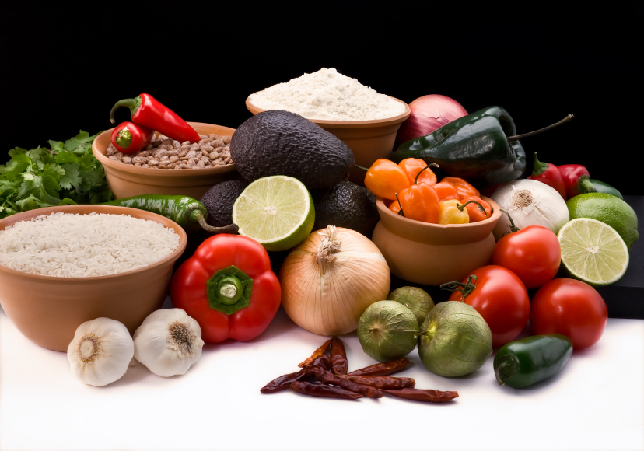
Recipe for: Stuffed Peppers with Quinoa

½ cup diced onion
1 tablespoon olive oil
1 tablespoon ground cumin¼ cup diced celery
1-15 ounce cans tomatoes, drain and reserve the juice2 teaspoons minced garlic
½ cup of chopped frozen spinach, thawed and dry¾ cup grated carrots
1- ½ cups pepper jack cheese¾ cup quinoa
4 red bell peppers, tops and seeds removed

Preheat oven to 375 degrees. Sauté onions and celery in olive oil until soft and add garlic, cumin, spinach, and tomatoes. Stir in quinoa, carrots, and two cups of water and cover. Simmer until quinoa is tender (about 20 minutes).
Remove from heat, stir in one cup of the pepper jack cheese, and stuff the mixture into the bell peppers. Pour reserved tomato juice into a baking dish and place bell peppers in the dish. Cover with foil and bake for one hour. Remove from oven and top with remaining cheese.
Created by Andrea Griffin, University of Wisconsin-Stout Dietetic Intern Sept 2011

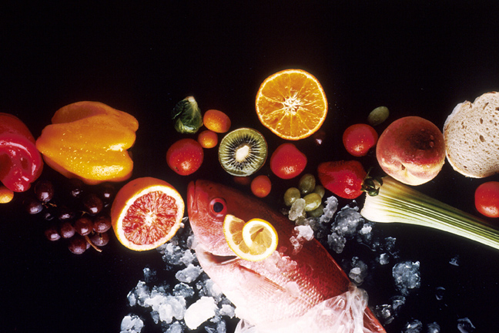
Recipe for: Pineapple Salsa

½ cup finely chopped fresh pineapple
¼ cup diced red bell pepper¼ cup diced green bell pepper
½ cup frozen corn kernels, thawed2 tablespoons chopped red onion
½ cup canned black beans, drained and rinsed2 tablespoons orange juice
2 tablespoons fresh cilantro1 tablespoon lime juice
¼ teaspoon ground cumin2 tablespoons sugar

Combine all ingredients in a large bowl and toss together. Cover and refrigerate until serving!

Created by Andrea Griffin, University of Wisconsin-Stout Dietetic Intern Sept 2011

Recipe for: Chorizo Stuffed Bell Peppers

4 bell peppers, tops and seeds removed
¼ cup each of diced celery, carrot, and onion
2 cloves of garlic, minced½ pound chorizo sausage
1 cup of canned whole peeled tomatoes, chopped1/3 cup uncooked rice
1/3 cup shredded pepper jack cheese1/3 cup water
1/3 cup shredded mozzarella cheese½ cup of tomato soup

Preheat oven to 350 degrees. In a large skillet brown chorizo and drain fat off. Stir in celery, carrots, onion, and garlic and simmer until soft. Add tomatoes, water, and rice and cook until the rice is tender. Remove from heat and add shredded cheeses. Stuff each pepper with the chorizo mixture and place in a 9X13 inch baking dish.
Mix tomato soup with enough water to create a gravy consistency and pour over peppers. Cover with foil and bake in the oven for one hour. *Chorizo can be replaced with ground turkey, ground beef, or pork sausage.
Created by Andrea Griffin, University of Wisconsin-Stout Dietetic Intern Sept 2011

Recipe for: Pepper and Pita Bread Pizza

6 inch pita, split into two rounds
1 teaspoon olive oil
4 tablespoons pizza sauce
3 tablespoons diced red pepper3 tablespoons diced onion
1 tablespoon minced garlic¼ cup mozzarella cheese
½ teaspoon basil½ teaspoon oregano

Preheat oven to 375 degrees. Brush olive oil over each pita round. Sprinkle cheese on each round and top with peppers, onion, and garlic. Season with basil and oregano. Bake in the oven for 7-10 minutes.

Created by Andrea Griffin, University of Wisconsin-Stout Dietetic Intern Sept 2011

