**Spinach**

**[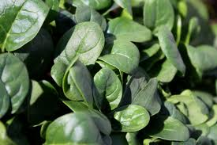](http://www.google.com/imgres?q=spinach&start=226&hl=en&biw=1144&bih=673&gbv=2&addh=36&tbm=isch&tbnid=dKHHoQ5yJkuaOM:&imgrefurl=http://www.artsjournal.com/speaker/2011/01/eat-your-spinach-and-other-arguments-for-learning-to-play-music/&docid=w5BawxhOpFMkTM&imgurl=http://www.artsjournal.com/speaker/wp-content/uploads/2011/01/baby-spinach.jpg&w=3600&h=2400&ei=hRnRT6mTOsPO2wWls6CEDw&zoom=1&iact=hc&vpx=722&vpy=285&dur=1203&hovh=183&hovw=275&tx=137&ty=112&sig=113594042619463674865&page=12&tbnh=148&tbnw=207&ndsp=21&ved=1t:429,r:19,s:226,i:201)**

**[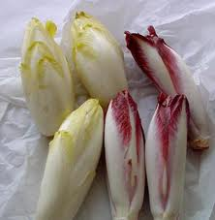](http://www.google.com/imgres?q=endive&hl=en&gbv=2&biw=1144&bih=673&tbm=isch&tbnid=4NzGttdFRHm0VM:&imgrefurl=http://www.chefdecuisine.com/vegetables/endive/endivemain.php&docid=BBL50nHyhJgJqM&imgurl=http://www.chefdecuisine.com/vegetables/endive/image0.jpg&w=440&h=451&ei=NhrRT_S6OKaa2AXci8ibDw&zoom=1)[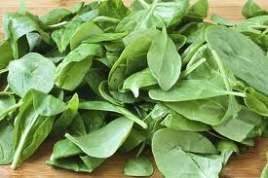](http://www.google.com/imgres?q=spinach&hl=en&biw=1144&bih=673&gbv=2&tbm=isch&tbnid=-fXVXj4FZ4p0JM:&imgrefurl=http://gimmesomeoven.com/spinach-artichoke-hummus/&docid=GavC8NIA-ITw3M&imgurl=http://www.gimmesomeoven.com/wp-content/uploads/2010/04/fresh-spinach.jpg&w=565&h=376&ei=aRnRT6TwMei22gWP4O2MDw&zoom=1&iact=hc&vpx=740&vpy=372&dur=2203&hovh=183&hovw=275&tx=159&ty=153&sig=113594042619463674865&page=1&tbnh=111&tbnw=167&start=0&ndsp=18&ved=1t:429,r:16,s:0,i:190)**

**Endive / Escarole**

**[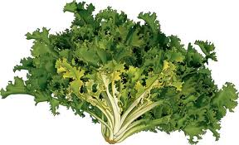](http://www.google.com/imgres?q=endive&start=267&hl=en&gbv=2&biw=1144&bih=673&addh=36&tbm=isch&tbnid=xszCqcVbC6nLlM:&imgrefurl=http://www.answers.com/topic/chicory&docid=8hTuFMfOJYj_RM&imgurl=http://content.answcdn.com/main/content/img/wiley/visualfood/04_LegumesFeuilles/40778-ChicoreeFrisee.jpg&w=500&h=305&ei=UxrRT5-ZGLPo2gXG84SUDw&zoom=1&iact=hc&vpx=293&vpy=233&dur=968&hovh=175&hovw=288&tx=156&ty=118&sig=113594042619463674865&page=14&tbnh=115&tbnw=189&ndsp=20&ved=1t:429,r:6,s:267,i:293)**

**Curly Kale**

**[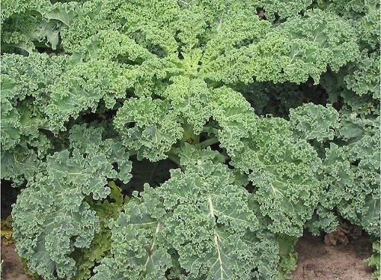](http://ecolocalizer.com/2012/03/25/delicious-nutritious-kale-photo-guide-to-different-varieties/curly_kale/)**

**[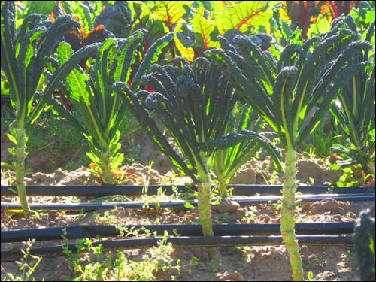](http://ecolocalizer.com/2012/03/25/delicious-nutritious-kale-photo-guide-to-different-varieties/kale-7/)Lacinato Kale**

**Premier Kale**

**[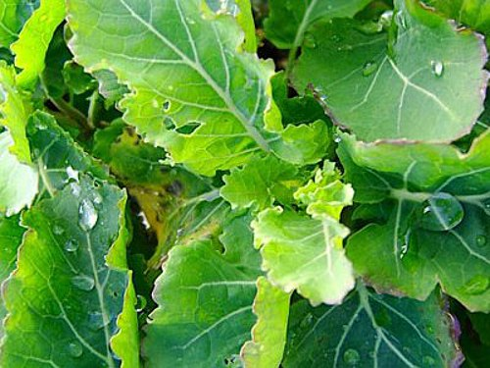](http://ecolocalizer.com/2012/03/25/delicious-nutritious-kale-photo-guide-to-different-varieties/premier_kale/)**

**[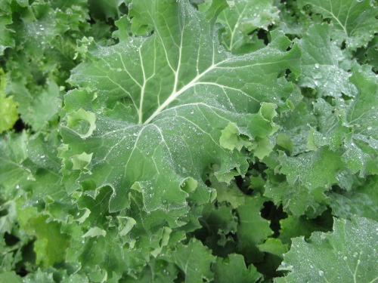](http://ecolocalizer.com/2012/03/25/delicious-nutritious-kale-photo-guide-to-different-varieties/siberian_kale/)Siberian Kale**

**Red Russian Kale**

**[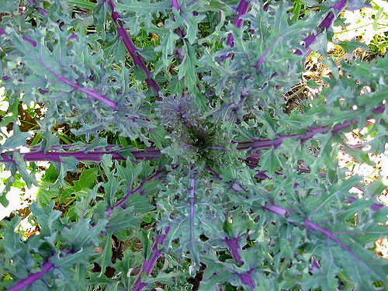](http://ecolocalizer.com/2012/03/25/delicious-nutritious-kale-photo-guide-to-different-varieties/red_russian_kale/)**

**Kamome Red Kale**

**[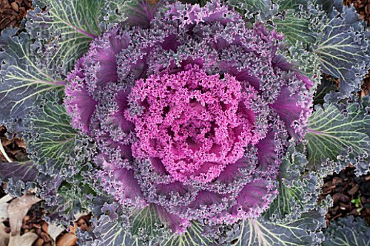](http://ecolocalizer.com/2012/03/25/delicious-nutritious-kale-photo-guide-to-different-varieties/kamome_red_kale/)**

**Chidori Kale**

[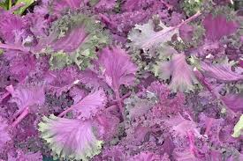](http://www.google.com/imgres?q=varieties+of+kale&start=176&hl=en&sa=X&gbv=2&biw=1144&bih=673&tbm=isch&prmd=imvns&tbnid=0i3x2aBYWwfZqM:&imgrefurl=http://articles.latimes.com/2011/dec/23/food/la-fo-marketwatch-20111223&docid=Cs4m7Ue9KMNCXM&imgurl=http://www.latimes.com/media/photo/2011-12/66940601.jpg&w=600&h=399&ei=KZ2-T-WfEaGf6AHI3qFG&zoom=1&iact=hc&vpx=515&vpy=52&dur=2734&hovh=183&hovw=275&tx=169&ty=114&sig=113594042619463674865&page=10&tbnh=147&tbnw=196&ndsp=20&ved=1t:429,r:12,s:176,i:211)

**Redbor Kale**

**[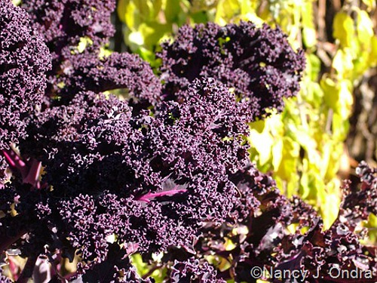](http://ecolocalizer.com/2012/03/25/delicious-nutritious-kale-photo-guide-to-different-varieties/redbor_kale/)**

**Swiss Chard**

[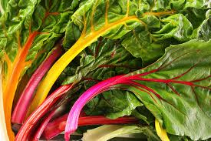](http://www.google.com/imgres?q=swiss+chard&start=78&hl=en&gbv=2&biw=1144&bih=673&tbm=isch&tbnid=6fR_drcUuKiYPM:&imgrefurl=http://rawdiet.com/the-health-benefits-of-swiss-chard&docid=K_X6EJ-7jEHDHM&imgurl=http://rawdiet.com/wp-content/uploads/2011/01/Swiss-Chard.jpg&w=900&h=600&ei=zqC-T5rCO-_46QGdyJg9&zoom=1&iact=hc&vpx=697&vpy=195&dur=688&hovh=183&hovw=275&tx=218&ty=109&sig=113594042619463674865&page=5&tbnh=137&tbnw=202&ndsp=23&ved=1t:429,r:21,s:78,i:50)

[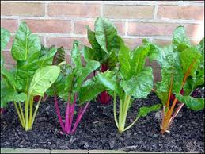](http://www.google.com/imgres?q=swiss+chard&start=326&hl=en&gbv=2&biw=1144&bih=673&addh=36&tbm=isch&tbnid=gysRlT91tTMZ-M:&imgrefurl=http://gardeningsolutions.ifas.ufl.edu/mastergardener/outreach/plant_id/vegetables/chard_swiss.shtml&docid=b4DQP49Ih5S2YM&imgurl=http://gardeningsolutions.ifas.ufl.edu/mastergardener/outreach/plant_id/images/vegetables/swisschard_color.jpg&w=400&h=300&ei=yqG-T8S7BKL16AGD0uDxBw&zoom=1&iact=hc&vpx=341&vpy=16&dur=4765&hovh=194&hovw=259&tx=145&ty=119&sig=113594042619463674865&page=17&tbnh=145&tbnw=222&ndsp=22&ved=1t:429,r:18,s:326,i:138)

**Romaine**

[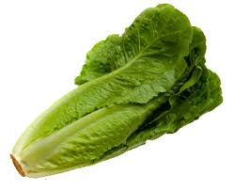](http://www.google.com/imgres?q=romaine&hl=en&gbv=2&biw=1144&bih=673&tbm=isch&tbnid=LqJlMJXx9lcpNM:&imgrefurl=http://beprepared.com/article.asp%3Fai%3D959&docid=m98NAru90yT_RM&imgurl=http://beprepared.com/images/art/romaine-lettuce.png&w=346&h=284&ei=uRzRT-SEEoP42QW_ko2wDw&zoom=1&iact=hc&vpx=672&vpy=220&dur=688&hovh=203&hovw=248&tx=166&ty=120&sig=113594042619463674865&page=4&tbnh=157&tbnw=191&start=60&ndsp=21&ved=1t:429,r:19,s:60,i:367)

**Watercress**

**[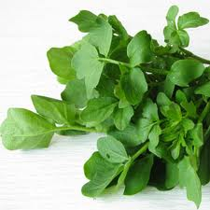](http://www.google.com/imgres?q=watercress&hl=en&gbv=2&biw=1144&bih=673&tbm=isch&tbnid=_r5K_9OpyGyuhM:&imgrefurl=http://www.worldhealth.net/news/watercress-lessens-exercise-induced-oxidative-stre/&docid=zqB7xo1bGMAh_M&imgurl=http://www.worldhealth.net/images/homefeature/092310_watercress.jpg&w=334&h=334&ei=KR3RT7zcG6bF2QXZqaiMDw&zoom=1&iact=hc&vpx=873&vpy=331&dur=1663&hovh=225&hovw=225&tx=140&ty=139&sig=113594042619463674865&page=1&tbnh=137&tbnw=130&start=0&ndsp=17&ved=1t:429,r:16,s:0,i:188)**

**Lamb’s Quarter**

**[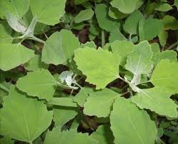](http://www.google.com/imgres?q=Wisconsin+lambs+quarter&start=99&hl=en&gbv=2&biw=1144&bih=673&addh=36&tbm=isch&tbnid=tHM_Iuw02Ea-IM:&imgrefurl=http://dandelionhaven.blogspot.com/2011_07_01_archive.html&docid=3SXDG1W3L2ll4M&imgurl=http://1.bp.blogspot.com/-wW4wnSnhj2Q/Th5nJv1tT6I/AAAAAAAADDY/KjkZN9WaKNc/s1600/014.JPG&w=800&h=649&ei=maO-T7rMBc716AG5jsk9&zoom=1)**

**[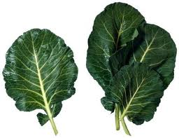](http://www.google.com/imgres?q=collard+greens&start=175&hl=en&gbv=2&biw=1144&bih=673&addh=36&tbm=isch&tbnid=WWjnwsmGCn18UM:&imgrefurl=http://thecollarddiaries.blogspot.com/&docid=NkCBQw1C8ExLDM&imgurl=http://i.ehow.com/images/a07/t4/tg/steam-baby-collard-greens-800x800.jpg&w=400&h=307&ei=Kqa-T4ONDu2A6QGVptCrCg&zoom=1&iact=hc&vpx=842&vpy=358&dur=3874&hovh=197&hovw=256&tx=183&ty=166&sig=113594042619463674865&page=10&tbnh=144&tbnw=186&ndsp=20&ved=1t:429,r:14,s:175,i:215)Mustard Greens**

[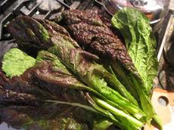](http://www.google.com/imgres?q=mustard+greens&start=369&hl=en&gbv=2&biw=1144&bih=673&addh=36&tbm=isch&tbnid=4cRyQbH8fvhdgM:&imgrefurl=http://forkandbottle.com/cooking/recipes/braisedveg.htm&docid=YNENAf8AZ2r0uM&imgurl=http://forkandbottle.com/cooking/images/mustardgr.jpg&w=288&h=216&ei=LB_RT9HLDuXE2gXsjr2gDw&zoom=1&iact=hc&vpx=686&vpy=240&dur=2206&hovh=172&hovw=230&tx=130&ty=104&sig=113594042619463674865&page=19&tbnh=148&tbnw=197&ndsp=20&ved=1t:429,r:13,s:369,i:327)

**Collard Greens**

[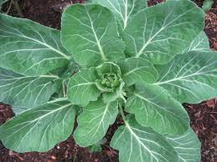](http://www.google.com/imgres?q=collard+greens&hl=en&gbv=2&biw=1144&bih=673&tbm=isch&tbnid=S0zLm69OE7U9LM:&imgrefurl=http://sophie-mis-guided.blogspot.com/2010/07/my-two-favorite-foods-are.html&docid=1tPCbd-HnUZXfM&imgurl=http://1.bp.blogspot.com/_CrHpfGkAQWY/TEY8YT0r7AI/AAAAAAAAAA8/fHBRcR5-gWE/s1600/100_0217.jpg&w=640&h=480&ei=qKW-T7aeMeW46QHV_8g4&zoom=1&iact=hc&vpx=839&vpy=71&dur=1624&hovh=194&hovw=259&tx=182&ty=90&sig=113594042619463674865&page=2&tbnh=147&tbnw=187&start=15&ndsp=20&ved=1t:429,r:19,s:15,i:214)