Summer Greens:

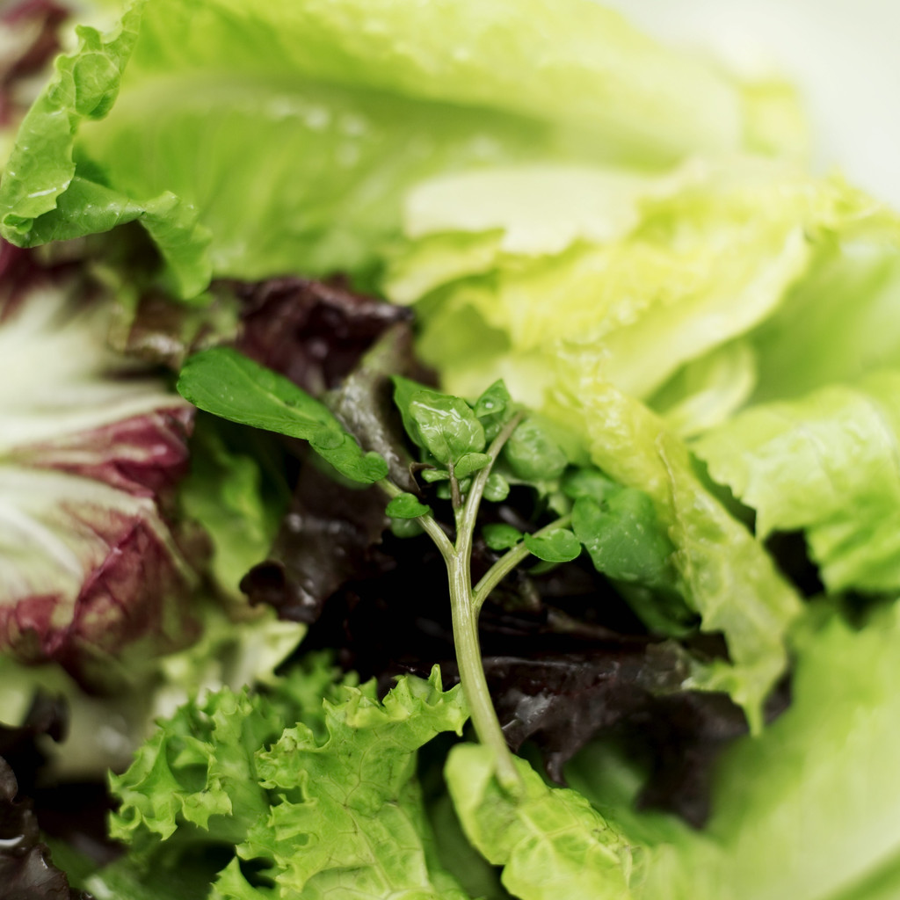
Eat ‘em

Colorful, Crunchy, Nutritious Powerhouses

- Swiss Chard
- Collard Greens
- Spinach
- Kale
- Romaine
- And a few Lettuce varieties

Beneficial Bites

Summer Greens:

Eat ‘em

Colorful, Crunchy, Nutritious Powerhouses

- Swiss Chard
- Collard Greens
- Spinach
- Kale
- Romaine
- And a few Lettuce varieties
Beneficial Bites

Summer Greens:

Eat ‘em

Colorful, Crunchy, Nutritious Powerhouses

- Swiss Chard
- Collard Greens
- Spinach
- Kale
- Romaine
- And a few Lettuce varieties
Beneficial Bites

A Quick Green Overview

- Great source of vitamins, minerals, and fiber

- Anti-inflammatory and cancer fighting properties

- Could potentially lower cholesterol

- Leafy can greens can interact with medications. Check with your doctor.

Here’s a replacement for that bag-o-chips:
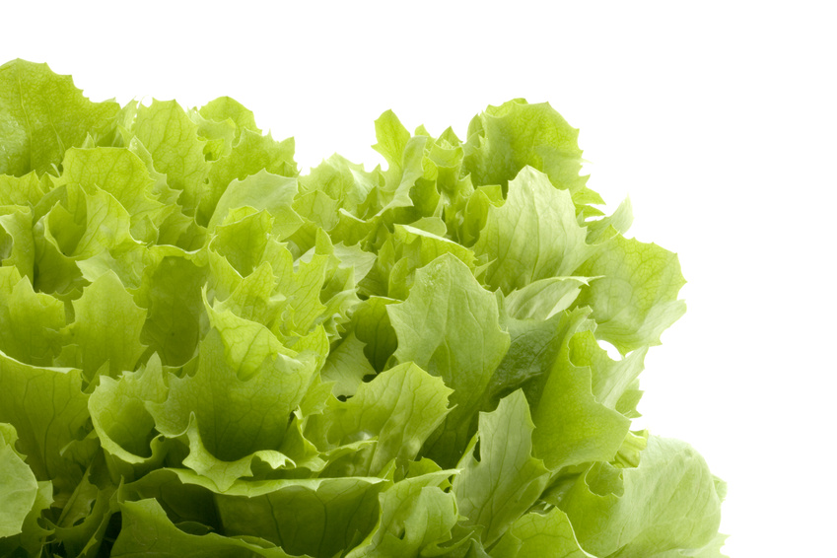

Chili Kale Chips

1 bunch of Kale
1/8-1/4 Cup olive oil
1 tsp chili powder

Coat the leaves with oil and grill or bake at 350 degrees until crisp the leaves are crisp. Dust them with chili powder. Serve.

Note: You can season the kale with whatever flavor you like, i.e. garlic powder, onion, rosemary. Experiment!!

Created by Brent Haugle, UW-Stout Dietetic Intern, February 2013

A Quick Green Overview

- Great source of vitamins, minerals, and fiber

- Anti-inflammatory and cancer fighting properties

- Could potentially lower cholesterol

- Leafy can greens can interact with medications. Check with your doctor.

Here’s a replacement for that bag-o-chips:

Chili Kale Chips

1 bunch of Kale
1/8-1/4 Cup olive oil
1 tsp chili powder

Coat the leaves with oil and grill or bake at 350 degrees until crisp the leaves are crisp. Dust them with chili powder. Serve.

Note: You can season the kale with whatever flavor you like, i.e. garlic powder, onion, rosemary. Experiment!!

Created by Brent Haugle, UW-Stout Dietetic Intern, February 2013

A Quick Green Overview

- Great source of vitamins, minerals, and fiber

- Anti-inflammatory and cancer fighting properties

- Could potentially lower cholesterol

- Leafy can greens can interact with medications. Check with your doctor.

Here’s a replacement for that bag-o-chips:

Chili Kale Chips

1 bunch of Kale
1/8-1/4 Cup olive oil
1 tsp chili powder

Coat the leaves with oil and grill or bake at 350 degrees until crisp the leaves are crisp. Dust them with chili powder. Serve.

Note: You can season the kale with whatever flavor you like, i.e. garlic powder, onion, rosemary. Experiment!!

Created by Brent Haugle, UW-Stout Dietetic Intern, February 2013

