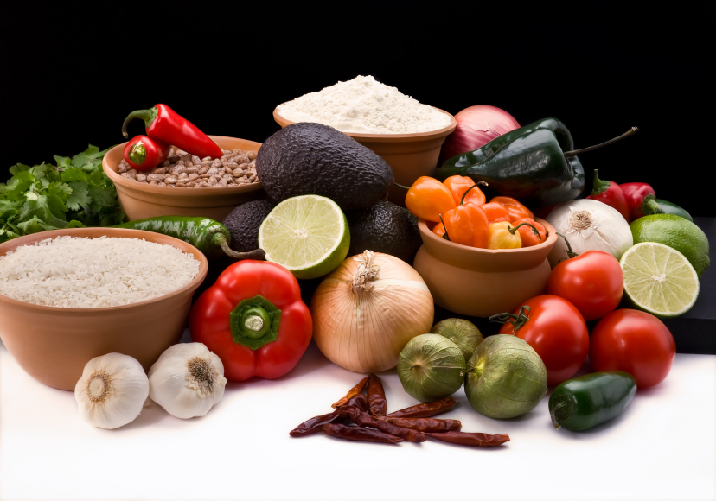
Recipe for: Dill Vinaigrette
¼ cup red wine vinegar
½ cup canola oil
2 tbsp honey (or 2 packets of Splenda)
1 tsp dried dill weed
1/4 tsp onion powder
1/4 tsp garlic powder
1/4 tsp dry mustard
Salt and pepper to taste
In a blender, combine the oil, vinegar, sugar, dill weed, onion powder, garlic powder, dry mustard. Blend until smooth. Add salt and pepper to taste. Cover and refrigerate until chilled.

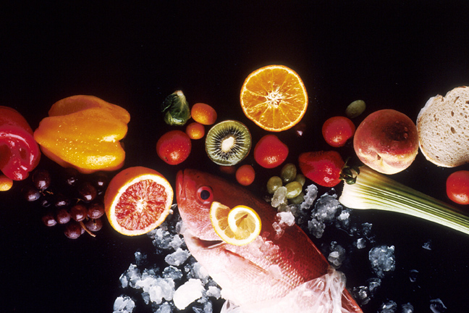
Recipe for: Tomato Herb Salad Dressing
1 ½ cups tomato juice
¼ cup chopped onion
2 tbsp chopped green pepper
3 tsp sugar
2 tsp lemon juice
1 ½ tsp garlic powder
1 tsp Worcestershire sauce
¾ tsp dried basil
¼- ½ tsp each dried marjoram, savory and celery seed
1 tbsp canola oil

Place all ingredients in blender, cover and process until smooth. Chill at least 4 hours before serving.

To reduce sodium, use a low sodium tomato juice. Can also use V-8 Juice for a flavor variation.

Recipe for: Avocado Ranch Dressing
½ cup ripe avocado
½ cup reduced fat mayonnaise
½ cup reduced fat sour cream
2 Tbsp buttermilk
1 Tbsp white vinegar
¼ tsp each: salt, dried parsley, dried dill weed, onion powder, & garlic powder

Combine avocado, mayo, sour cream, buttermilk & vinegar in blender. Process until smooth adding additional milk if needed to make desired consistency. Add remaining ingredients, blend well and chill until ready to serve.

Recipe for: Honey Balsamic Vinaigrette
½ cup balsamic vinegar
1 small onion, chopped
1 Tbsp soy sauce
3 Tbsp honey
1 Tbsp white sugar
2 garlic cloves, minced
½ tsp crushed red pepper flakes
2/3 cup extra virgin olive oil

In blender, process ingredients, except olive oil. Puree on high until smooth. Continue pureeing while drizzling olive oil into mixture. Process an additional 1-2 minutes or until thick and well mixed.

Recipe for: Low Fat Buttermilk Ranch
2/3 cup low fat buttermilk
1/3 cup low-fat mayonnaise
1/3 cup low-fat sour cream
½ tsp garlic powder
½ tsp onion powder
½ tsp each: dried chives, dill weed, parsley flakes*
¼ tsp salt
Dash pepper

Whisk together buttermilk, mayo and sour cream in bowl, until smooth. Stir in remaining ingredients. Cover and refrigerate at least 30 minutes before serving.

*If using fresh herbs, use 1 teaspoon chopped.

Recipe for: Cranberry Dijon Dressing
¼ cup cranberry sauce
¼ cup Dijon mustard
1 clove garlic
¼ cup chopped walnuts
Salt & pepper
¼ cup rice vinegar
1 cup apple cider vinegar
1 ¼ cup canola oil

In blender, combine cranberry sauce, Dijon mustard, garlic, walnuts, salt, pepper, and vinegars. Process until smooth. Drizzle a steady stream of oil into mixture while blender is processing on low. Blend another minute once all oil is added. Dressing should be creamy and thick. For best flavor, chill before serving.

Recipe for: Orange Vinaigrette Dressing
½ cup orange juice (freshly squeezed is ideal)
2 Tbsp honey
½ cup olive oil
¼ cup white wine vinegar
1 tsp grated orange peel
2 Tbsp chopped fresh parsley
¼ tsp salt
¼ tsp cayenne pepper

Combine all ingredients in blender using pulse setting until well blended. For best flavor, refrigerate 3-4 hours. Shake before serving.

Recipe for: Roasted Roma Vinaigrette

1 pound Roma (plum) tomatoes, quartered1 shallot
3 garlic cloves2 Tbsp olive oil
1 sprig fresh sage1 sprig fresh rosemary
Salt & black pepper
1 cup balsamic vinegar
1 cup canola oil

Preheat oven to 350°. Toss tomatoes, shallots, garlic, olive oil, sage and rosemary together in bowl until everything is coated with oil. Season w/salt and pepper and spread into baking dish. Roast until garlic cloves are soft, about 20 minutes. In a blender, process the roasted mixture with balsamic vinegar until smooth. Drizzle oil into mixture with blender on. Process until even distributed and dressing consistency is reached.

