**Health Benefits:**

* Excellent source of Vitamin C and antioxidants
* Good source of folic acid, fiber and potassium
* Very low in saturated fat, cholesterol and sodium
* One cup of fresh strawberries contains 160% of your daily Vitamin C for only 50 calories!

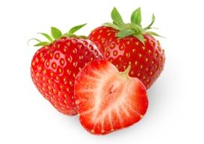

**Interesting Facts:**

* The first garden strawberry was grown in France
* There are 600 varieties of strawberries
* Strawberries rank among the top 10 fruits and vegetables in antioxidant capacity
* At Wimbledon each year, strawberries and cream are eaten between tennis matches by properly attired English
* Legend has been told that strawberries were named by English children who picked, strung it on grass straws and sold them as “straws of berries.”



**Health Benefits:**

* Excellent source of Vitamin C and antioxidants
* Good source of folic acid, fiber and potassium
* Very low in saturated fat, cholesterol and sodium
* One cup of fresh strawberries contains 160% of your daily Vitamin C for only 50 calories!



**Interesting Facts:**

* The first garden strawberry was grown in France
* There are 600 varieties of strawberries
* Strawberries rank among the top 10 fruits and vegetables in antioxidant capacity
* At Wimbledon each year, strawberries and cream are eaten between tennis matches by properly attired English
* Legend has been told that strawberries were named by English children who picked, strung it on grass straws and sold them as “straws of berries.”



**Health Benefits:**

* Excellent source of Vitamin C and antioxidants
* Good source of folic acid, fiber and potassium
* Very low in saturated fat, cholesterol and sodium
* One cup of fresh strawberries contains 160% of your daily Vitamin C for only 50 calories!



**Interesting Facts:**

* The first garden strawberry was grown in France
* There are 600 varieties of strawberries
* Strawberries rank among the top 10 fruits and vegetables in antioxidant capacity
* At Wimbledon each year, strawberries and cream are eaten between tennis matches by properly attired English
* Legend has been told that strawberries were named by English children who picked, strung it on grass straws and sold them as “straws of berries.”



Check out the June menu for these “Strawberry” foods

[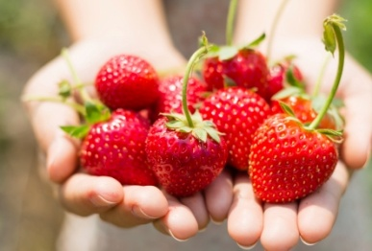](http://www.care2.com/greenliving/?attachment_id=1257913)

Featured Recipes:

* Strawberry Rhubarb Pie
* Strawberry Ice Cream
* Strawberry Pretzel Dessert
* Strawberry Cheesecake Bars
* Angel Food Cake & Strawberries
* Strawberry Cream Cheese Pie

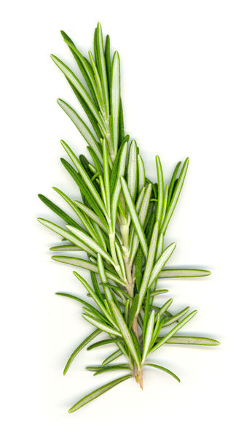

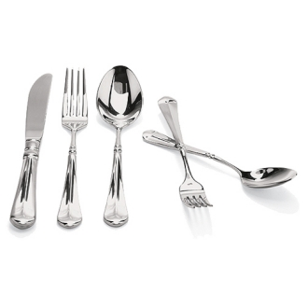

Check out the June menu for these “Strawberry” foods

[](http://www.care2.com/greenliving/?attachment_id=1257913)

Featured Recipes:

* Strawberry Rhubarb Pie
* Strawberry Ice Cream
* Strawberry Pretzel Dessert
* Strawberry Cheesecake Bars
* Angel Food Cake & Strawberries
* Strawberry Cream Cheese Pie

Check out the June menu for these “Strawberry” foods

[](http://www.care2.com/greenliving/?attachment_id=1257913)

Featured Recipes:

* Strawberry Rhubarb Pie
* Strawberry Ice Cream
* Strawberry Pretzel Dessert
* Strawberry Cheesecake Bars
* Angel Food Cake & Strawberries
* Strawberry Cream Cheese Pie



