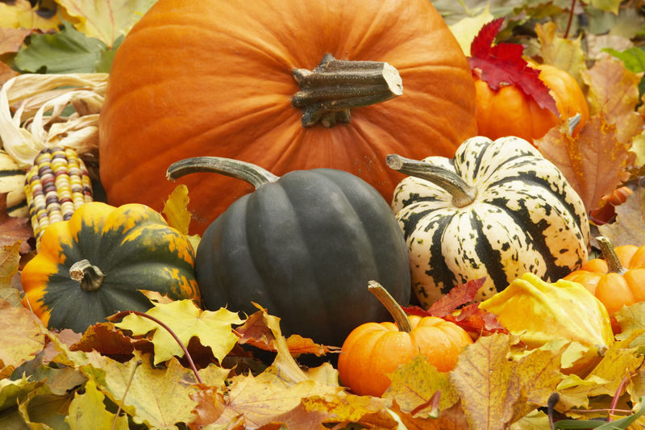
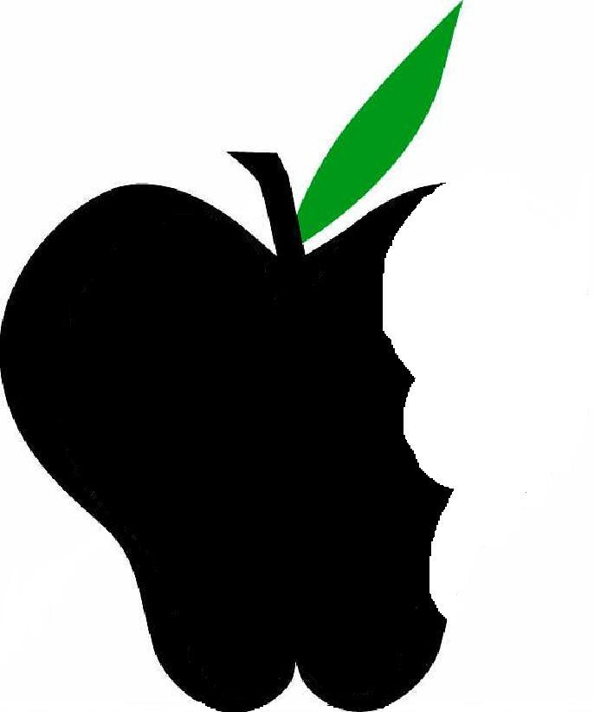
Beneficial Bites
Beneficial Bites
Squash was one of the “three sisters” used by Native Americans for agriculture. Beans and maize (corn) were the other too.
In colonial times, pumpkin was used in the crust of pies, not as the filling
In North America squash is divided into summer squash and winter squash.
The world’s largest pumpkin pie was over five feet in diameter and weighed over 350 pounds (see picture below)

Squash/Pumpkin
Squash/Pumpkins are full of beta carotene, an antioxidant that helps fight cancer.

High amount of fiber in squash/pumpkin keeps things moving in your digestive system and helps lower cholesterol levels.

Squash/Pumpkin
CookinG tips

Created by Tiffany Hahn,
UW Stout Dietetic Intern 2010

Squash/pumpkin

Fun facts
Baked pumpkin seeds
Put aluminum foil on baking sheet and put seeds in a single layer and bake at 350 degrees Fahrenheit for 10 to 20 minutes or until lightly brown and crisp
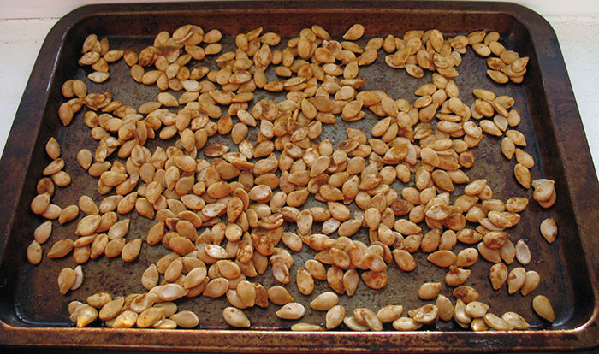

Cooked spaghetti squash
Cook spaghetti squash in microwave for 10-15 minutes. Remove seeds, and separate squash into strands. Serve cooked spaghetti squash like you would pasta. Top it with olive oil, tomatoes, and basil.
