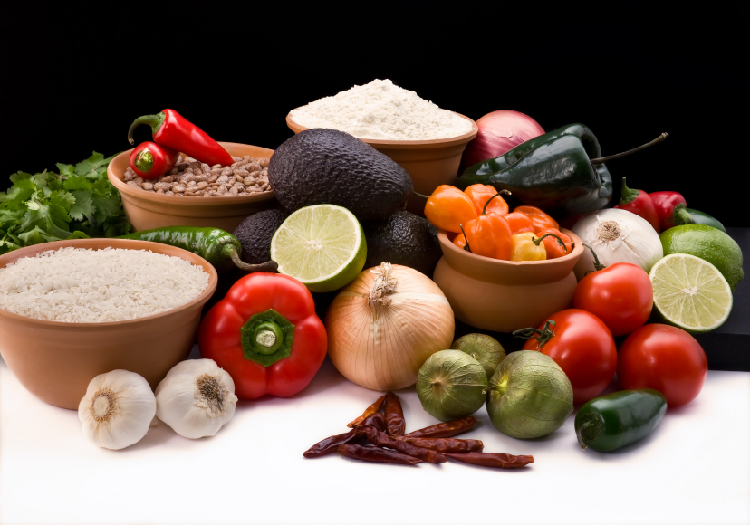
Recipe for: Zucchini Casserole
6 cups sliced zucchini
1/2 cup diced onion
1 can cream of chicken soup
1 cup sour cream
1 cup shredded carrots
1 pkg stuffing mix (stove-top)
1/2 cup melted butter

Microwave zucchini and onion for 5 minutes. Drain. Combine soup, sour cream and carrots. Fold into zucchini and onions. Combine butter and stuffing mix. Cover bottom of 9x13 baking dish with 1/2 of the stuffing. Add zucchini mixture. Top with remaining stuffing. Bake at 350 degrees for 30 minutes.

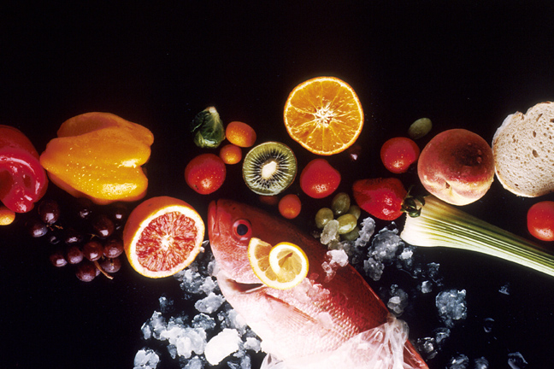
Recipe for: Easy Pumpkin Mousse
1-1/2 cups cold fat-free milk
1 package (1 ounce) sugar-free instant butterscotch pudding mix
1/2 cup canned pumpkin
1/2 teaspoon ground cinnamon
1/4 teaspoon ground ginger
1/4 teaspoon ground allspice
1 cup fat-free whipped topping, divided

In large bowl, whisk the milk and pudding mix for 2 minutes or until soft and set. Add pumpkin and spices and whip until smooth. Fold in half of the whipped topping. Refrigerate at least 30 minutes to allow it to set better. Serve with a dollop of remaining whipped topping.
Recipe for: Pumpkin Bread Pudding
5 cups French bread, cubed 2 cups half-and-half
3 large eggs2/3 cup granulated sugar
2/3 cup brown sugar1 can (15 ounces) pumpkin puree
1 cup dried cranberries3 tablespoons melted butter
1 teaspoon ground cinnamon½ teaspoon ground nutmeg
½ teaspoon ground ginger1 teaspoon vanilla
cinnamon sugar, optional

Butter an 11x7-inch baking dish. Heat oven to 350°. In a bowl, cover the torn bread with the half-and-half; set aside. In another bowl, combine eggs, sugars, pumpkin, cranberries, melted butter, spices, and vanilla; blend well. Pour pumpkin mixture over soaked bread and stir to blend. Pour mixture into the prepared baking dish. Sprinkle top with cinnamon-sugar, if desired. Bake for 45 to 60 minutes, or until set. Serve with a vanilla dessert sauce or brown sugar sauce, whipped cream, or vanilla ice cream. Serves 8.

Recipe for: Pumpkin Pancakes
2 cups plain low-fat yogurt¼ cup + 1 T. sugar
1 2/3 cup flour1 t. baking soda
1 t. cinnamon½ t. ground nutmeg
1 cup low-fat milk2 T. tub margarine, melted
1 egg½ cup canned pumpkin

In large bowl, combine 1 T. sugar, flour, baking soda, cinnamon and nutmeg. In medium bowl, combine yogurt and ¼ cup sugar. Stir in milk, margarine, egg and pumpkin and combine well. Add to the dry ingredients and stir until moist and free of lumps.
Lightly coat griddle or skillet with non-stock cooking spray and heat to low or medium. Using ¼ cup measure, pour the batter onto hot griddle. Cook until the bubbles begin to burst, then flip and cook until golden brown.
Yield: 6 (1/2-pint) jars

