Squash For All Seasons
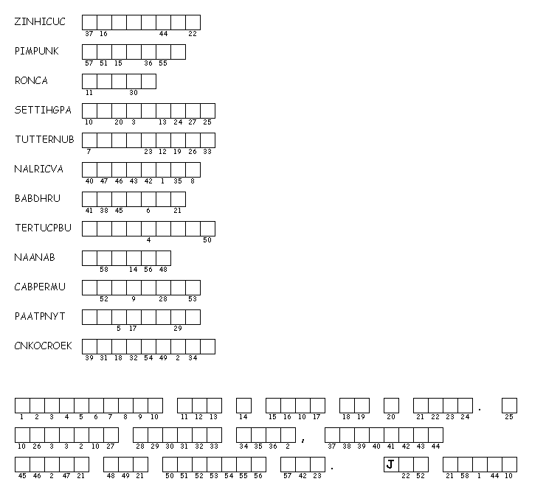
Unscramble each of the clue words. Copy the letters in the numbered cells to other cells with the same number.

