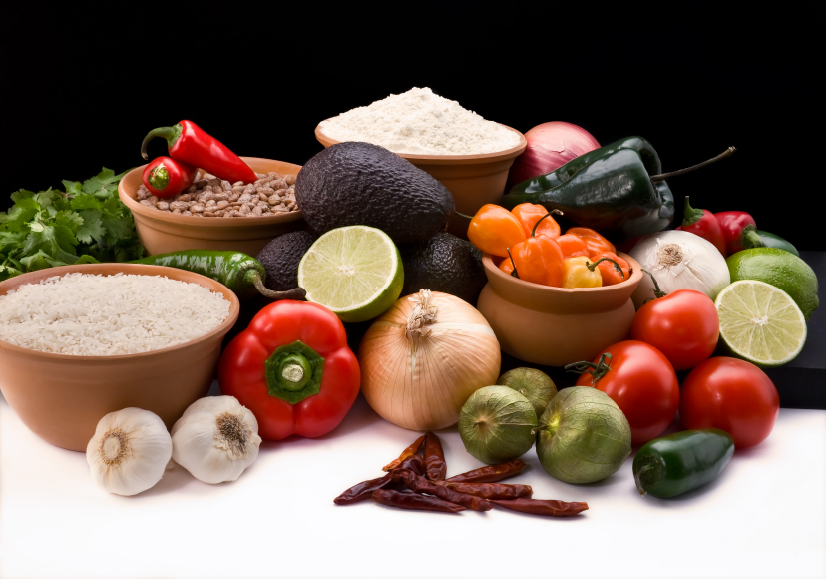
Recipe for: Pumpkin Sage Biscuits
2 cups all-purpose flour (plus more for rolling)
1 Tbsp light brown sugar 10-12 fresh sage leaves, finely chopped
2 ½ tsp baking powder 6 Tbsp butter, cold and cut into cubes
1 ½ tsp salt 1/3 cup buttermilk
½ tsp baking soda ¾ cup pumpkin puree

Preheat oven to 425 degrees. Spray a 9 inch round pan. In a bowl, stir together flour, brown sugar, baking powder, salt, and baking soda, then lightly stir in chopped sage. Add the cubes of butter and use an electric mixer to blend. In a smaller bowl whisk the buttermilk and pumpkin puree, add to the flour mixture, and blend until the dough just comes together. If dough is too moist, add a bit more flour. On a floured surface, pat the dough into a circle about ½ inch thick and use a floured biscuit cutter. Place the biscuits close together to the sides of the pan. Gently reform the dough and continue until it is used. Bake the biscuits for 10 minutes, remove and brush on melted butter, then bake for another two minutes or until risen and lightly golden. Keep in airtight container up to two days.


Recipe for: Parmesan Sage Pork Chops
2 Tbsp all-purpose ½ tsp grated lemon zest
½ tsp salt 2 boneless pork chops
1 pinch ground black pepper 1 Tbsp olive oil
1 egg, lightly beaten 1 Tbsp butter
¾ cup Italian Bread Crumbs 1 ½ tsp rubbed sage
½ cup grated parmesan cheese
Preheat oven to 425 degrees and lightly grease 7X11 inch baking dish. Mix flour, salt, and ground pepper in a shallow dish. Gently press pork into flour mixture to coat and shake off excess flour. Dip into beaten egg, and then press into bread crumbs. Gently toss between your hands so any excess crumbs falls off. Place breaded pork onto a plate while breading the rest, but do not stack. Heat olive oil and butter in a skillet over medium heat and brown the pork chops on each side, about 4 minutes per side. Transfer to baking dish and bake for about 10 minutes or until done.

Recipe for: Roasted Sage Broccoli

1 (12 ounce) bag broccoli florets (thawed)
½ red onion, chopped or sliced
8 fresh sage leaves, torn
2 Tbsp olive oil
½ tsp salt
½ tsp garlic salt
¼ tsp ground black pepper
Preheat oven to 400 degrees and line a baking sheet with aluminum foil. Spread broccoli in a single layer on the prepared baking sheet. Sprinkle onion and sage leaves over broccoli and drizzle with olive oil. Sprinkle the salt, garlic salt, and pepper over the broccoli mixture: toss to coat. Roast in the preheated oven until broccoli is browned and crisp, 20 to 30 minutes.

Recipe for: Healthy Harvest Stuffing

1 lb whole wheat Italian bread (cut into 1 inch pieces)
¾ cup walnuts, coarsely chopped1 Granny smith apple, cored and diced
2/3 c dried cranberries1/3 cup fresh parsley, minced
1 Tbsp olive oil1 Tbsp fresh sage leaves, minced
1 small onion, finely chopped1 Tbsp fresh thyme leaves, minced
½ cup chopped celeryCoarse salt and ground pepper
8 oz fresh mushrooms, chopped3 cups low sodium chicken broth
Preheat oven to 400 degrees with oven rack in middle position. Place bread on a rimmed baking sheet and bake, tossing occasionally, until crisp, about 10 minutes. Transfer to large bowl along with walnuts and dried cranberries; set aside. In a large nonstick skillet, heat oil over medium and cook the onion, celery, and mushrooms until softened. Add apple and continue to cook until almost tender, about 5 minutes. Add parsley, sage, thyme, and cook, stirring until fragrant, about 30 seconds. Remove from heat and season with salt and pepper.

Add onion mixture to bowl with bread mixture; stir to combine. Add enough broth to moisten the bread without soaking it. Spoon the stuffing into a 2 quart casserole dish, cover with foil, and bake 20 minutes. Uncover, mist the top with oil cooking spray, and bake until gold brown.

Recipe for:

Recipe for:

