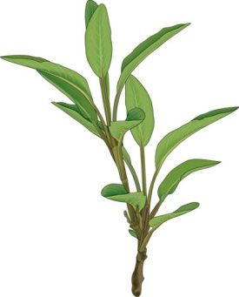

**Are you wondering how to dress up that Thanksgiving stuffing this year? Just add some of the historical healing herb: sage. However, this herb to too good to just bring out during the holidays. It can also be used to add fantastic flavor to other dishes such as beans, potatoes, risotto, cheese, and tomato sauces.**

**Not only is its flavor wonderful and contains vitamin K, but folklore history of sage includes it being used for many medicinal purposes such as treating sore throats and coughs. It was even used to protect against witchcraft thousands and thousands of years ago!**

**You may already have this perennial growing in your garden. Wouldn’t you know it is SUPER easy to turn those fresh leaves into your own special dry rub? You may discover that this herb may be your “secret” ingredient to keep your guests coming back for seconds!**

***Darby Simpson, Dietetic Intern***

***University of Wisconsin-Stout***

