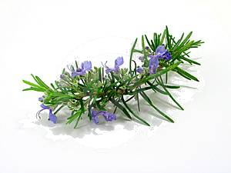
Ring Around The Rosemary

A S E L B A T E G E V X H C K M Y
B T L X U R E T E N U E A J O U T
D N X L J Q C Y E M I Q Y O U I L
D A L N X B I F G Q Q U V I F S A
I D K I Y F T D Y U Z C P A O S Y
S I L O W Y E U P M N M U M L A O
I X M Z X R R Q T J K J F U K T L
N O T D J G U D I C P R F I L O J
F I Z N S R I T A S Q A V S O P V
E T R Z G E D N N R M Z T E R F Z
C N M Q K P M M E U F L S N E L O
T A K P Y E G U I K D O M G D C H
A M E C B L H C F R C I J A Q N E
N R E V J L L A X R O I X M T I R
T P R A R A W E V J E A H K O Z B
L N G U C N Y U V O S P S C E E D
Q C G K P T J M N P M P P T E F U


antioxidant | folklore | potassium
calcium | greek | repellant
chicken | herb | roast
disinfectant | loyalty | vegetables
diuretic | magnesium | zinc
egyptian | perfumes
Beneficial Bites
Ring Around The Rosemary

A S E L B A T E G E V X H C K M Y
B T L X U R E T E N U E A J O U T
D N X L J Q C Y E M I Q Y O U I L
D A L N X B I F G Q Q U V I F S A
I D K I Y F T D Y U Z C P A O S Y
S I L O W Y E U P M N M U M L A O
I X M Z X R R Q T J K J F U K T L
N O T D J G U D I C P R F I L O J
F I Z N S R I T A S Q A V S O P V
E T R Z G E D N N R M Z T E R F Z
C N M Q K P M M E U F L S N E L O
T A K P Y E G U I K D O M G D C H
A M E C B L H C F R C I J A Q N E
N R E V J L L A X R O I X M T I R
T P R A R A W E V J E A H K O Z B
L N G U C N Y U V O S P S C E E D
Q C G K P T J M N P M P P T E F U

antioxidant | folklore | potassium
calcium | greek | repellant
chicken | herb | roast
disinfectant | loyalty | vegetables
diuretic | magnesium | zinc
egyptian | perfumes
Beneficial Bites

