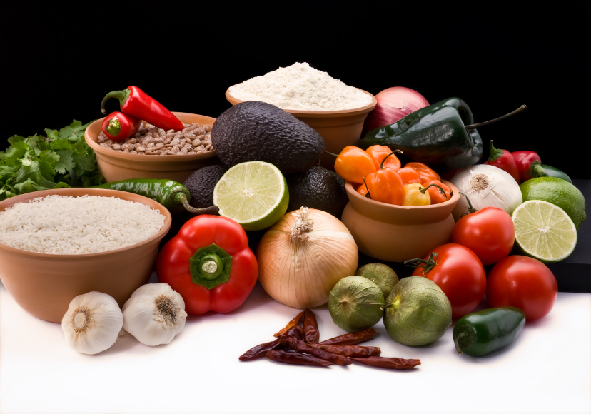
Recipe for: Rhubarb Vinaigrette
1/4 cup honey
1/2 cup water
4 stalks rhubarb (about 2 loosely packed cups), finely chopped
1/4 cup red wine vinegar
Zest of one lemon
1/4 cup extra-virgin olive oil
Coarsely ground pepper & sea salt
Combine water and honey over medium heat. When the mixture begins to boil, add rhubarb and boil five minutes more, stirring often. Stir in vinegar and lemon zest, and cook five to 10 more minutes, until dressing is reduced by about half. Remove from heat, and let cool slightly. Whisk the olive oil into the dressing. Season with salt and pepper. Serve warm or cold over fresh salad greens. Yields about 2 cups.

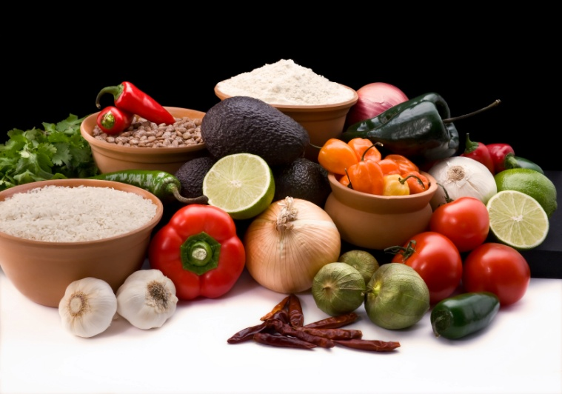

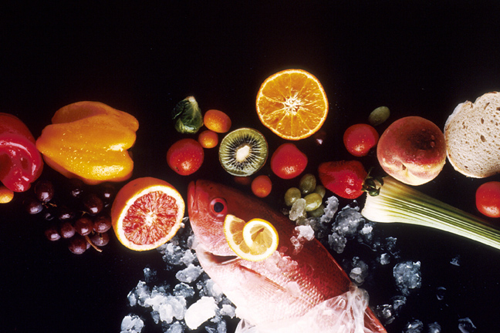
Recipe for: Rhubarb Pecan Muffins

1 cup all-purpose flour1 cup whole wheat flour
1 ½ tsp baking powder1 tsp salt
½ tsp baking soda¾ cup sugar
1 large egg¼ cup vegetable oil
¾ cup orange juice2 tsp grated orange peel
1 ¼ cups rhubarb, finely chopped¾ cup pecans – chopped

Combine all dry ingredients. Beat egg and oil; add orange juice. Add to flour mixture. Stir in rhubarb and pecans just until moistened. Pour into 12 greased muffin tins. Bake at 350 degrees for 25-30 minutes.

Recipe for: Rhubarb Custard Pie
Admittedly not so healthy, but definitely delicious!

1 ½ cups sugar
¼ cup flour
3 eggs
4 cups chopped fresh rhubarb
9” unbaked pie shell

Combine sugar, flour, eggs and rhubarb in large bowl. Pour into pie shell, sprinkle with oatmeal topping and bake at 400° for about one hour. To prevent edges of crust from overbrowning, cover edges with foil for first 35-40 minutes of baking. Remove foil and continue baking.
This pie will sometimes bubble over…so you’ll want to place it on a baking sheet unless you really enjoy cleaning your oven!

Recipe for: Spiced Rhubarb Sauce

4 cups chopped fresh rhubarb
2 large onions, chopped
1 medium green pepper, chopped
3/4 cup packed brown sugar
3/4 cup cider vinegar
1/4 cup reduced-sodium soy sauce
2 teaspoons steak seasoning
1 garlic clove, minced
1/2 teaspoon celery seed
1/2 teaspoon ground coriander
1/2 teaspoon ground cinnamon
1/2 teaspoon ground allspice

In a large saucepan, combine all ingredients. Bring to a boil. Reduce heat; simmer, uncovered, for 45-50 minutes or until thickened. Serve warm with chicken or pork. Refrigerate leftovers. .

Oatmeal topping
½ cup oatmeal
¼ cup flour
¼ cup brown sugar
¼ cup butter/margarine
½ tsp cinnamon
Combine all ingredients in bowl until crumbly.
Recipe for: Rhubarb Bread Pudding
8 slices whole wheat bread, cut into ½ inch cubes
1 ½ cups low fat milk (or fat-free half & half)
1/4 cup butter, cubed
5 eggs, lightly beaten
3 cups chopped rhubarb
1 ½ cups sugar
1/2 teaspoon ground cinnamon
1/2 cup packed brown sugar
Place cubed bread in a greased 1-1/2-qt. baking dish. In a large saucepan, scald milk over medium heat; remove from the heat. Stir in butter until melted. Pour over bread; let stand for 15 minutes. In a large bowl, combine the eggs, rhubarb, sugar, cinnamon and salt; stir into bread mixture. Sprinkle with brown sugar. Bake at 350° for 45-50 minutes or until set. Serve warm. Refrigerate leftovers. Yield: 8 servings.

Recipe for: Rhubarb Spritzer
6 cups chopped fresh or frozen rhubarb
2 cups water
1 cup sugar
1 cup pineapple juice
1 liter lemon-lime soda, chilled*
Bring rhubarb and water to a boil in large pot. Boil for 15 minutes. Cool for 10 minutes; Strain, discard pulp and reserve juice. Add sugar and pineapple juice to reserved juice; stir until sugar is dissolved. Chill thoroughly. Just before serving, add soda and ice cubes. Garnish with sliced pineapple and a strawberry.
*Cut calories and carbohydrates by using diet lemon-lime soda

Recipe for: Rhubarb Bread
1 ½ cup brown sugar1 egg
2/3 cup oil1 tsp salt
1 ¼ cup all-purpose flour1 ¼ cup whole wheat flour
1 tsp baking soda1 cup buttermilk
1 tsp vanilla1 ½ cup diced rhubarb
½ cup nuts2 Tbsp cinnamon-sugar mixture

Grease two loaf pans and preheat oven to 325°. In large bowl, combine sugar, egg and oil and beat well. In medium bowl, sift flours and salt together. Dissolve baking soda in milk and set aside. Alternately add flour mixture and milk mixture to sugar-oil mixture. Then gently stir in vanilla, rhubarb and nuts. Pour into loaf pans, sprinkle lightly with cinnamon-sugar and bake about one hour. Remove from pans and cool on wire rack.

Recipe for: Rhubarb Relish

4 cups diced fresh or frozen rhubarb*
1-1/2 cups water
1/2 cup sugar
1 large package strawberry gelatin (2 pkgs sugar-free is okay)
1 cup orange juice
1 teaspoon grated orange peel
1 cup sliced fresh strawberries

In a saucepan over medium heat, bring the rhubarb, water and sugar to a boil. Cook, uncovered, until rhubarb is tender, about 6-8 minutes. Remove from the heat; stir in gelatin until dissolved. Stir in the orange juice and peel. Chill until mixture begins to thicken. Fold in strawberries. Pour into a 2-qt. bowl and chill until set. Garnish with mandarin oranges & mint sprigs.
*if using frozen rhubarb, thaw first and drain.

