Quinoa
Pronounced Keen-wah

Quinoa, quinoa my favorite whole grain,
Boiled or toasted, seasoned or plain.
High in protein, gluten free,
Rich in iron and vitamin B.
Full of fiber and a nutty flavor,
Easy to cook and a pleasure to savor.
Overshadowed by couscous, barley, and rice.
The less-popular quinoa is twice as nice.
It's fluffy and versatile; add veggies or beans.
Or make pudding, cold salads – nearly any cuisine!
I could eat it daily, again and again.
This healthful quinoa, "the mother grain!"
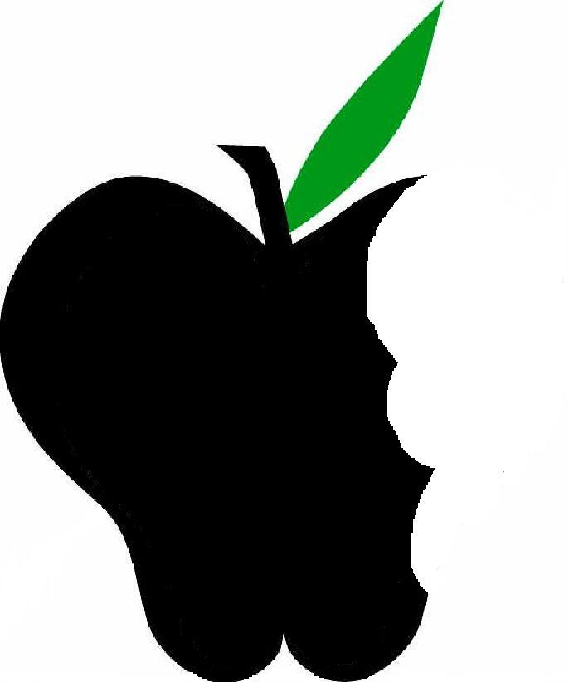
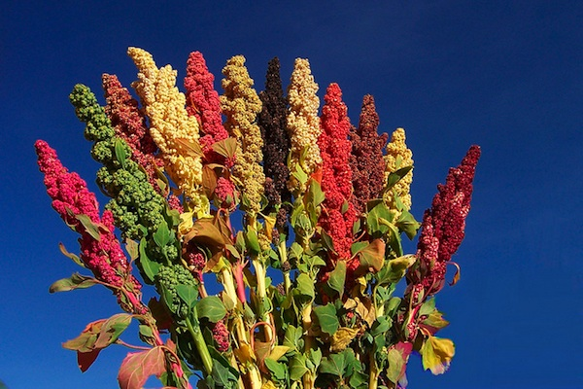

To Cook Quinoa
- Soak/Rinse in water for 5-10 minutes then drain.
- Add one cup Quinoa to two cups water in a saucepan.
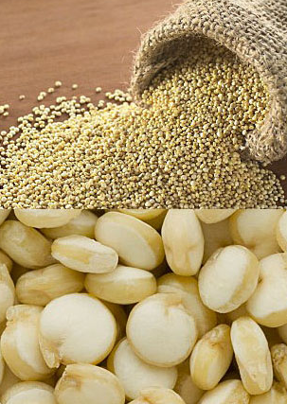
- Bring to a boil, reduce heat, cover and let simmer.
- This usually takes 15 minutes or less.
- You will know when the quinoa is done because it will look like it has popped open

How Does it Taste?
Quinoa looks a bit like couscous and is as versatile as rice, but it has a richer, nuttier flavor than either of them. The seeds have a naturally bitter coating to deter birds that must be soaked off before preparing. Packaged quinoa has likely been pre-soaked, but it’s always a good practice to wash and rinse before cooking.

Created and developed by Tera Orr, UW-Stout Dietetic Intern, April 2013
Did you Know!?
Just one cup of cooked Quinoa gives your body:

222 calories
3.6 grams of fat
39.4 grams of carbohydrate
8.1 grams of protein
5.2 grams of fiber

Ways to Enjoy
- Add nuts and fruits to cooked quinoa and serve as breakfast porridge.
- Try Quinoa as side dish instead of rice.
- Add quinoa to your favorite vegetable soups.
- Cooked quinoa can be added to casseroles, pilafs, and risotto-like dishes.
- Quinoa flour can be added to cookie or muffin recipes.

