Quinoa Presentation

- What is Quinoa?

  - Pronounced Keen-wah
  - Quinoa grows on magenta stalks three to nine feet tall, with large seed-heads that can be almost any color, from red, purple, orange, green, black, or yellow.
  - Over 120 different varieties of quinoa are known, but the most commonly cultivated and commercialized are white, red, and black.
  - Its appearance and manner of consumption would lead us to believe that the seedling is similar to a grain. However, it actually is not a grain!
    - It’s what we call a "pseudo-cereal" – foods that are cooked and eaten like grains and have similar nutrient profiles.
  - Botanically, quinoa is related to beets, chard and spinach, and in fact the leaves can be eaten as well as the grains.
  - Quinoa is native to South America, where locals have cultivated it for thousands of years.
  - The quinoa harvest starts in late March.
  - Grows best in mountainous regions, 10 thousand feet or more above sea level, and thrives in poor soil, thin air and extreme weather.

- History of Quinoa

  - Researchers date the popularity of quinoa to approximately 3000 BC, when its consumption became widespread in the Andes mountains regions of South America.
  - Sacred to the Incas, quinoa was referred to by them as the “Mother of all Grains”.
    - Quinoa served as a staple food in the Incan diet.
    - Legend has it that each year, the Incan emperor would sow the first quinoa seeds, in a ceremony.
    - Quinoa came close to disappearing after 1532. That's when Francisco Pizarro, the Spanish explorer, destroyed the quinoa fields to undermine the Incan culture.
    - Only small pockets of wild quinoa at high altitudes survived, and quinoa was largely forgotten until its "rediscovery" by the outside world in the 1970s.
  - Most quinoa consumed in the United States comes from South America.
  - Peru is the largest commercial producer of quinoa and Bolivia the second largest producer. Together, these two South American countries produced nearly 99% of the world’s commercially grown quinoa in 2010.

- Nutrition and Health Benefits

  - Quinoa is much more than a simple grain, and can be listed as a “superfood”.
  - Quinoa is gluten-free
  - Quinoa is made up of 71% carbohydrates, 15% proteins, and 14% fat. It also provides fiber and many vital minerals making up the rest of the seed.
  - Quinoa is a Complete Protein. Complete proteins are rare in the plant world, making quinoa an excellent food for vegetarians.
Complete proteins are those that have all of the amino acids needed by the body.

    - Especially rich in lysine, which promotes healthy tissue growth throughout the body
  - Quinoa is a great source of Fiber. A single cup of quinoa has 5 grams of fiber.
That’s 20% of your daily requirements of fiber in one meal!

  - Quinoa is a source of many Vitamins
Free Radicals produced by the body, some of which can cause damage to other cells!

    - Quinoa contains many of the B vitamins (thiamin, riboflavin, B6 and niacin), which are important to the body's ability to convert food into energy.
    - It also offers folate, another B vitamin which helps form red blood cells.
    - Quinoa also provides vitamin E, an antioxidant that helps scavenge disease-causing free radicals in the body
  - Quinoa is a source of many Minerals.
    - It provides iron, which is essential to red blood cell development.
    - Magnesium which is critical for enzyme activation, energy production and mineral regulation.
    - Phosphorus for the bone-building and potassium, which helps balance minerals and fluids.
    - It also provides several trace minerals, including copper, manganese, zinc and selenium.
  - Research is also showing these possible benefits:
    - Keeping your gastrointestinal system healthy: It offers plenty of insoluble fiber, which helps in regulating bowel movements.
    - Maintaining your weight: The combination of fiber and protein in quinoa makes it a very filling food.
    - Relieving migraines: Magnesium found in quinoa may provide some relief for migraine sufferers. This mineral can make your blood vessels more relaxed, which is an important factor in dealing with vascular headaches.

- Preparation & Storage

  - Quinoa is generally available in prepackaged containers as well as bulk bins.
  - To cook the quinoa
    - Add one part of the grain to two parts liquid in a saucepan.
Similar to Rice
    - After the mixture is brought to a boil, reduce the heat to simmer but covering is not necessary.
    - One cup of quinoa cooked in this method usually takes 15 minutes to prepare.
  - When cooking is complete, you will notice that the grains have become translucent, and the white germ has partially detached itself, appearing like a white-spiraled tail.
  - If you desire the quinoa to have a nuttier flavor, you can dry roast it before cooking.
    - To dry roast, place it in a skillet over medium-low heat and stir constantly for five minutes.
  - Store quinoa in an airtight container. It will keep for a longer period of time, approximately three to six months, if stored in the refrigerator.

- How to Enjoy

  - Combine cooked chilled quinoa with pinto or black beans, green onions, corn, tomatoes. Use chili powder, cumin or taco seasoning packet and enjoy this south-of-the-border inspired salad or hot side dish.
  - Add nuts and fruits to cooked quinoa and serve as breakfast porridge.
  - For a twist on your favorite pasta recipe, use noodles made from quinoa.
  - Add quinoa to your favorite vegetable soups.
  - It can be served hot or cold, in many of the same ways you would use rice.

- Fun Facts

  - It has a natural covering called saponin (a bitter resin that acts as a pesticide and keeps birds away). Saponin has been removed from most commercially packaged quinoa but it’s a good idea to rinse it anyway. This substances is also the reason that most quinoa can be labeled “organic” since it doesn’t require pesticides or genetic modification to prevent crop damage.
  - The protein found in quinoa is similar to soy. The protein in quinoa is even better than that found in beans, peas, legumes, nuts and seeds.
  - NASA has proposed quinoa as an ideal food for long-duration space flights.
  - Chenopodeum, the botanical name for quinoa, means "goose foot," so named because the leaves of the plant resemble the webbed foot of a goose.
  - Inca warriors ate balls of quinoa and fat to keep them going on long marches and in battle.
  - In times of drought, when other crops in quinoa-growing areas fail, quinoa can actually increase its yields. The crop can thrive on as little as three to four inches of annual rainfall.
  - The seed-heads are prolific: a half pound of seed can plant a full acre, yielding 1200-2000 pounds of new seeds per acre.
  - In the U.S. and Canada, quinoa is now being grown in areas of the Rocky Mountains, from Colorado to Saskatchewan, mostly at elevations of 7,000 to 10,000 feet.

- Activities

  - Sample Quinoa recipes
  - Read poem:
Quinoa, quinoa my favorite whole grain,
Boiled or toasted, seasoned or plain,
High in protein, gluten free,
Rich in iron and vitamin B,
Full of fiber and a nutty flavor,
Easy to cook and a pleasure to savor,
Overshadowed by couscous, barley, and rice,
The less-popular quinoa is twice as nice.
It's fluffy and versatile; add veggies or beans,
Or make pudding, cold salads – nearly any cuisine!
I could eat it daily, again and again,
This healthful quinoa, "the mother grain!"

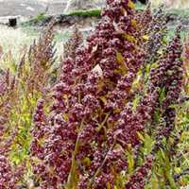 | Quinoa Plants Growing in the Field  This is what quinoa plants look like, growing in the high altitudes of mountainous regions.
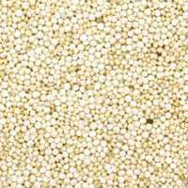 | Quinoa or White Quinoa  This is the most common kind of quinoa available in stores, so you'll often see it just called quinoa. Sometimes it's also called ivory quinoa.
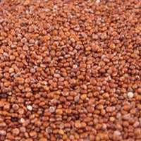 | Red Quinoa  Cooks report that red quinoa holds its shape after cooking a bit better than white quinoa, making it more suitable for cold salads or other recipes where a distinct grain is especially desirable.
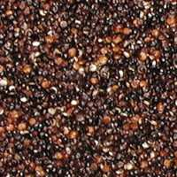 | Black Quinoa  A bit earthier and sweeter than white quinoa, black quinoa keeps its striking black color when cooked.
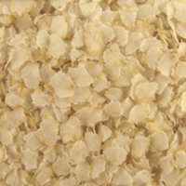 | Quinoa Flakes  As with rolled oats or barley flakes, quinoa flakes are created by steam-rolling the whole grain kernel. Flaked grains always cook faster than whole kernels (groats) but since quinoa is already a quick-cooking grain, these flakes make a great instant breakfast.
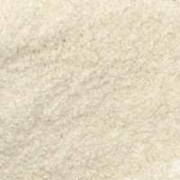 | Quinoa Flour  Okay, all flours look pretty similar, so you'll have to trust us – this is quinoa flour.

