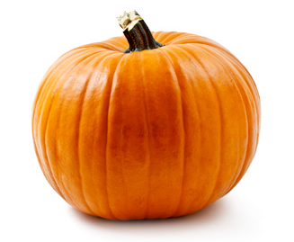

Beneficial Bites:
- Pumpkin is one of the richest food sources of vitamin A. Just a half-cup of canned pumpkin provides 381% of the daily value of vitamin A!

- Besides being fat-, sodium-, and cholesterol-free, pumpkin is also a great natural source of fiber and the antioxidant beta-carotene.

- Pumpkin is a good source of several other vitamins and minerals as well.

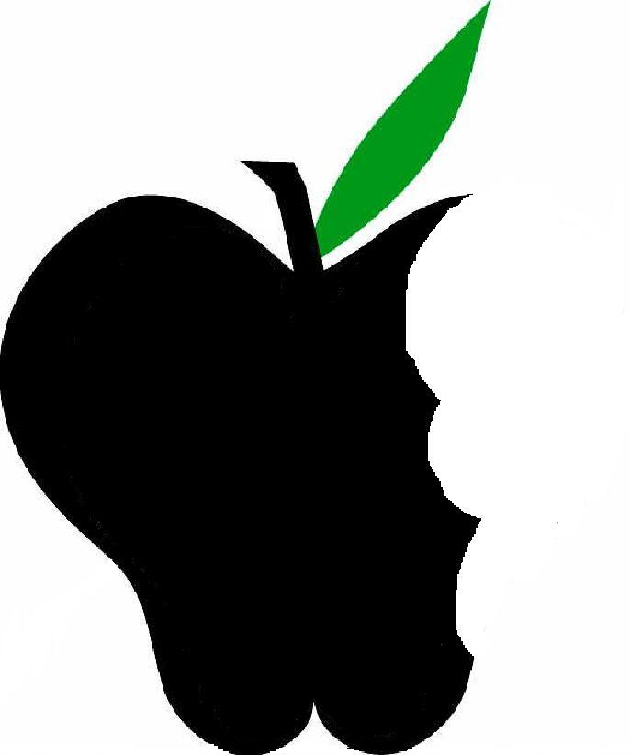

Did you know?
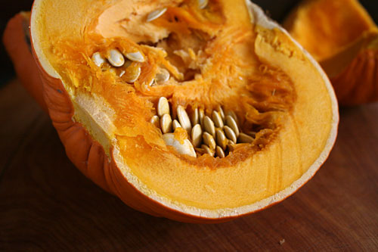
- Pumpkins are considered the world’s largest fruit. (That’s right—fruit!) They belong to the same family as squash, muskmelons, and watermelons.

- An important part of American history, pumpkin was a staple of the Native American and early settlers’ diets.

- October 26th is National Pumpkin Day.

- Pumpkins weren’t always the feature of the pie; in colonial times, they were part of the crust.

- Jack-o-lanterns evolved from an Irish myth about the ghostly spirit of Stingy Jack and other similarly shaped carved vegetables meant to ward off evil spirits.

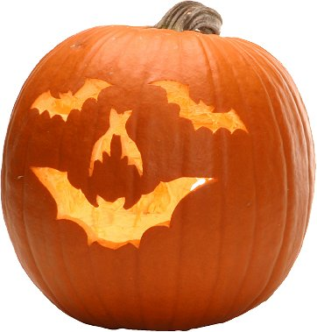

Food for thought:
- Save those seeds! Roast them for a tasty snack high in protein, fiber, potassium, and omega-3. Pumpkin Seeds
- Preheat oven to 300°
- Spoon seeds and pulp out of pumpkin into a bowl
- Remove pulp, rinse under water and shake dry
- Spread in a single layer on an oiled baking sheet; roast for 30 minutes
- Toss with olive oil, salt, and spices…
- Sweet: cinnamon and sugar
- Spanish: smoked paprika & slivered almonds
- Italian: grated parmesan & dried oregano
- Barbecue: brown sugar, chipotle chile powder, & ground cumin
Created by Amy Erickson, University of Wisconsin-Stout Dietetic Intern, Sept 2012

