**Recipe for: Pumpkin Sage Biscuits**

1 ½ cup all purpose flour 2 tsp baking powder

½ tsp baking soda ½ tsp salt

3 tsp dried crumbled sage 2 Tbsp cold butter cut into small pieces  
¾ cup pumpkin puree ½ cup Greek yogurt

2 Tbsp butter, melted

Preheat oven to 425 degrees. Line baking sheets with parchment paper. Combine dry ingredients, cut in the cold butter until pea sized pieces. In a separate bowl combine pumpkin puree and Greek yogurt. Combine wet ingredients with the dry and knead dough about 6 times on a floured surface. Roll out dough to a half inch thickness. Cut into 2-3 inch circles. Bake 11-14 minutes Serve warm. Yields 10 biscuits.



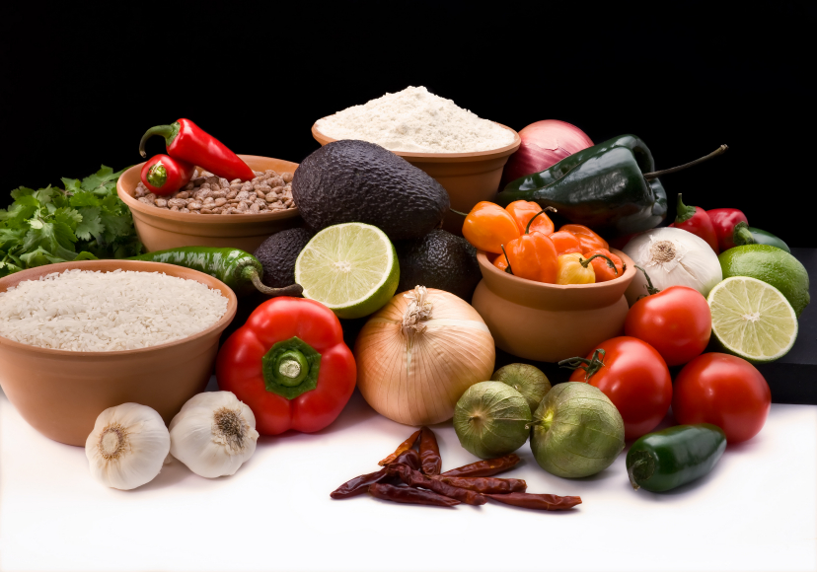

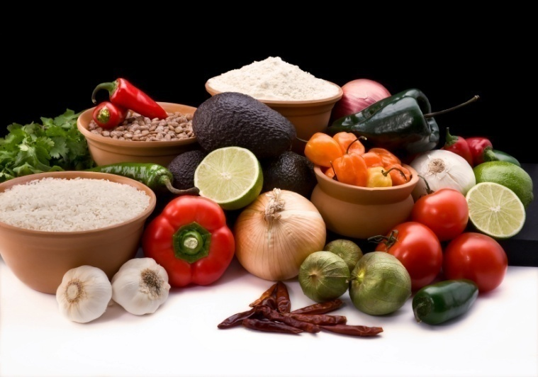

1 box spice cake mix

1 cup water

15oz can pumpkin puree

Preheat oven to 350 degrees. Combine all ingredients. Pour into 24 greased muffin tins. Bake at 350 degrees for 20-25 minutes.

**Recipe for:** **Easy Pumpkin Muffins**



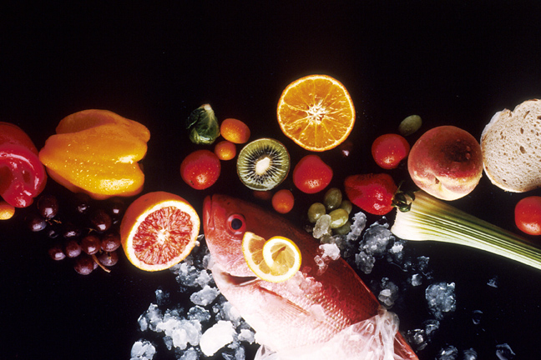

**Recipe for: Pumpkin Chili**

1 Tbsp oil 1 large onion, chopped

4 cloves minced garlic 1 cup pumpkin puree

1 cup canned tomatoes 1 cup vegetable stock

1 can black beans ½ can garbanzo beans

½ Tbsp cumin 1 Tbsp chili powder

In a large pot or skillet, cook onion and garlic in oil for about 5 minutes on medium heat. Add the remaining ingredients. Reduce to a simmer and cook for 20 minutes.





**Recipe for: Pumpkin French Toast Bake**

6 to 7 cups 1-inch bread cubes 7 large eggs

2 cups milk 1 tsp vanilla extract

1 ½ tsp pumpkin pie spice ½ cup pumpkin puree

3-4 Tbsp brown sugar for topping Nuts, walnuts or pecans (optional)

Lightly grease a 9x13 baking dish, fill with cubed bread. In a large bowl whisk eggs, milk, vanilla, pumpkin, and spices until well combined. Pour over bread in baking dish. Cover with plastic wrap and refrigerate overnight.

In the morning preheat oven to 350 degrees, uncover baking dish, top with brown sugar and nuts. Bake 35-45 minutes or until golden brown and no longer wet. Serve immediately with maple syrup or honey. Store leftovers in the refrigerator covered for up to three days.





**Recipe for: Roasted Pumpkin Seeds**

Rinse the seeds from 1 pumpkin in a colander. Add 2 cups of water and 1 tablespoon salt in a saucepan for every half cup of seeds. Bring to a boil and let simmer for 10 minutes. Remove from heat and drain. Coat the bottom of a roasting pan with oil, place seeds on pan. Roast on the top rack in a 400 degree oven for 5-20 minutes, until golden brown. Cool before enjoying.





**Recipe for: Pumpkin Rice Pudding**

1 1/2 cups cooked rice 2 cups milk  
2 eggs  3/4 cup pumpkin puree   
1/2 cup sugar  1/4 teaspoon salt

1/2 teaspoon cinnamon  1/2 teaspoon pumpkin pie spice  
1/2 teaspoon vanilla

Preheat oven to 350 degrees. In a bowl, whisk milk, eggs and pumpkin puree until combined. Whisk in sugar, salt, pumpkin pie spice, cinnamon and vanilla until combined. Stir in rice. Transfer to a glass baking dish. Bake for 1 hour 15 minutes or until custard is set.



