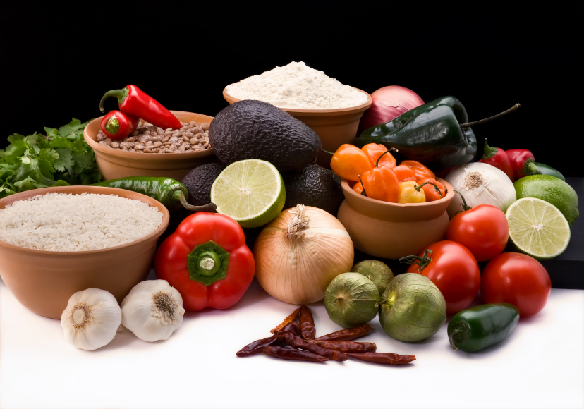
Recipe for: Warm Roast Pumpkin Cashew Salad
2 c pumpkin, cubed
1 T coconut oil
1 T grated ginger
1 lime
1/2 c mixed greens
1 green onion, chopped
2 T cashews
Mix oil, ginger, juice of lime and pour over cubed pumpkin, bake on cookie sheet at 350 F for 25 minutes. Create a salad with mixed greens, onion, cashews and warm pumpkin and serve.

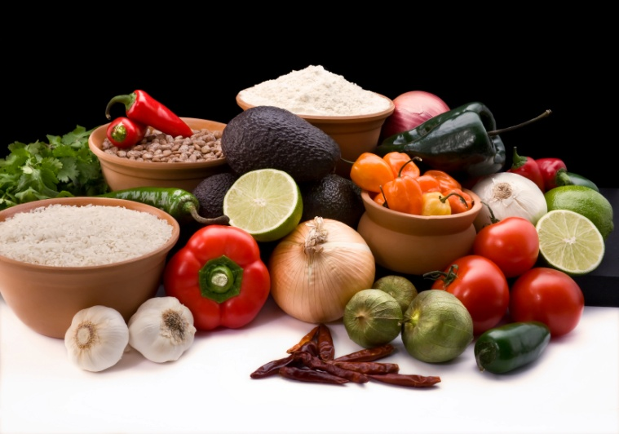

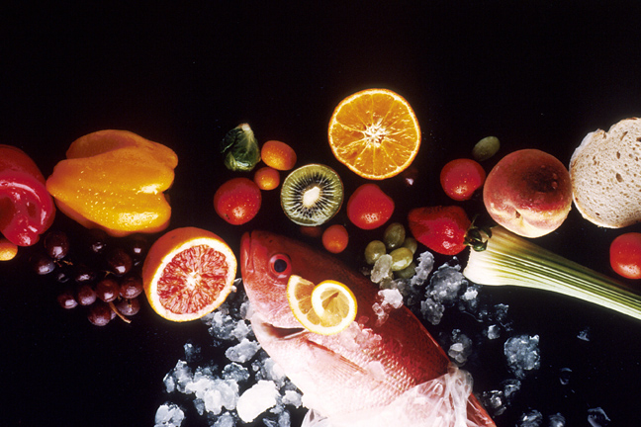
Recipe for: Pumpkin Chipotle Baked Pastries
½ c skim milk 1 T molasses
4 T butter 1 chipotle pepper, minced (optional)
½ tsp salt ½ tsp cinnamon
½ c flour ½ tsp chili powder
3 eggs ½ c shredded parmesan cheese
1/3 c pumpkin puree

Bring milk and butter to a boil. Add salt and flour, reduce heat and cook on low 2 minutes, stir constantly. Transfer to bowl, add eggs – one at a time, mixing well each egg. Add pumpkin, molasses, chipotle, cinnamon, chili powder and cheese and mix. Spoon balls onto baking sheet, bake at 400 F for 15 min.
Recipe for:Quinoa Black Bean Pumpkin Soup
1 T olive oil1 tsp cumin
1 onion, diced½ tsp oregano
1 red chili pepper, diced½ tsp red pepper flakes
5 cloves garlic, minced2 bay leaves
3 cups cubed pumpkin, dicedoptional garnish: avocado, cilantro, lime
½ c quinoa
1 can black beans
5 c vegetable broth
Cook onion, garlic and pepper. Add pumpkin and spices. Add broth, quinoa, beans and bay leaf and bring to a boil, simmer 15 minutes. Serve with garnishes if desired.
Recipe for: Chipotle Bacon Pumpkin Deviled Eggs

6 whole eggs¼ tsp salt
½ c canned pumpkin¼ tsp pepper
1 chipotle peppercilantro for garnish
½ tsp Dijon mustard
½ tsp lime juice
¼ tsp smoked paprika
2 slices bacon, crumbled
Prepare hard boiled eggs, cool and peel. Slice eggs in half. Mix egg yolks with pumpkin, pepper, mustard, lime juice, paprika, bacon, salt and pepper thoroughly. Fill each egg with pumpkin mixture, top with cilantro if desired.

Recipe for:

Recipe for: Creamy Pumpkin Ham Rigatoni
12 oz rigatoni1/8 tsp nutmeg
1 T olive oil¾ c heavy whipping cream
4 oz ham, chopped½ c chicken broth
½ onion, chopped¼ c shredded parmesan
½ c pumpkin pureesalt and pepper
Cook rigatoni according to package, set aside. Cook ham and onion in oil until browned. Add pumpkin, nutmeg, cream and broth and bring to a simmer until thick. Stir in cheese and salt and pepper to taste. Add rigatoni and toss to combine.

