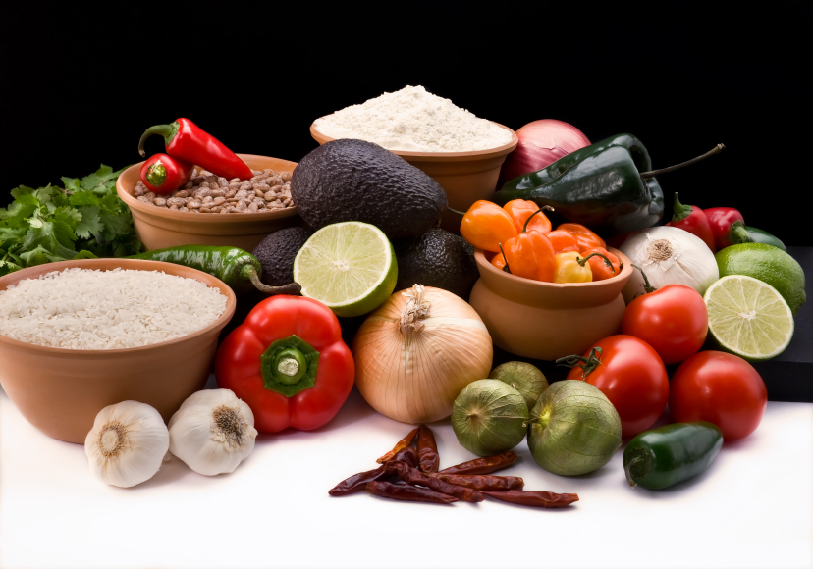
Recipe for: Garlicky Roasted Potatoes w/Herbs
2 Tablespoons chopped garlic
1 Tablespoon olive oil
1 ½ # quartered Yukon Gold or red potatoes
1 ½ teaspoon sea salt
¼ teaspoon freshly ground black pepper
¼ cup chopped fresh parsley, tarragon, rosemary or your favorite herb
½ teaspoon grated lemon rind

Preheat oven to 475. Combine garlic and oil in small pan over medium heat. Sautee on low until golden, stirring constantly. In large bowl, toss potatoes with oil/garlic mixture. Arrange on baking sheet and lightly coat with baking spray. Sprinkle with salt, pepper, herbs and lemon rind. Bake at 475 until potatoes are golden and soft.

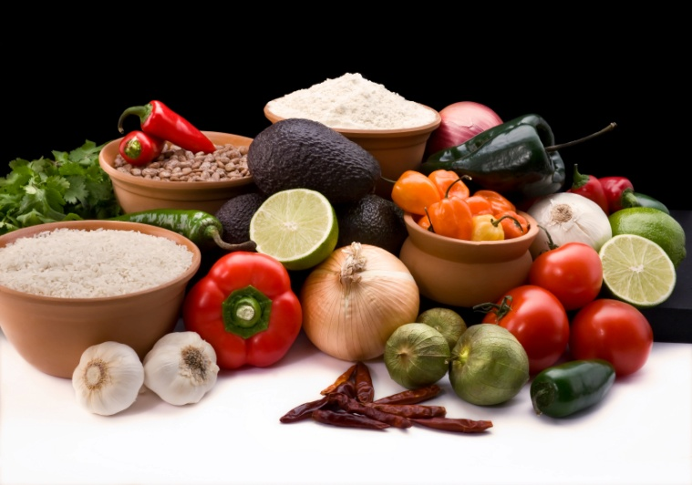

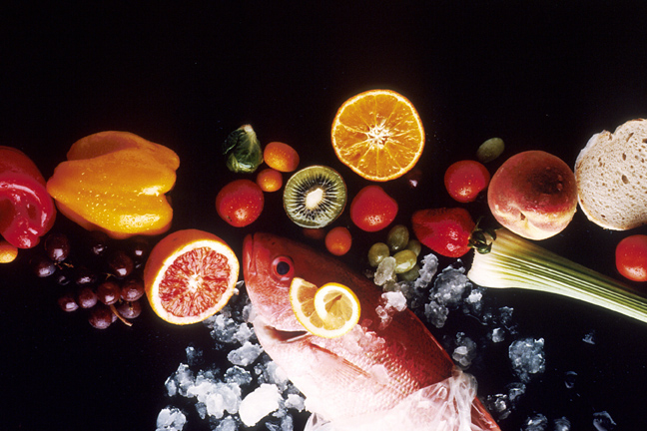
Recipe for: Potato & Root Vegetable Mashers
4 cups cubed baking potatoes (1” cubes)
2 cups cubed, peeled turnips (1” cubes)
2 cups cubed, peeled carrots (1” cubes)
1 tablespoon butter
1/3 cup light sour cream
¼ cup skim or 1% milk
Salt & pepper

Combine vegetables in large saucepan. Cover with water and bring to a boil. Reduce heat and simmer, covered for 15-20 minutes or until vegetables are tender. Drain and return pan to medium low heat. Add butter and milk and mash. Stir in sour cream and season to taste.

Recipe for: Grilled Potato Planks
3 tablespoons olive oil
1 clove garlic, minced
2 teaspoons finely chopped favorite herb
Salt & pepper
1 ½ # (about 3 large) unpeeled baking potatoes, cut into ½ inch thick slices

Preheat grill. Combine oil, garlic and herb. Brush both sides of each potato slice with mixture. Lightly salt and pepper. Grill potatoes for 8-10 minutes on each side, until cooked through and soft. Serve immediately.

Recipe for: Asparagus & Potato Frittata
3 teaspoons canola oil1 garlic clove, minced
1 small onion, chopped1 teaspoon chopped rosemary
1 tomato, seeded and chopped2 small cooked potatoes, diced into ½” pieces
4 large eggs4 large egg whites
10-12 cooked asparagus stalks-2” pieces ¼ cup grated Parmesan or Gruyere cheese
2 tablespoons fresh chives or scallionsSalt & pepper

Preheat broiler. Heat 2 teaspoons oil in large, ovenproof skillet over medium heat. Add onion, garlic, rosemary and half of tomato; cook, stirring until onion is transluscent. Add potatoes and cook, stirring frequently, until browned, about 4 minutes. Add asparagus and heat through. Remove vegetables from pan and season with salt and pepper. Wipe out pan, brush with remaining oil and return to low heat. In medium bowl, lightly whisk together whole eggs, egg whites and cheese. Add the vegetable mixture and pour into pan, gently stirring to distribute the vegetables. Cook over low heat until the underside is light golden, 5-8 minutes.

Place the pan under the broiler and broil until the top of the frittata is puffed and golden brown, 1-2 minutes. Loosen the frittata and slide onto platter. Garnish with chives/scallions and remaining tomato.

Recipe for: Potato Orange Spinach Salad
For Vinaigrette:
1 cup olive oil½ cup diced plum tomatoes
¼ cup orange juice1 tablespoon grated orange peel
¼ cup sherry or red wine vinegarSalt & Pepper
2 tablespoons tomato pureeOptional: Sugar if tomatoes are too acidic

Whisk together all ingredients for vinaigrette and set aside.
For Salad:
8 cups spinach leaves, washed6 small potatoes, roasted and sliced
1 cup celery, sliced½ cup finely diced red onion
4 oranges, peeled and segmented½ cup toasted slivered almonds

Toss spinach leaves with small amount of vinaigrette and place on salad plates. Dress salad with remaining ingredients and drizzle with remaining

Recipe for: Steak & Potato Wrap
1 # potatoes, cut into ½” cubes12 oz flank steak
2 tablespoons vegetable oil¼ cup Worcestershire sauce
2/3 cup finely chopped green onion 1 cup shredded, reduced fat cheddar cheese
Salt & PepperFlour tortillas, heated
Steak sauce

Microwave potatoes on high for 7 minutes or just until tender. Set aside. Cut steak lengthwise into thirs, then crosswise into ¼ inch thick slices. Heat 1 tablespoon oil in skillet over medium heat and add ½ steak. Cook and stir 2 minutes or until steak loses pink color. Remove steak and repeat with remaining oil and steak. Add Worcestershire sauce to all of cooked steak in bowl. Add potatoes to skillet. Cook and stir until most liquid is absorbed. Add steak and onions. Season with salt and pepper. Spoon ½ cup of potato/steak mixture onto center of tortilla. Sprinkle with cheese and fold to enclose filling. Serve with steak sauce.
Recipe for: Calico Salad
10 oz pkg frozen mixed vegetables, prepared as directed
1 large green pepper, diced1 cup sliced celery
1 large potato, peeled, cubed, cooked1 small onion, chopped
15 oz can kidney beans, drained¼ cup minced parsley (or 1 T dried flakes)
½ cup sugar3 tablespoons flour
5 teaspoons prepared mustard½ cup cider vinegar

Combine cooled mixed vegetables, green peppers, celery, cooled potato, onion, kidney beans and parsley in large bowl. Cover and refrigerate. Combine sugar, flour, mustard and vinegar in small saucepan and cook over moderate heat until mixture thickens. Remove from heat and set aside to cool. Pour over vegetables but do not mix. Cover and refrigerate at least 8 hours or overnight. Gently toss before serving.
Recipe adapted from Kitchen Kleen Potato website www.kitchenkleen.com/recipes

Recipe for: Mashed Potato Muffins
½ cup all-bran cereal¾ cup buttermilk
1 cup all-purpose flour½ cup whole wheat flour
2 teaspoons baking powder1 teaspoon baking soda
1 teaspoon salt½ cup butter, softened
½ cup packed brown sugar1 egg, beaten
½ cup leftover mashed potatoes½ cup raisins

Combine bran and milk in small bowl. Let stand 10 minutes. Combine dry ingredients and set aside. In bowl, cream butter and brown sugar until light and fluffy. Add egg, potatoes and bran mixture; beat until smooth. Stir in dry ingredients and raisins just until moistened. Spoon into 12 greased muffin cups. Bake at 375 for 20 minutes or until center springs back when touched.
Recipe from Taste of Home website www.tasteofhome.com

