Potatoes

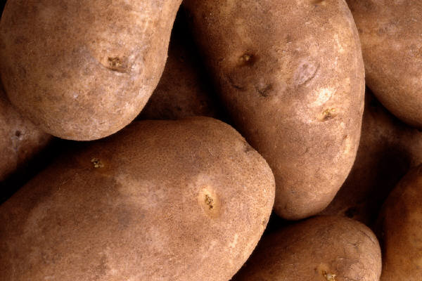

What would meat be without them?

What they bring to the table

- Vitamin C
- Potassium
- Vitamin B₆
- Fiber
- Antioxidants
- Carbohydrates

Beneficial Bites

Potatoes

What would meat be without them?

What they bring to the table

- Vitamin C
- Potassium
- Vitamin B₆
- Fiber
- Antioxidants
- Carbohydrates
Beneficial Bites

Potatoes

What would meat be without them?

What they bring to the table

- Vitamin C
- Potassium
- Vitamin B₆
- Fiber
- Antioxidants
- Carbohydrates
Beneficial Bites

Oh that Beautiful Starch

- All that iron your body needs is better absorbed with the Vitamin C in your potato.

- The carbohydrates give you fuel and keeps the brain running on all cylinders.
- A baked potato has only 110 tasty calories.

Baked Garlic Potato Wedges

5 lbs large potatoes
2 tsp olive oil
1/2Cup melted butter
2 tsp garlic powder

Preheat oven to 350 degrees F (175 degrees C). Grease a baking sheet with the olive oil. Brush potato wedges with butter, Place wedges on prepared baking sheet. Bake in preheated oven for 20 minutes. Remove from oven and turn wedges; cook for 10 to 15 minutes, or until tender.
Created by Brent Haugle, UW Stout Dietetic Intern February 2013

Oh that Beautiful Starch

- All that iron your body needs is better absorbed with the Vitamin C in your potato.
- The carbohydrates give you fuel and keeps the brain running on all cylinders.
- A baked potato has only 110 tasty calories.

Baked Garlic Potato Wedges

5 lbs large potatoes
2 tsp olive oil
1/2Cup melted butter
2 tsp garlic powder

Preheat oven to 350 degrees F (175 degrees C). Grease a baking sheet with the olive oil. Brush potato wedges with butter, Place wedges on prepared baking sheet. Bake in preheated oven for 20 minutes. Remove from oven and turn wedges; cook for 10 to 15 minutes, or until tender.
Created by Brent Haugle, UW Stout Dietetic Intern February 2013

Oh that Beautiful Starch

- All that iron your body needs is better absorbed with the Vitamin C in your potato.
- The carbohydrates give you fuel and keeps the brain running on all cylinders.
- A baked potato has only 110 tasty calories.

Baked Garlic Potato Wedges

5 lbs large potatoes
2 tsp olive oil
1/2Cup melted butter
2 tsp garlic powder

Preheat oven to 350 degrees F (175 degrees C). Grease a baking sheet with the olive oil. Brush potato wedges with butter, Place wedges on prepared baking sheet. Bake in preheated oven for 20 minutes. Remove from oven and turn wedges; cook for 10 to 15 minutes, or until tender.

Created by Brent Haugle, UW Stout Dietetic Intern February 2013

