
Beneficial Bites

Pomegranate

Pomegranate selection and storage tips
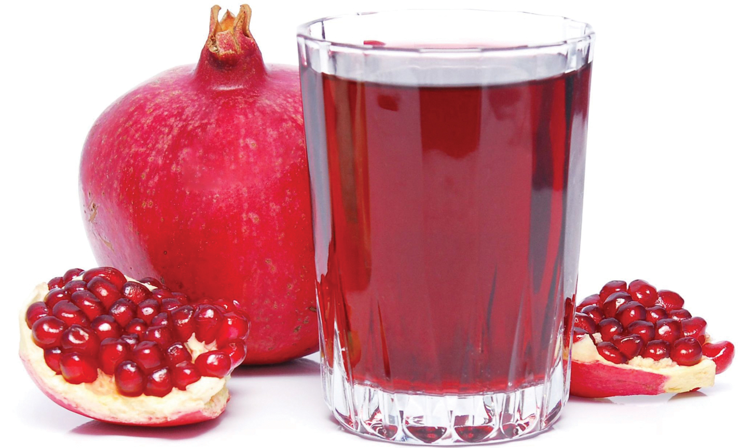

Health Benefits

- Powerful antioxidant
- Potent anti-cancer and immune supporting effects
- Inhibits normal platelet aggregation that could cause heart attacks, strokes, and embolic disease
- Lowers blood pressure
- Shown to promote reversal of atherosclerotic plaque
- May protect against osteoporosis

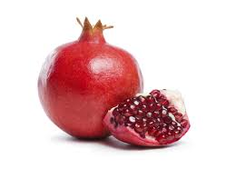
- You can purchase fresh pomegranates in most grocery stores from September through January
- Look for the largest, firmest, shiniest one available
- It should feel heavy for its size so you know it's full of seeds.
- Can be stored in refrigerator for up to two months

Add pomegranate
seeds to:
  - Salads
  - Jello/Desserts
  - Chicken salad
  - Salsa
  - Water

Add pomegranate juice
to Smoothies

Eat a Pomegranate Today
Beneficial Bites


