**Recipe for: Pomegranate Jello**

2 cups pomegranate juice

2 envelopes unflavored gelatin

2 tablespoons sugar

½ cup pomegranate seeds

Place 1/2 cup of the pomegranate juice into a medium mixing bowl and sprinkle the gelatin on top. Set aside. Place the remaining juice and the sugar into a small saucepan and place over high heat. Bring just to a boil. Remove from the heat and add to the juice and gelatin mixture, stirring to combine. Place the bowl into the refrigerator and chill, just until the mixture begins to set up, approximately 30 to 40 minutes. Remove from the refrigerator and stir in the seeds. Place into a 2 cup mold of your choice or 4 1/2 cup individual molds and chill until set.  
  
Read more at: http://www.foodnetwork.com/recipes/alton-brown/pomegranate-gelatin-recipe.html?oc=linkback  
  
  
* Can substitute 1 butternut squash, peeled and seeded.



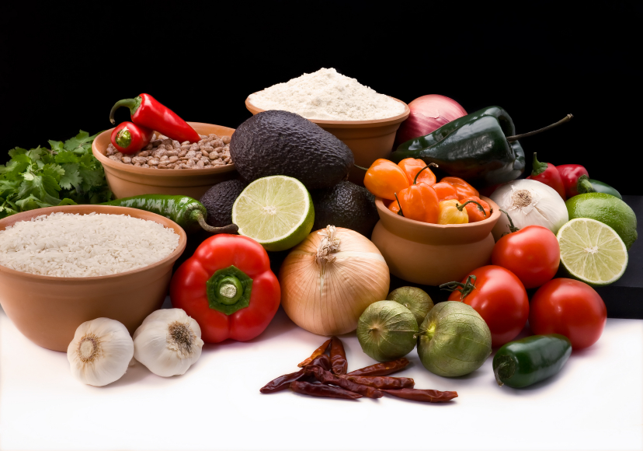

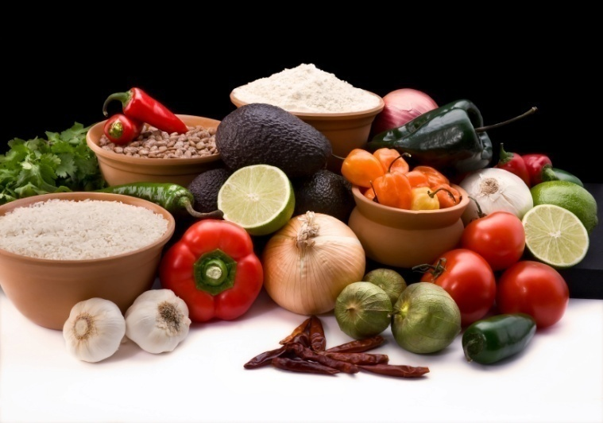

Seeds from 1 pomegranate ¼ teaspoon nutmeg

1 tablespoon of lemon juice ½ teaspoon ground cinnamon

2 tablespoons light brown sugar 2 tablespoons finely chopped almonds (optional)

Place the sliced pears and pomegranate seeds into a bowl. Toss with lemon juice to coat. Combine the brown sugar, nutmeg, and cinnamon in a small cup or bowl, then mix into the fruit. Cover and refrigerate for at least 1 hour before serving to blend the flavors. Serve in individual dishes, and garnish with a sprinkling of chopped almonds.   
*\* Beautiful dish to serve at your holiday party*

**Recipe for:** **Spiced Pears and Pomegranate**



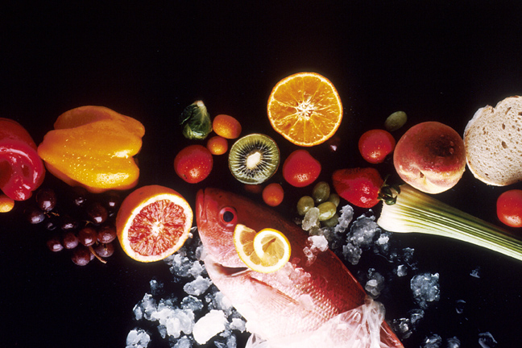

**Recipe for: Pomegranate Breakfast Soda**

16 ounces pomegranate juice

16 ounces sparkling water

½ ounce lime juice

1 tablespoon sugar

Mix the ingredients together in a pitcher and serve over ice.





**Recipe for: 5-Ingredient Pear Pomegranate Salsa**

2 pears cored and diced ½ cup chopped fresh cilantro leaves

Seeds from 1 pomegranate Juice of half a lime

Half a red onion, diced

Toss all ingredients together until combined. Season to taste with salt and pepper. Serve immediately, or store in a sealed container for up to 2 days.





**Recipe for: Spinach Pomegranate Salad**

1 (10 ounce) bag baby spinach leaves, rinsed and drained

1/4 red onion, sliced very thin

1/2 cup walnut pieces

1/2 cup crumbled feta

Seeds of 1 pomegranate

4 tablespoons balsamic vinaigrette

Place spinach in a salad bowl. Top with red onion, walnuts, feta, and sprouts. Sprinkle pomegranate seeds over the top, and drizzle with vinaigrette.





**Recipe for: Pomegranate Chicken Salad**

½ cup mayonnaise 1 rotisserie chicken, shredded

½ cup plain yogurt 1 cup pomegranate seeds

¼ cup Dijon mustard 2 tablespoons chopped fresh chives

2 tablespoons lemon juice 1 stalk celery, sliced

Salt and pepper

Combine the mayonnaise, yogurt, Dijon mustard, lemon juice and some salt and pepper.

Add the shredded chicken, pomegranate seeds, chives and celery to a bowl. Pour some of the dressing around the sides of the bowl and toss to combine. Add more dressing as desired.



