POMEGRANATE

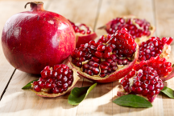
Health Benefits:
- Powerful antioxidant
- Potent anti-cancer and immune supporting effects
- Inhibits normal platelet aggregation that could cause heart attacks, strokes, and embolic disease
- Lowers blood pressure
- Shown to promote reversal of atherosclerotic plaque
- May protect against osteoporosis

Check out these December
menu items:

Featured Recipes
- Pomegranate Pistachio Pudding
- Broccoli Pomegranate Salad
- Tossed Salad with Pomegranate Seeds

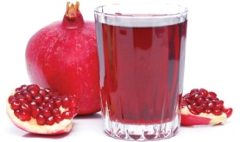

POMEGRANATE

Health Benefits:
- Powerful antioxidant
- Potent anti-cancer and immune supporting effects
- Inhibits normal platelet aggregation that could cause heart attacks, strokes, and embolic disease
- Lowers blood pressure
- Shown to promote reversal of atherosclerotic plaque
- May protect against osteoporosis

Check out these December
menu items:

Featured Recipes
- Pomegranate Pistachio Pudding
- Broccoli Pomegranate Salad
- Tossed Salad with Pomegranate Seeds

POMEGRANATE

Health Benefits:
- Powerful antioxidant
- Potent anti-cancer and immune supporting effects
- Inhibits normal platelet aggregation that could cause heart attacks, strokes, and embolic disease
- Lowers blood pressure
- Shown to promote reversal of atherosclerotic plaque
- May protect against osteoporosis

Check out these December
menu items:

Featured Recipes
- Pomegranate Pistachio Pudding
- Broccoli Pomegranate Salad
- Tossed Salad with Pomegranate Seeds

FUN FACTS
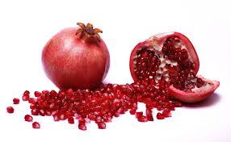
- At weddings and at New Years, Greeks break a pomegranate on the ground for good luck.
- The rind of the fruit and bark of the shrub are used in some traditional medicines to treat parasites.
- In India the astringent white pith is used as toothpaste with salt, pepper, and ginger. The juice, however, is highly tannic (like wine), and will stain teeth rather than clean them.
- The name pomegranate comes from Medieval Latin meaning "seeded apple."
- The blossom was crushed to make a red dye, and the peel was used to dye leather.
- The Pomegranate Council in California believes that the pomegranate may have been the actual forbidden fruit of the Garden of Eden, rather than the apple.
- In Indian cuisine, dried pomegranate seeds flavor everything from spiced chickpeas to sweet chutneys.

Created by Allison Freeman, MS
UW-Stout Dietetic Intern, October 2015

FUN FACTS
- At weddings and at New Years, Greeks break a pomegranate on the ground for good luck.
- The rind of the fruit and bark of the shrub are used in some traditional medicines to treat parasites.
- In India the astringent white pith is used as toothpaste with salt, pepper, and ginger. The juice, however, is highly tannic (like wine), and will stain teeth rather than clean them.
- The name pomegranate comes from Medieval Latin meaning "seeded apple."
- The blossom was crushed to make a red dye, and the peel was used to dye leather.
- The Pomegranate Council in California believes that the pomegranate may have been the actual forbidden fruit of the Garden of Eden, rather than the apple.
- In Indian cuisine, dried pomegranate seeds flavor everything from spiced chickpeas to sweet chutneys.

Created by Allison Freeman, MS
UW-Stout Dietetic Intern, October 2015

FUN FACTS
- At weddings and at New Years, Greeks break a pomegranate on the ground for good luck.
- The rind of the fruit and bark of the shrub are used in some traditional medicines to treat parasites.
- In India the astringent white pith is used as toothpaste with salt, pepper, and ginger. The juice, however, is highly tannic (like wine), and will stain teeth rather than clean them.
- The name pomegranate comes from Medieval Latin meaning "seeded apple."
- The blossom was crushed to make a red dye, and the peel was used to dye leather.
- The Pomegranate Council in California believes that the pomegranate may have been the actual forbidden fruit of the Garden of Eden, rather than the apple.
- In Indian cuisine, dried pomegranate seeds flavor everything from spiced chickpeas to sweet chutneys.

Created by Allison Freeman, MS
UW-Stout Dietetic Intern, October 2015

