
Beneficial Bites

Most of the plums we see today originated from the European and Japanese varieties.
The European plum is thought to have made its way to the United States when the
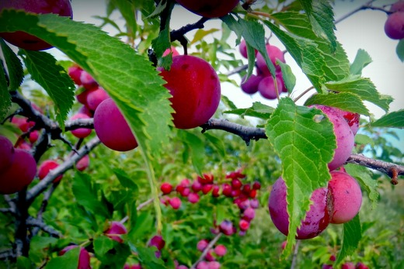
pilgrims and early
settlers first came
over.

When they arrived, they were surprised to see wild plums already growing in the United States.

Even though this was the case, many of the wild plums were eventually replaced with the European crop.

The Japanese plum actually originated in China and was introduced to Japan about 300 years ago. It is thought that the Japanese plum was introduced to the United States around 1870.
What’s So Great About Plums?
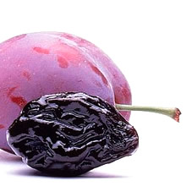
Plums are good
sources of
vitamin C,
vitamin K,
potassium,
antioxidants,
and dietary fiber.

Prunes, also known as dried plums, are not a good source of vitamin C.
Vitamin C is destroyed during the drying process of prunes.
They are still good sources of the other nutrients in fresh plums.
One cup of fresh plums has about 70 to 80 calories, whereas one cup of prunes contains about 420.
Most people should limit their consumption of

prunes to about
¼ cup per day.

Prunes And The Link to Bone Health
Recently a study was published in the British Journal of Nutrition that found that eating prunes can help prevent fractures and osteoporosis.
Researchers think the connection is from prunes ability to suppress the breakdown of bone, which tends to exceed the rate of new bone growth as people age.
The connection may be due to prune’s phenolic compounds (antioxidants), and good source of nutrients that influcence bone health including potassium, vitamin K, and boron.
Even though prunes might help in bone loss, remember that getting your calcium from dairy sources is best. Try for 3 to 4 servings of dairy per day, and toss some prunes in for great bone health.


Created by Tiffany Halama, RD

