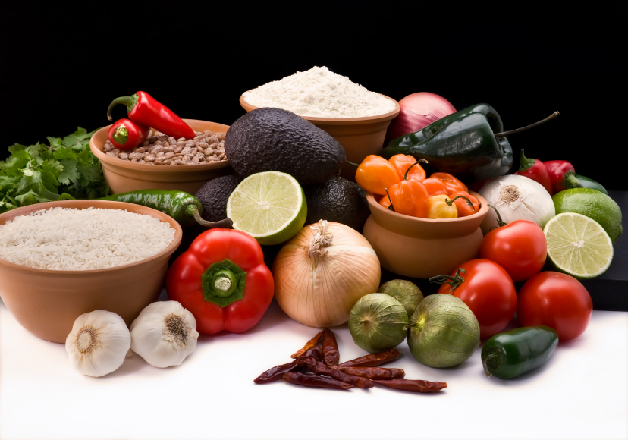
Recipe for: Dried Plum Waldorf Salad
3/4 cup reduced-fat mayonnaise
3 tablespoons freshly squeezed orange juice
3 cups chopped red apples
1 1/2 cups (8 ounces) cubed smoked turkey
1 cup (about 6 ounces) chopped dried plums
3/4 cup chopped celery
1/2 cup coarsely chopped walnuts, toasted
Red or green lettuce leaves (optional)

In medium bowl, combine mayonnaise and orange juice; add apples, turkey, dried plums, celery and walnuts, tossing to coat. Chill in refrigerator; serve on lettuce, if desired.

Tip: To toast walnuts, arrange in even layer on baking sheet. Bake in 350°F oven 8 to 10 minutes or until lightly browned.

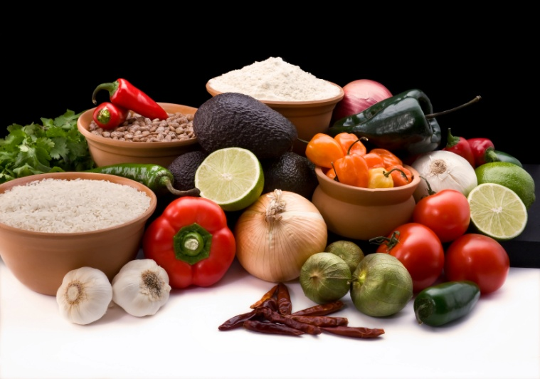

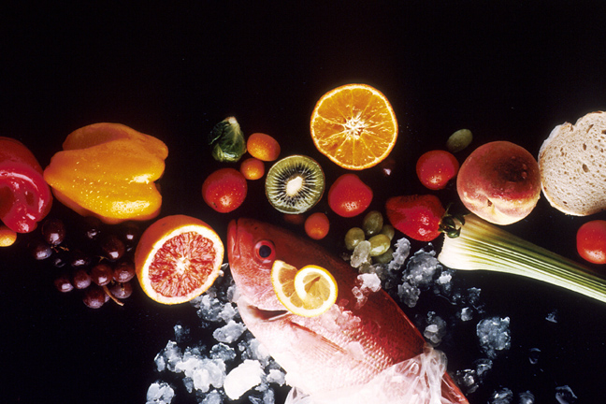
Recipe for: Plum Chicken Salad
8 ounces fresh plums, pitted and thinly sliced
2 tablespoons balsamic vinegar 1 Tbs. chopped fresh oregano, or 1 tsp. dried
3/4 cup chopped almonds 1/4 cup olive oil
Salt and black pepper 2 celery stalks, thinly sliced
8 oz (2 cups) roasted or grilled boneless, 1/2 red onion, chopped
skinless chicken, chopped or shredded
6 cups mixed greens, torn into bite-size pieces

Toss the plums with the vinegar in a large salad bowl. Cover and refrigerate for at least 15 minutes and up to 2 hours. Put the almonds in a dry skillet over medium heat and toast, shaking the pan frequently, until they are aromatic and beginning to darken, 3 to 5 minutes. Remove from the heat and let cool. Sprinkle the plums with salt and pepper and add the oregano, oil, celery, onion and chicken; toss to combine. Taste and adjust the seasoning if necessary. To serve, toss with greens or place plum-mixture on top of greens on plate. Garnish with the toasted almonds.

Recipe for: PB & Banana Dried Plum Sandwich
4 slices whole wheat bread, toasted
1/4 cup peanut butter
1 medium banana, sliced
1/4 cup (about 2 ounces) quartered pitted dried plums
2 tablespoons honey
1/8 teaspoon ground cinnamon (optional)

On each of two bread slices, spread 2 tablespoons peanut butter. Top with banana slices and dried plums. Mix honey with cinnamon, if desired. Drizzle honey over dried plums. Top each with remaining bread slices.

Recipe for: Hot & Spicy Cider

2 cups prune juice
2 cups apple juice
2 cinnamon sticks
12 whole cloves

In medium saucepan, combine prune juice, apple juice, cinnamon sticks and cloves; bring to a boil. Reduce heat; simmer 15 minutes. Remove and discard cinnamon and cloves.

Recipe for: Dried Plum Filled Oatmeal Bars

1 ½ cups coarsely chopped dried plums½ cup apricot jam
2 cups oatmeal¾ cup packed brown sugar
½ cup flour½ tsp ground cinnamon
½ tsp salt½ tsp baking soda
1 egg1 ½ Tbsp melted butter or margarine

In medium bowl, combine prunes and apricot jam, set aside. Lightly spray 8” square pan with cooking spray. In large bowl, combine dry ingredients and mix well. In small bowl, lightly beat egg and butter. Add to dry ingredients, mixing until crumbly. Pr4ess 2 cups of mixture into bottom of pan. Spread prune mixture over. Sprinkle remaining oat mixture over top. Bake at 350° about 20 minutes or until deep golden brown. Cool then sift a little powdered sugar over top if desired.
www.californiadriedplums.org

Recipe for: Old-Fashioned Fruit Crumble
1 1/4 cups plums (or other fresh or frozen fruit)
1 1/2 teaspoons sugar
4 teaspoons all-purpose flour, divided
1 1/2 teaspoons orange juice
1/4 cup old-fashioned oats
3 tablespoons chopped almonds
4 teaspoons brown sugar; Pinch of cinnamon
1 tablespoon canola oil

Preheat oven to 400°F. Combine fruit with sugar, 1 1/2 teaspoons flour and orange juice. Divide between two 6-ounce ovenproof ramekins. Combine oats, almonds, brown sugar, the remaining 2 1/2 teaspoons flour and cinnamon. Drizzle with oil and stir to combine. Sprinkle over the fruit mixture. Place the ramekins on a baking sheet and bake until the fruit is bubbling and the topping is golden, 20 to 25 minutes.

