**Recipe for: Herbed Pecan Snack Mix**

5 Cups rice or corn Chex 1 Tablespoon dried parsley flakes

1½ Cups pretzels 1 Teaspoon dried thyme (crushed)  
1 Cup pecan halves or pieces ½ Teaspoon celery salt  
1/3 Cup butter(melted) ½ Teaspoon onion powder

Preheat oven to 325 degrees. Combine cereals, pretzels and pecans in a 13x9x2” baking pan. In a bowl, stir melted butter and remaining ingredients together. Pour over cereal mixture, tossing gently until well coated. Bake at 325 degrees for 25 minutes, stirring once or twice. Spread in a large shallow pan or on foil to cool before serving



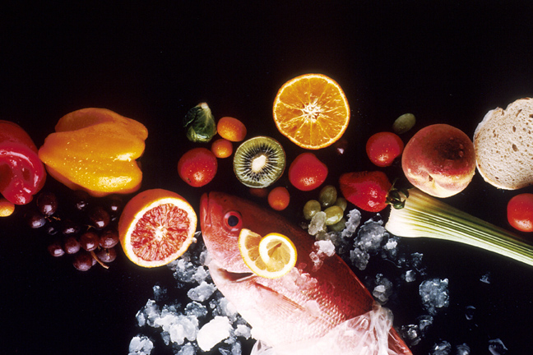

**Recipe for: Pecan Banana Bread**

1¾ Cup whole wheat flour 2 ripe bananas (mashed)  
½ Cup maple syrup ½ Cup pecans (coarsely chopped)  
1 Tablespoon baking powder 1 Tablespoon grated lemon peel  
¼ Teaspoon baking soda 2 eggs (slightly beaten)  
½ Cup butter

Preheat oven to 350 degrees. In a bowl, mix first four ingredients with fork. Use knife to cut in butter until mixture has crumbly appearance. With fork, stir bananas, pecans, lemon peel and eggs into flour mixture until flour is just moistened. Spoon batter into lightly greased 9×5″ loaf pan. Bake at 350 degrees for 40-50 minutes or until inserted knife comes out clean. Cool at least 10 minutes before slicing and serving.





**Recipe for: Lemon Pecan Green Beans**

1 lb. fresh green beans 1 Teaspoon dried rosemary

Salt to taste 2 Teaspoon lemon juice

1 Tablespoon olive oil 2 Teaspoon grated lemon rind (optional)

¼ Cup sliced green onions

¼ Cup chopped/toasted pecans

Wash beans and remove ends. Sprinkle with salt. Arrange beans in a steamer basket and place over boiling water. Cover and steam for approximately 10 minutes, or until crisp-tender. Plunge green beans into cold water to stop cooking process. Drain and set aside. In large skillet, heat olive oil over medium heat. Add green onions and cook, stirring constantly, for three minutes. Add green beans, pecans, rosemary and lemon juice. Cook, stirring constantly, until mixture is thoroughly heated. Sprinkle with lemon rind and garnish with lemon slice or fresh rosemary sprigs if desired.





**Recipe for: Fruit, Barley and Pecan Salad**

1Cup quick-cooking barley ¼ Cup maple syrup

2 Cups water 1 ½ Cups chopped mixed fresh fruits- kiwi, strawberries, blueberries

½ Teaspoon salt Ground cinnamon to taste (optional)

2 granola bars

2/3 Cup pecan halves

½ Cup low fat plain yogurt

In a medium-size pot, boil water. Add barley and salt, reduce heat to simmer, cover and cook 10 minutes. Remove from heat and let stand, uncovered, for 5 minutes. Spread barley on baking sheet to cool completely. Meanwhile, cut granola bars into small crouton-like cubes syrup, mixing until; set aside. Toast pecan halves in skillet or oven until toasted, crisped, and fragrant; set aside. Combine yogurt and maple blended; set aside. When barley has cooled, transfer to a large mixing bowl. Add the granola pieces, pecan halves, and fruit mixture, tossing gently.

To serve- spoon salad onto plates. Serve with yogurt dressing and a shaker of ground cinnamon to sprinkle as desired





**Recipe for: Rigatoni Pasta with spinach and Pecans**

8 ounces rigatoni pasta (1 box) 5 ounces baby spinach  
¼ Cup Italian or Greek dressing 1 Cup ricotta cheese  
2 Tablespoons olive oil ½ Teaspoon kosher salt  
½ Cup sweet onion, chopped Black pepper, to taste  
1 Clove garlic, minced ½ Cup toasted pecans

Cook pasta in boiling, salted water until al dente, 7 to 8 minutes. Transfer pasta to large bowl and toss with dressing. Keep warm. Heat olive oil in skillet over medium-high heat. Sauté onions for 3-4 minutes or until they become translucent. Add garlic and sauté 1 minute longer, stirring constantly. Add spinach to skillet and sauté until just beginning to wilt, 2-3 minutes. Combine with pasta and mix in ricotta cheese. Season with salt and pepper. Top with toasted pecans.





**Recipe for: Buttered Pecan Popcon**

8 Cups popped popcorn (about 1/3-1/2 Cups. unpopped)   
Nonstick cooking spray ¼ Cups instant butter pecan pudding mix (dry)  
½ Cups pecan pieces ¼ Teaspoon vanilla  
2 Tablespoon butter or margarine 1/3 Cup light corn syrup

Preheat oven to 300 degrees. Air Pop popcorn. After popping, discard unopened popcorn kernels. Spray a roasting pan with nonstick cooking spray. Place the popped corn and pecans in the pan. In a separate pan, heat butter and corn syrup, then stir in pudding mix and vanilla. Pour mixture over popcorn. Bake in oven at 300 degrees for 16 minutes, stirring halfway through baking. Remove pan from oven and turn mixture onto a large piece of foil. Cool popcorn completely. When cool, break into large pieces and serve.



