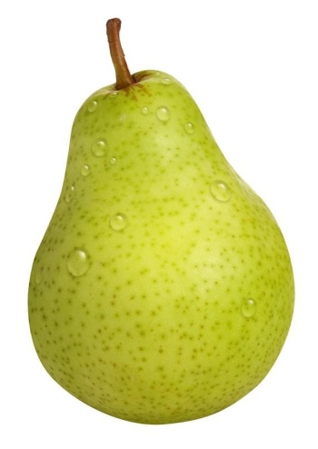
Pears are a member of the rose family of plants, Rosaceae, which are related to apples, apricots, cherries, peaches, and many other fruits.
Pear Nutrition:
- 1 medium pear = ~100 calories
- Excellent source fiber
- Excellent source of copper, vitamin A, and vitamin C
- Excellent source of antioxidants and anti-inflammatory support
Pears are popular!
There are 6 main states in the U.S. that produce pears but of these states, Washington, Oregon, and California make up the majority of production. In 2014, 776 million pounds of Bartlett pears were produced just from these 3 states!

Just Pearfect
The Bartlett pear is the most popular variety of pear in the U.S.
December is National Pear Month
About 3,000 varieties exist throughout the world but only 3 species account for the vast majority of edible production
1 medium pear contains about 15% of your daily copper – a trace mineral that’s essential for a healthy central nervous system
Pear wood is favored for things such as furniture and instruments because it does not warp
China is the largest producer of pears, followed by the U.S.
Pears contain a core, much like an apple
Anything that can be done with an apple can be done with a pear!
Pears
Since the skin of a pear provides about half of the pear’s total dietary fiber as well as its antioxidant and anti-inflammatory phytonutrients, it is best not to peel the fruit but to eat the entire pear. To cut the pear into pieces, you can use an apple corer by cutting from the fruit’s base.
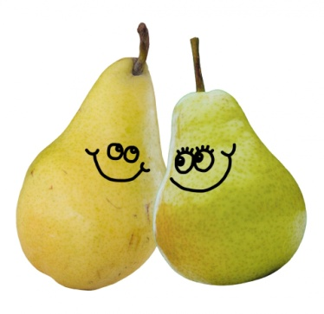
The perfect pear…
…make jelly or jams
…toss into salads
…add to smoothies
…freeze or can them for later use

Pick pears when the fruit has a faint yellow blush but is still green. Ripen pears at room temperature and know when they are ripe by “checking the neck” for gentle give around the stem.

