

Beneficial Bites

**Just Pearfect**:

* Peaches are an excellent source of fiber, copper, vitamin C, vitamin A, and other antioxidants. These may be beneficial in promoting better memory, lower cardiovascular disease, ease inflammation, and promote a healthy central nervous system as well as aide in digestion.
* Since the skin of a pear provides about half of the pear’s total dietary fiber as well as its antioxidant and anti-inflammatory phytonutrients, it is best not to peel the fruit but to eat the entire pear.

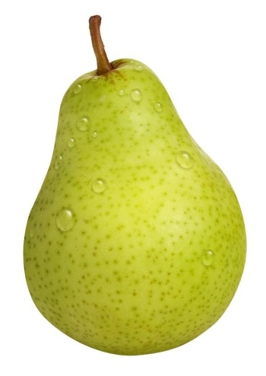

Pears are a member of the rose family of plants, *Rosaceae*, which are related to apples, apricots, cherries, peaches, and many other fruits.



Beneficial Bites

**Just Pearfect:**

* Peaches are an excellent source of fiber, copper, vitamin C, vitamin A, and other antioxidants. These may be beneficial in promoting better memory, lower cardiovascular disease, ease inflammation, and promote a healthy central nervous system as well as aide in digestion.
* Since the skin of a pear provides about half of the pear’s total dietary fiber as well as its antioxidant and anti-inflammatory phytonutrients, it is best not to peel the fruit but to eat the entire pear.



Pears are a member of the rose family of plants, *Rosaceae*, which are related to apples, apricots, cherries, peaches, and many other fruits.



Beneficial Bites

**Just Pearfect**:

* Peaches are an excellent source of fiber, copper, vitamin C, vitamin A, and other antioxidants. These may be beneficial in promoting better memory, lower cardiovascular disease, ease inflammation, and promote a healthy central nervous system as well as aide in digestion.
* Since the skin of a pear provides about half of the pear’s total dietary fiber as well as its antioxidant and anti-inflammatory phytonutrients, it is best not to peel the fruit but to eat the entire pear.



Pears are a member of the rose family of plants, *Rosaceae*, which are related to apples, apricots, cherries, peaches, and many other fruits.

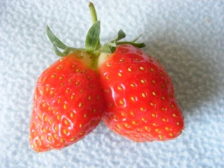



Beneficial Bites

**The Perfect Pear**

* **Pick pears when the fruit has a faint yellow blush but is still green. Ripen pears at room temperature and know they are ripe by “checking the neck” for gentle give around the stem.**
* China is the largest producer of pears, followed by the U.S.
* The Bartlett Pear is the most popular variety of pear in the U.S.
* December is National Pear Month
* About 3,000 varieties exist throughout the world but only 3 species account for the vast majority of edible production
* Anything that can be done with an apple can be done with a pear!

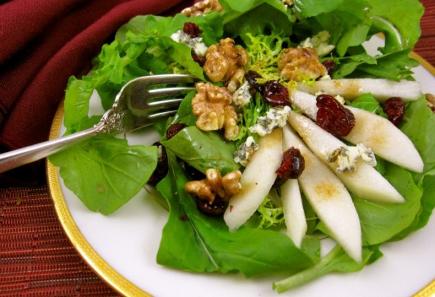

**December Menu items**

Tossed Salad with Pears

Pear Halves

**The Perfect Pear**

* **Pick pears when the fruit has a faint yellow blush but is still green. Ripen pears at room temperature and know they are ripe by “checking the neck” for gentle give around the stem.**
* China is the largest producer of pears, followed by the U.S.
* The Bartlett Pear is the most popular variety of pear in the U.S.
* December is National Pear Month
* About 3,000 varieties exist throughout the world but only 3 species account for the vast majority of edible production
* Anything that can be done with an apple can be done with a pear!



**December Menu items**

Tossed Salad with Pears

Pear Halves

**The Perfect Pear**

* **Pick pears when the fruit has a faint yellow blush but is still green. Ripen pears at room temperature and know they are ripe by “checking the neck” for gentle give around the stem.**
* China is the largest producer of pears, followed by the U.S.
* The Bartlett Pear is the most popular variety of pear in the U.S.
* December is National Pear Month
* About 3,000 varieties exist throughout the world but only 3 species account for the vast majority of edible production
* Anything that can be done with an apple can be done with a pear!



**December Menu items**

Tossed Salad with Pears

Pear Halves



Beneficial Bites



Beneficial Bites