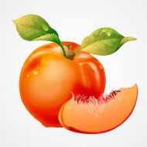
Peaches belong to the family of rose, and are considered a drupe fruit - containing a stone, just like plums, nectarines, cherries and apricots.

Peach Nutrition:
- Excellent source of Vitamin C
- Excellent source of fiber and potassium
- Excellent source of antioxidants
- Low in fat and calories
Peaches are a favorite fruit! Georgia is known as the “Peach State” because of the high quality of peaches they can grow. California is the highest producer; South Carolina is second, with Georgia the third highest producer domestically.

Just Peachy …
Voted a top 3 favorite fruit among most Americans
Versatile and easy to use in both sweet and savory dishes
Peach trees generally live for 12 years
Each tree can produce up to 130 peaches each year
Shown to aid in disease prevention and improve skin and eye health
Packed with vitamin C and loaded with beneficial antioxidants
Best availability is between May and September
Grown mainly in California, South Carolina, and Georgia. Not commercially grown in Wisconsin because of the climate
August is National Peach Month
Peaches
To remove the stone from the peach, cut into the peach near the top until you feel it hit the stone. Then you can continue to cute the peach lengthwise around the stone. After splitting the peach in half, the stone will be exposed and you will be able to remove it.
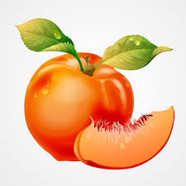
Practice what you peach…
…add to cereal & yogurt
…make jelly or jams
…toss into salads
…add to pancake & waffle batters
…add to lemonade and smoothies
…freeze them for later use
Enjoy peaches in the summer months when they are the freshest! When buying peaches, when gently squeezing, a ripe peach will “give.”

