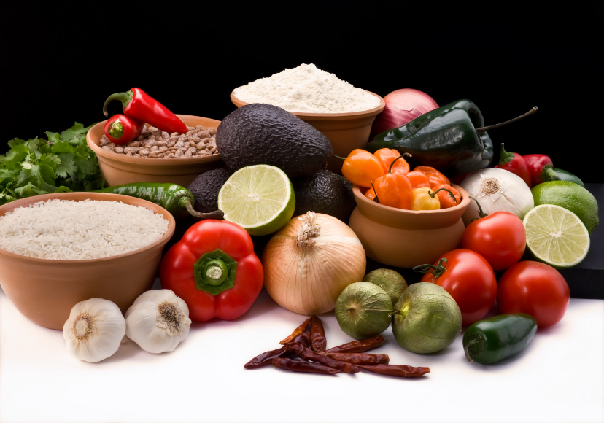
Recipe for: Peach Crumble

8 ripe peaches, peeled, pitted and sliced½ c flour
Juice from 1 lemon¼ c brown sugar
1/3 tsp cinnamon¼ c quick cooking oats
¼ tsp nutmeg2 T butter

Heat oven to 375 F. Coat 9 inch pie pan with cooking spray. Arrange peach slices in pie plate. Sprinkle with lemon juice, cinnamon and nutmeg. Mix together flour, sugar, oats, and crumble in butter, mix evenly. Sprinkle mixture on top of peaches. Bake about 30 minutes or until browned.
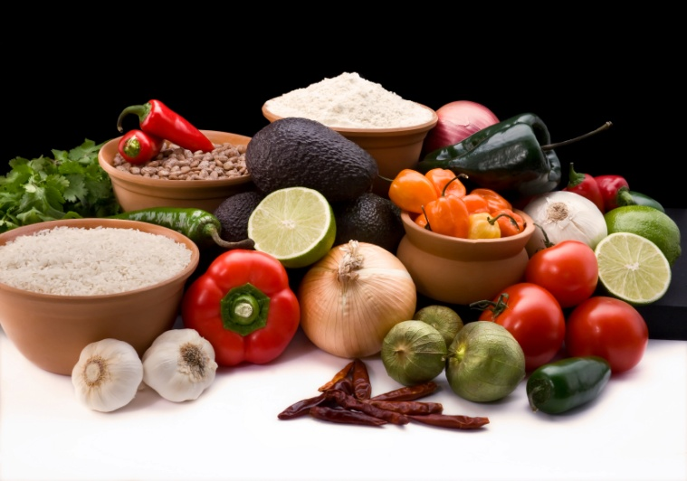

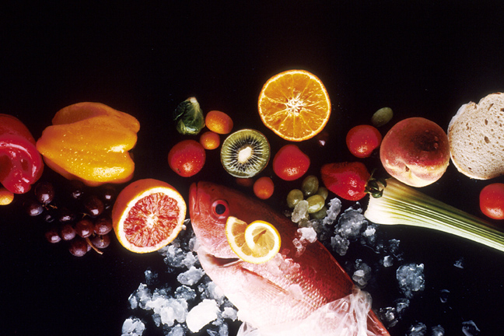
Recipe for: Blackberry Peach Coffee Cake

½ c butter, soft2/3 c milk
1 c sugar2 tsp vanilla
2 large eggs2 c peeled, pitted and sliced peaches
2 tsp baking powder1 c blackberries
½ tsp saltpowdered sugar

Heat oven to 350 F. Beat butter, gradually add sugar. Add eggs, 1 at a time, beating until blended. Combine flour, baking powder and salt; add to butter mixture alternatively with milk. Stir in vanilla. Pour batter into greased 9 inch pan, top with fresh fruit. Bake 1 hr 20 min or until cake is set. Dust with powdered sugar and garnish with fresh fruit if desired.
Recipe for: Peach Blackberry Yogurt Parfaits

2 ripe peaches, pitted and sliced
1 ½ c Greek yogurt
3 T honey
¾ c blackberries
½ c granola

Stir yogurt and honey together. Divide peaches, blackberries, yogurt mixture and granola among 4 glass bowls. Drizzle with honey if desired. Serve immediately.

Recipe for: Peach Salsa

2 cans peachesDash of Salt
1 red onion¼ tsp chili powder
1 red bell pepperLime, juiced
1 jalapeno, optional
½ bunch cilantro

Chop all ingredients very fine and combine. Add seasonings and lime juice. Refrigerate 1 hr. Serve with chips.

Recipe for:

Recipe for:

