

Beneficial Bites

**Practice what you peach**:

* Peaches are an excellent source of vitamin C, vitamin A, vitamin E and other antioxidants and flavonoids. These may be beneficial in promoting better memory, lower cardiovascular disease, ease inflammation, promote bone health and promote eye health.
* Peaches provide dietary fiber, both soluble (fleshy part of the fruit) and insoluble (skin of the fruit). Fiber aids with digestion.
* Peaches also provide potassium, magnesium, calcium and iron.

Originating in China, peaches are seen as a symbol of good luck, protection, and longevity. Being a drupe fruit, peaches contain a stone in the middle.



Beneficial Bites

**Practice what you peach**:

* Peaches are an excellent source of vitamin C, vitamin A, vitamin E and other antioxidants and flavonoids. These may be beneficial in promoting better memory, lower cardiovascular disease, ease inflammation, promote bone health and promote eye health.
* Peaches provide dietary fiber, both soluble (fleshy part of the fruit) and insoluble (skin of the fruit). Fiber aids with digestion.
* Peaches also provide potassium, magnesium, calcium and iron.

Originating in China, peaches are seen as a symbol of good luck, protection, and longevity. Being a drupe fruit, peaches contain a stone in the middle.

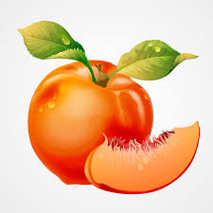



Beneficial Bites

**Practice what you peach**:

* Peaches are an excellent source of vitamin C, vitamin A, vitamin E and other antioxidants and flavonoids. These may be beneficial in promoting better memory, lower cardiovascular disease, ease inflammation, promote bone health and promote eye health.
* Peaches provide dietary fiber, both soluble (fleshy part of the fruit) and insoluble (skin of the fruit). Fiber aids with digestion.
* Peaches also provide potassium, magnesium, calcium and iron.

Originating in China, peaches are seen as a symbol of good luck, protection, and longevity. Being a drupe fruit, peaches contain a stone in the middle.

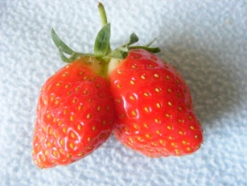

**August Menu items**

Fresh Peach

Peach Pie

Cottage Cheese & Peaches

**August Menu items**

Fresh Peach

Peach Pie

Cottage Cheese & Peaches

**Just Peachy**

* **Americans love peaches, ranking in the top 3 favorite fruits**
* Every year in Georgia, the world’s largest peach cobbler is made measuring 11’x5’
* The largest peach on record weighed 25.6 ounces, picked in Coloma, Michigan in August 2002
* August is National Peach Month
* Peach trees usually live around 12 years



Beneficial Bites



Beneficial Bites

**Just Peachy**

* **Americans love peaches, ranking in the top 3 favorite fruits**
* Every year in Georgia, the world’s largest peach cobbler is made measuring 11’x5’
* The largest peach on record weighed 25.6 ounces, picked in Coloma, Michigan in August 2002
* August is National Peach Month
* Peach trees usually live around 12 years

**August Menu items**

Fresh Peach

Peach Pie

Cottage Cheese & Peaches

Strawberry Cheesecake Bars

**Just Peachy**

* **Americans love peaches, ranking in the top 3 favorite fruits**
* Every year in Georgia, the world’s largest peach cobbler is made measuring 11’x5’
* The largest peach on record weighed 25.6 ounces, picked in Coloma, Michigan in August 2002
* August is National Peach Month
* Peach trees usually live around 12 years



Beneficial Bites