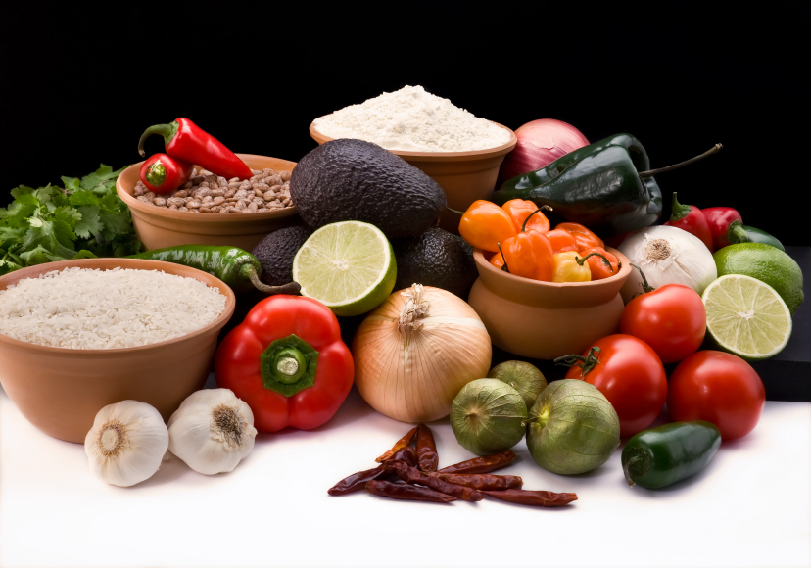
Recipe for: Italian Herb Bread
1 (.25 ounce) package active dry yeast½ T dried basil
1 cup warm water½ T dried oregano
1 T white sugar½ tsp. garlic powder
¼ cup olive oil½ tsp. onion powder
½ T salt¼ cup grated Parmesan Cheese
3 cups whole wheat flour

Mix yeast, water and sugar together in a large bowl. Set aside for five minutes or until mixture becomes foamy. Stir olive oil, salt, herbs, garlic and onion powder, cheese and 1 ½ cups of the flour. Gradually mix in the remaining 1 ½ cups flour. Knead dough for 5 to 10 minutes, or until it is smooth and rubbery. Coat the surface of the dough with oil and cover with a damp towel. Allow to rise for one hour, or until the dough has doubled in size. Punch the dough to release all the air and shape into a loaf. Place in a greased 9 x 5 loaf pan. Allow to rise 30 minutes, or until doubled in size. Bake at 350 degrees for 35 minutes. Remove from pan and let cool on wire rack.

*This bread will be heavier and drier than white bread but will contain higher amounts of fiber and lower amounts of calories. Sift the flour to incorporate more air and use oil instead of flour on your hands when kneading.

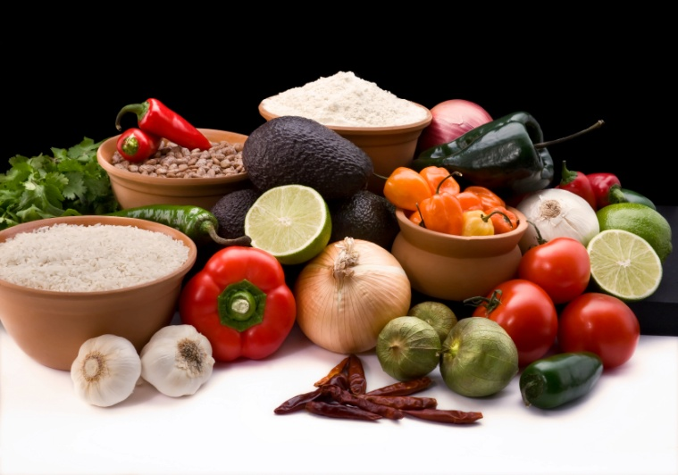

Recipe for: Roasted Potatoes with Oregano

1 lb red potatoes1 tsp. dried rosemary
1 lb Yukon gold potatoes 2 tsp. dried oregano
2 T olive oilSalt and pepper to taste

Preheat oven to 350 degrees. Wash potatoes and cut into quarters. Combine oil, rosemary and oregano in a large bowl. Gently toss the potatoes in the oil mixture until the coated. Spread the potatoes, skin side down, on a baking sheet. Bake for 45 minutes, or until the potatoes are soft when punctured with a fork.

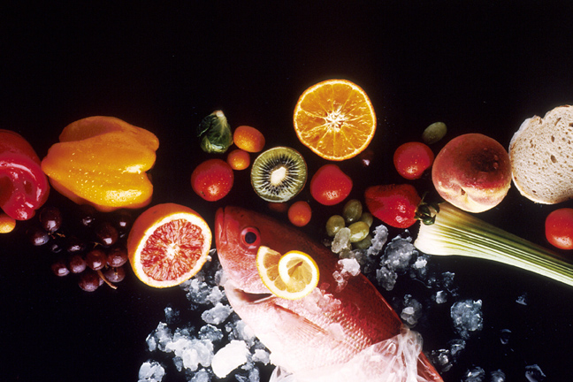
Recipe for: Popcorn with Dried Oregano

4 T Extra Virgin olive oil2 tsp. dried oregano
2 T fresh lemon juice2 tsp. sesame seeds
½ cup popcorn kernels½ tsp. pepper
1 tsp. saltAdd additional herbs and spices to your liking

Whisk together olive oil and lemon juice in a small bowl; set aside. Pop kernels according to the package directions and then transfer to a large serving bowl. Pour the oil and lemon mixture on top and mix well. Season with the remaining ingredients and toss. Serve immediately.

Recipe for: Oregano Chicken

2 chicken breasts without the skin or bonesDash of garlic powder
1 T olive oilDash of black pepper
1 tsp. dried oregano2 slices provolone cheese

Preheat oven to 400 degrees. Using the olive oil, grease the bottom of an 8 x 10 inch baking dish. Place the chicken in the baking dish and sprinkle the spices on top. Cover the dish with aluminum foil and bake for 20 minutes. Remove the aluminum foil. Lay the slices of cheese on the chicken and bake an additional 5 minutes, or until cheese is melted and the juices of the chicken run clear.

