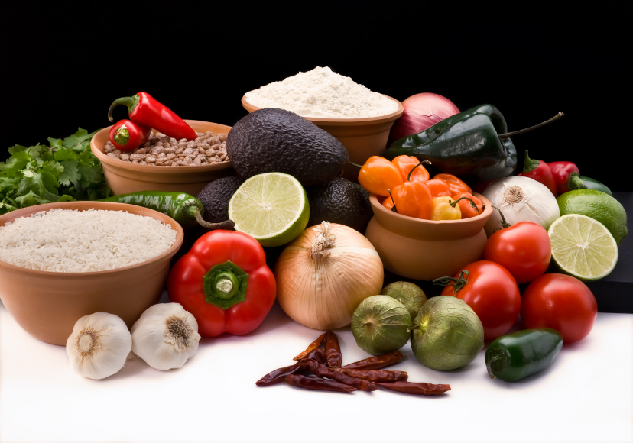
Recipe for: Beets in Orange Sauce
8 whole fresh beets*
¼ cup sugar2 teaspoons cornstarch
Dash pepper1 cup orange juice
1 teaspoon grated orange peel 1 navel orange, peeled and diced
Place beets in large saucepan; cover with water, bring to boil. Reduce heat and cook for 25-30 minutes or until tender. Drain, cool enough to peel and slice. Place in serving bowl and keep warm.
In small saucepan, combine sugar, cornstarch and pepper. Stir in orange juice until smooth. Bring to boil; cook and stir for 2 minutes or until thickened. Add orange peel. Remove from heat and pour over warm beets. Stir in diced oranges and serve immediately.

*You can substitute fresh beets for 15 oz can. Drain beets and omit step #1.

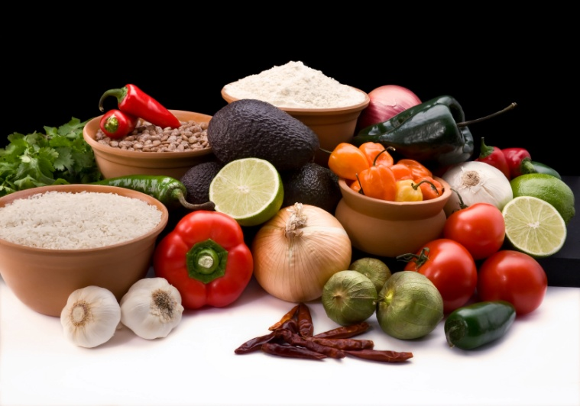

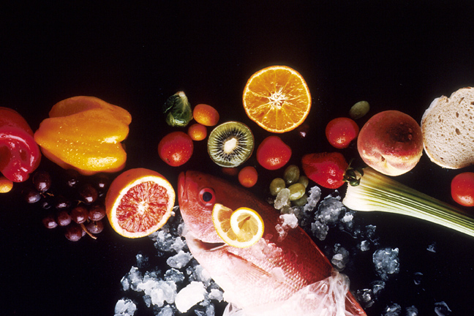
Recipe for: Tangerine Muffins
2 cups unbleached flour½ cup sugar
2 teaspoons baking powder1 teaspoon baking soda
½ teaspoon salt1 cup vanilla yogurt
1 egg, lightly beaten¼ cup butter, melted
2 tablespoons milk1 cup peeled, diced, seeded tangerine
1 tablespoon grated tangerine peel

Preheat oven to 400°. In a bowl, combine flour, sugar, baking powder, soda and salt. In small bowl, combine yogurt, egg, butter and milk until smooth. Stir into dry ingredients just until moistened. Stir in tangerine and peel. Fill greased or paper-lined muffin cups about 2/3’s full. Bake 18-20 minutes or until toothpick comes out clean. Cool 5 minutes before removing from pan. Makes about 1 doz.

One muffin prepared with skim milk and fat-free yogurt equals about 175 calories, 30 gms carbohydrate, and 1 gm fiber.

Recipe for: Broccoli Orange Salad

5 cups broccoli flowerets2 tablespoons sliced almonds
2 clementines, peeled sectioned1 navel orange, grated peel and juice
5 green onions, chopped2 tablespoons white vinegar
1 tablespoon sugar2 tablespoons olive oil
Salt and pepper

Steam broccoli flowerets in covered saucepan for ONLY 3 minutes. Remove quickly and rinse with cold running water until broccoli is no longer warm. Place in serving bowl and chill. In medium bowl, combine almonds, clementines, grated peel and juice from navel orange, green onions, vinegar, sugar, and oil. Toss gently and let stand at room temperature for 30 minutes.
When ready to serve, pour marinated orange mixture on chilled broccoli and toss gently. Season with salt and pepper and serve.
Recipe from www.sunkist.com/recipes/default.aspx

Recipe for: Honeyed Tangerine Blossoms
½ cup fresh squeezed tangerine juice½ cup honey
1 tablespoon grated tangerine peel ¼ cup lemon juice
3-4 whole cloves6-8 tangerines or clementines, peeled
¼ cup sliced or slivered almonds

In saucepan, combine honey, tangerine juice, lemon juice, tangerine peel and cloves. Simmer a 2-3 minutes on low to blend flavors. Add almonds.

Meanwhile, carefully spread peeled tangerine segments apart slightly to create flower petals. Arrange in tangerine “blossoms” in pie dish or muffin pan. Pour hot honey mixture over tangerines. Chill basting regularly with honey mixture. Remove cloves before serving.

Garnish with mint leaves or a stemmed maraschino cherry.
Recipe from www.sunkist.com/recipes/default.aspx

Recipe for: Orange Glazed Carrots

4 cups julienned fresh carrots
½ cup orange juice, divided
2 tablespoons sugar
2 teaspoons cornstarch
Dash salt and pepper

In microwave safe dish, combine carrots and ¼ cup orange juice. Cover and microwave on high for 4-6 minutes are until carrots are crisp tender.

Combine the sugar, cornstarch and remaining orange juice until smooth. Stir into carrots. Microwave, uncovered for 2-3 minutes or until sauce has come to boil and has thickened, stirring after each minute. Add salt and pepper, stir and let stand for a couple of minutes before serving.

Recipe for: Orange Nut Bread

1 cup orange juice1 cup dates or raisins, finely chopped
2 teaspoons grated orange peel1 teaspoon vanilla
1 egg, beaten2 tablespoons melted butter
1 ½ cup a.p. unbleached flour½ cup whole wheat flour
1 teaspoon baking powder¼ teaspoon salt
½ teaspoon baking soda1 cup sugar
½ cup chopped nuts

Preheat oven to 350°. In small saucepan, bring orange juice to boil and reduce to simmer. Add dates/raisins and orange peel. Cool. Stir in butter, vanilla and egg. In medium bowl, sift together flours, baking powder, salt, soda and sugar. Pour in first mixture. Beat well then stir in chopped nuts. Bake in greased and floured loaf pan for about 1 hour or until toothpick comes out clean when inserted in center. Allow to cool for 15 minutes before removing from loaf pan to wire rack.

Recipe for: Southern Ambrosia

1 cup orange juice
2 medium navel oranges, peeled and sectioned
2 clementines, peeled and sectioned
1 can (8 ounces) pineapple chunks, undrained
1/2 cup seedless red grapes, halved
1/2 cup shredded toasted coconut
1/2 cup chopped toasted pecans

Combine juice, orange sections, pineapple, and grapes, stirring gently to blend. Refrigerate until serving time. Spread pecans and coconut on baking sheet and toast in oven for 3-4 minutes at 350°. Allow to cool. Fold in coconut and pecans just before serving. Serves 6.

Recipe for: Mandarin Orange Chicken

3 boneless chicken breasts2 tablespoons a.p. flour
Salt and Pepper1 tablespoon canola oil
½ cup orange juice¼ cup orange marmalade
2 tablespoons honey mustard¼ teaspoon ground thyme
1 can mandarin oranges, drained*1 teaspoon grated orange peel

Flatten chicken to ¼ inch thickness, then cut into pieces about ½” x 1”. In large Ziploc bag, combine flour, salt and pepper. Add chicken, seal bag and turn to coat. In large skillet, brown chicken in oil on both sides and continue cooking until chicken juices run clear. Remove chicken from skillet. Combine orange juice, marmalade, mustard and thyme in skillet. Bring to a boil, reduce heat and cook until sauce is thickened. Stir in orange peel. Add chicken and mandarin oranges. Serve over brown rice.
*Use 1 cup fresh clementine segments if desired. Add these to sauce, a few minutes before adding chicken to soften a little.

