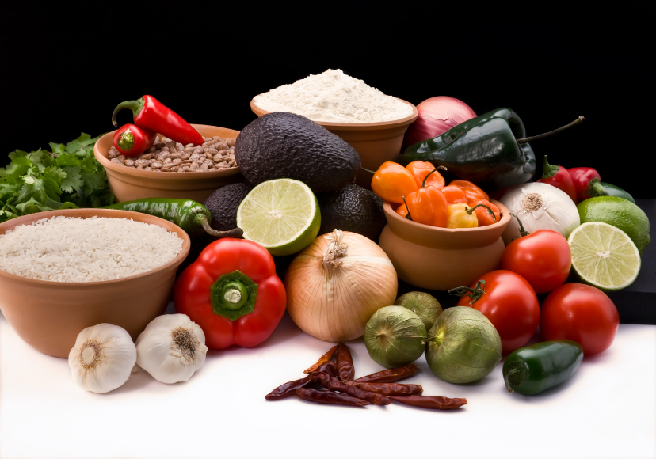
Recipe for: Caramelized Onions
6 slices bacon, chopped*
2 sweet onions, cut into thin strips
2 tablespoons molasses
Dash Pepper

Place bacon in heavy skillet. Cook over medium heat until crisp. Remove bacon, reserving 1 tablespoon drippings in skillet. Crumble bacon and set aside. Cook onions in reserved drippings for 15 minutes on low-medium heat until soft and caramel colored. Stir in molasses and pepper. Add crumbled bacon. Pile onto your grilled hamburger or steak!

*for a Bite with more Benefit, skip the bacon, and use canola or olive oil for caramelizing.


Recipe for: Dixie Cabbage Salad

1 pound prepared, finely shredded cabbage
1 each red, green and yellow pepper, julienned
1 sweet onion, quartered, sliced thin
1 teaspoon lemon zest
½ cup lemon juice
½ teaspoon each salt and freshly ground black pepper
2/3 cup olive oil

Mix vegetables; In separate, small bowl, whisk together lemon juice, zest, salt, pepper and oil. Fold into vegetables. Refrigerate at least 2 hours before serving.

Recipe for: Savory Onion Mini Pies
2-mini unbaked pie shells
2 large or 3 medium yellow onions, thinly sliced1 tablespoon olive oil
¼ cup diced ham1 ½ teaspoons sugar
½ tablespoon flourDash salt & pepper
Dash garlic powder2 eggs, slightly beaten
1/3 cup milk½ cup grated Swiss cheese

Saute onions in olive oil until tender and translucent. Stir in ham and remove from heat. Cool 15 minutes. In bowl, combine sugar, flour and seasonings. Add slightly beaten eggs and milk to dry ingredients and mix well. Stir in onion/ham mixture and add cheese. Pour into pie shells. Bake at 400°F for 35 minutes or until top is golden brown and knife inserted into center comes out clean of any egg mixture. (cheese may stick to knife but just make sure the “custard” is set. Let stand 10 minutes before serving.

Recipe for: Creamy Vidalia Onion Soup

4 Vidalia onions, thinly sliced3 tablespoons margarine
1 tablespoon flour¼ teaspoon salt
2 cups chicken broth1 cup milk
½ cup fat free half & half3 egg yolks beaten
Drop hot pepper sauceBlack pepper to taste
2 tablespoons chopped fresh parsley

Melt margarine over medium heat and add onions. Saute until golden brown. Stir in flour and salt and mix thoroughly. Gradually add broth, stirring constantly. Cover and simmer over low heat about 10 minutes. When onions are very tender, stir in milk and half & half. Heat through. Remove ½ cup of soup, and slowly add egg yolks to this. Then gradually add egg yolk mixture back into soup. Do not allow soup to boil. Stir in hot pepper sauce and black pepper. Serve hot, garnished with parsley.

